Topic 1: Basic rules of cavity preparation: Explanation of each rule, Preparation, Instruments

Introduction

Over 100 years ago, the American Dr. G.V. Black (1836-1915) developed a system to categorize carious lesions based on the type of tooth affected (anterior or posterior tooth) and on the exact location of the lesion (lingual, buccal, occlusal, proximal). He also formulated the basic rules of preparation of cavities and developed the guidelines for amalgam fillings including the optimal composition of amalgam. Because of his contributions to the dental science he is still known as one of the founders of modern dentistry. His rules and his categorization of carious lesions are nowadays still present and used. It is noticeable that today’s ideas have changed slightly and we are focusing much more on minimal intervention because materials have further developed. A new class was added to his system (Class VI).

Classes according Black

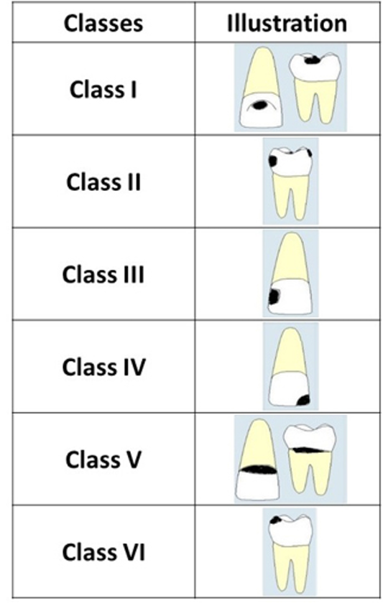

Class I.:
Cavity in pits or fissures on the occlusal surfaces of molars and premolars, palatal surface of upper molar, buccal surface of lower molar and palatal surface of maxillary incisor (these 3 are known as foramen caecum). Class I corresponds to the carious surfaces you can clinically see.

Class II.:
Cavity on proximal surfaces of premolars and molars. You cannot see the proximal surface clinically, it is for example detectable by radiography.or other imaging methods (difoti). We can see this lesion only if it is large.
Class III.:
Cavity on proximal surfaces of incisors or canines that do NOT involve the loss of incisal angle/ridge.
Class IV.:
Proximal surfaces of incisors or canines that involve the loss of incisal angle/ridge.
Class V.:
Cavity on the cervical third of the facial or lingual surface on any tooth (neck of the tooth).
Added Class VI:
Cavity on incisal edges of anterior teeth and cusp tips of posterior teeth. Here can be small defects or abrasion and here can dental caries originate.

Preparation rules according to Black

For the preparation of teeth which are damaged by dental caries there are the following rules to follow:
- Extension for prevention
The risk of secondary caries on the prepared surface should be minimal.
- Principles of Retention
The preparation must be done in a way that the filling is not going to fall out.
- Principles of Resistance
The filling needs to be strong enough to face up occlusal forces.not only filling but also the tooth. Both.

Steps of preparation

- Access to the cavity
- Outlines (depending on class) – cavosurface margin
- Excavation of carious dentin
- Cavosurface margin* (Extension for prevention)
- Principles of retention
- Principles of resistance
- Preparation of borders
- Finishing
- Control

*Cavosurface Margin: Ideal outline includes all occlusal pits and fissures. If crista transversa (1st lower premolar) or oblique ridge (1st and 2nd upper molar) are not affected, it is strongly recommended not to prepare them.

Outlines

The preparation of outlines depends on the material used. For amalgam (mainly used for posterior teeth) it is important to remove the fissure in order to fulfill the rule of extension for prevention and to have undercuts in order to follow the rule of Retention. When using Composite, such as in Class IV the enamel needs to be beveled (seen on picture below) to ensure the material connects with the dental tissue.

Class I.
Recommended material: Amalgam, Composite (if small cavity)

Class II.
Recommended material: Amalgam, Composite (if small cavity)

Class III.
Recommended material: Composite, Glassionomer Cement

Class IV.
Recommended material: Composite.

Class V.
Recommended material: Composite, Glassionomer Cement, Amalgam (posterior area)

Instruments

Instruments for investigation
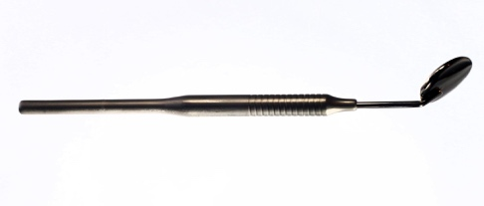
- Mirror – for viewing
- Straight probe – measuring depth
- Periodontal probe – calibrated
- Tweezer – to pick up burrs

Hand instruments:
- Excavator – removing carious dentin
Chisels – for finishing of gingival wall in class II cavities

Filling instruments:
- Spatula and condenser
- 3 angled spatula
- Frahm – used to create fissure system out of amalgam
- Wiland-carver
- Burnishers – polishing amalgam
- Condenser

Lever tools:
- Used for extractions of teeth
- 2 types- pliers and levers
- Dental extraction pliers: axis of pliers’ jaw must be parallel to axis of tooth root
Upper incisors and canines – use straight pliers
Upper molars and premolars – use S-shaped pliers
Mandibular teeth – right-angled plier
- Root removers: penetrate into periodontal cavity and circle around tooth root with mild pressure directed at root apex; causes rupturing of periodontal fibres and dental socket (alveolus) widens, allowing tooth to be removed

Handpieces:
- Turbine – 400,000 rpm; low torque control, used for vigorous preparation
- Electromotor – maximum 40,000 rpm
- Air motor – maximum 20,000 rpm
- It’s possible to modify the rpm by using handpieces with various gears; each handpiece has a different colour
  - High speed = red
    - Better control in comparison with turbine handpiece
    - Gear 1:5 to fast
  - Low speed = green
    - Suitable for slow work e.g. excavation of carious dentin
    - Gear 2,7 :1 or more.
  - Gear 1:1 = blue
    - preparation in dentin recommended
  - Oscillation (rotation is locked) = yellow
- There are also special handpieces, e.g.:
  - Handpiece for compaction of amalgam
  - EWA system – instrument doesn’t rotate, it only oscillates
  - Handpieces for endodontology and implantology

Rotary instruments
- Consist of 3 main parts: source of rotary movement, transmission system and handpiece with rotary tool
- Power source can be electric motor, compressed air or streaming liquid
- Handpieces are what attach to rotary tools; they can be high or low rate and produced straight or angular
- Increased rotation creates heat which damages dental pulp, therefore instruments are equipped with water spray
Burrs
- There are 5 characteristics (A-E) burrs can have:
  - A = material (stainless steel. Tungsten, carbide, diamond)
  - B + C = size and kind of handpiece (straight handpiece, contra-angle, turbine)
  - D = shape of working part/of burr (ball, pear, fissure, inverted cone)
  - E = further characterisation (grit/texture of burr)

Diamonds
- Classifications of diamonds:
  - Blue – standard; universal use; grit = 90-120 µm
  - Black – extra coarse (150-180 µm); not for cavities e.g. used for cutting old crowns
  - Green – coarse (125-150 µm), for special purposes, not for cavities
  - Red – fine (20-40 µm), used for finishing of preparation, smoothing or bevelling
  - Yellow – extra fine (12-22 µm), for finishing of composite fillings
  - White – ultra fine (6-12 µm), polishing of composite fillings

By Sacha Koeppen, Tamo Schiedermair, Juliette Pardon

