**EMBRYOLOGY**

Name: UČO: Group: Date:

1) Label all structures in image:

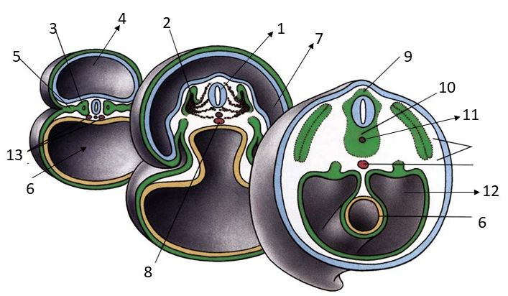

2) Where can you find (**in image**) the embryonic base of vertebrae (spinal column)? No ………………

Name this structure:………………………………………………………………………………………………………………………

3) The inner fetal membrane is called ………………………………………………….. and is composed of

………………………………………………………………………………………………………………………………………………….

4) Name two fields of germ disc where ectoderm and endoderm remain connected (without mesoderm): …………………………………………………………………………………………………………………………..

5) What does it mean decidua basalis?......................................................................................................

6) Intraembryonic mesoderm differentiates into (according to relation to the notochord): ………………………………………………………………………………………………………………………………………………………………..

7) Name at least 2 anomalies of the placenta…………………………………………………………………………………………..

8) Folding of embryo is caused by (2 main reasons) ……………………………………………..….and ……………………………………………………………………………………………………………………

9) What is the correct scheme of monozygotic twins (**image**) that arise after splitting on stage of two blastomeres?...............................

10) Name the arrangement of the fetal membranes (amnion and chorion) in **image C**:

……………………………………………………………………………………………………………………………………………………..

