9. Renal colic

Renal colic is a symptom of acute obstruction of the urinary tract. It manifests itself as pain of variable intensity ("in waves"), which spreads from the flanks to the lower abdomen or genitals (and vice versa). It originates in the kidney or upper urinary tract. The most common cause is urolithiasis.

Clinically, colic-like pain is accompanied by motor restlessness (the patient does not stand still) and vegetative symptoms (sweating, nausea, vomiting, even paralytic ileus). Blood (micro or macrohematuria) is usually present in the urine. Irradiation of acute pain in the genitals can also mimic acute scrotal syndrome in men.

Ultrasound
Of the imaging methods, the method of choice is ultrasound. The task of ultrasound is to answer the question of whether or not there is an obstruction of the urinary tract, i.e. whether there is a risk of renal impairment.

Dilated renal collecting system on ultrasound appears as a centrally located anechoic non-vascularized formation corresponding to dilated pelvis and calices, sometimes followed by a distally dilated ureter. The dilated pelvis or calyx should be measured in a shorter size (anteroposterior), thus reducing the risk of confusing the ampular type of the pelvis with dilatation. Ultrasound frequently allows visualisation of impacted stone in the ureter/pelviureteral junction, which is displayed as a hyperecho with an acoustic shadow in the lumen of the dilated collecting system. Obstruction of the renal drainage system may include diffuse edematous enlargement of the affected kidney and swelling of adjacent fat.
In a non-dilated collecting system, small kidney stones are very difficult to see because they are hyperechogenic, similar to the central echocomplex of the kidney, and furthermore acoustic shadows may also originate in calcifications of the renal artery wall. On ultrasound, the resolution limit of the stones is considered to be 3-4 mm.

In case of chronic obstruction of the renal collecting system, the thickness of the renal parenchyma gradually decreases and results in renal atrophy.

Another task of ultrasound is to find any other pathology in the abdominal cavity, retroperitoneum or groin, which mimics renal colic. Limitations of ultrasound examination are generally sonographically difficult to examine patients and other pathologies mimicking dilatation of the collectiong system such as parapelvic cysts, polycystic kidney disease or chronic dilatation of the hollow system due to another cause (e.g. vesicoureteral reflux).

Non-contrast CT
Ultrasound is usually followed by non-contrast CT (no intravenous contrast agent) to confirm dilatation of the collecting system, verify the position of the lithiasis, detect the number of stones, and treatment planning. In patients with recurrent renal colic without diagnostic uncertainty, a CT scan can be performed immediately (ultrasound is skipped).
Most stones have a much higher density than the surrounding soft tissues, so CT without contrast is sufficient.
If another cause of obstruction is suspected (e.g. oncological or iatrogenic), in addition to non-contrast CT, CT with intravenous contrast administration in one or more postcontrast phases is required. Contast-enhanced CT of the kidneys always involves the excretory phase. The excretory phase is performed after 7-10 minutes from contrast administration, when the contrast agent is already partially excreted in the urine. Contrast-enhanced CT allows visualisation of ureters filled with contrast, and soft-tissue structures causing the obstruction. Renal function can be assessed very unreliably (i.e. kidney either excrete or does not excrete the contrast into the urine).

Renal scintigraphy can be used to more accurately assess renal function and urine drainage with minimal morphological data.
^{99m} Tc-DTPA (diethylenetriaminepentaacetic acid) or ^{99m} Tc-MAG3 (mercaptoacetyltriglycine orthoiododpurpuran sodium) are used for renal scintigraphy.

An overview of urinary outflow from the kidneys was also provided by intravenous urography (IVU, X-rays taken after 7,14 and 21 minutes from intravenous contrast administration), which is already considered obsolete due to radiation exposure and small information benefit compared to CT.
An X-ray is only suitable for monitoring of X-ray contrast lithiasis during therapy (usually ESWL - Extracorporeal shock wave lithotripsy) or to confirm the position of inserted stents.

Magnetic resonance imaging is not used in the acute diagnosis of renal colic.

Diagnosis and therapy of renal colic can be complicated by relatively frequent anatomical varieties of the kidneys and the collection system. These varieties include, for example, ureter fissus, ureter duplex, ren arcuatus.
Modern CT machines can measure X-ray absorption in 2 different energies (dual source or dual layer CT) and are therefore able to estimate the chemical composition of the urinary tract stones. It is thus possible to distinguish uric acid from non-uric acid stones, which significantly accelerate the diagnosis, because in such cases there is not necessary to wait for a detailed urine analysis. Unlike others, uric acid stones are treated conservatively.

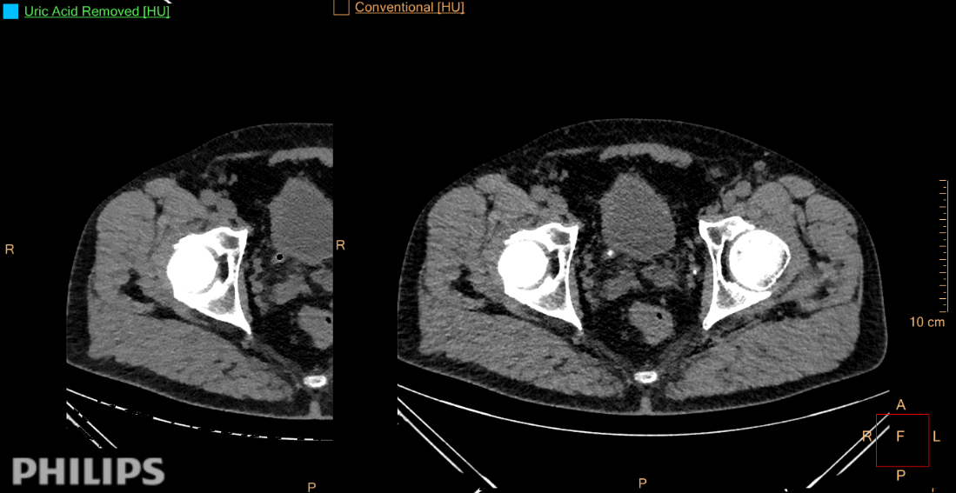
Fig. C - Spectral CT with supression of the uric acid signal (left) and standard non-contrast CT (right) – juxtavesical ureterolithiasis composed of uric acid.

C
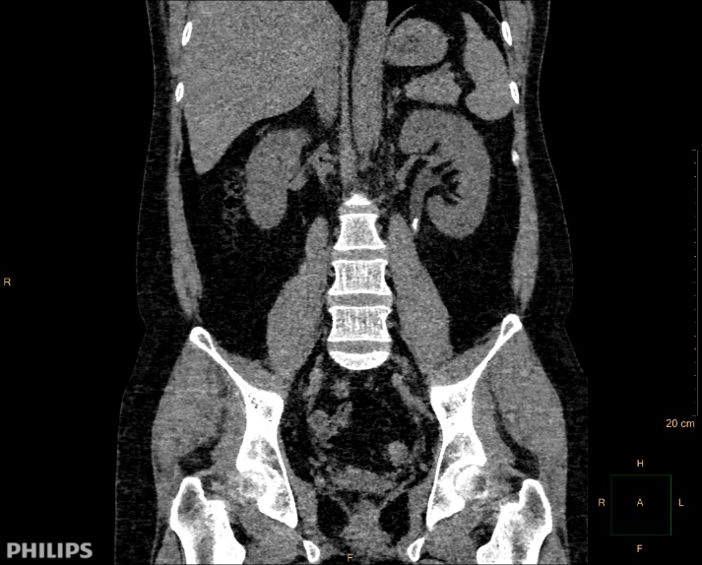
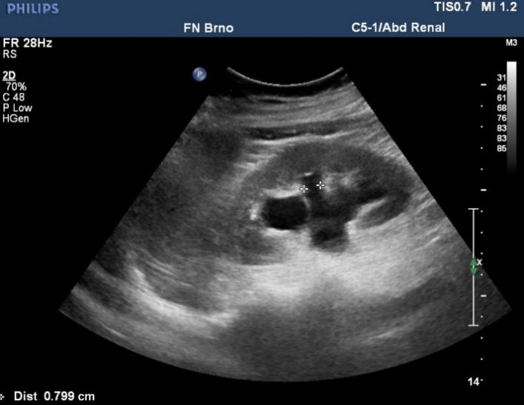
Fig. A - Ultrasound – dilation of pelvicocalyceal systém of the kidney
Fig. B – Non-contrast CT – proximal ureterolithiasis (white arrow)

A
B

