15. Lymfadenopathy

Lymphadenopathy is a term used to describe any lymph node pathology. From the point of view of imaging methods, it is mostly about enlarging of lypmh nodes. Pathological enlargement of the lymph nodes is accompanied by a large number of diseases. Enlarged nodes can be caused by infections, malignancies (metastatic nodal involvement, hematooncological diseases - lymphoma and leukemia), granulomatous processes (eg sarcoidosis), autoimmune diseases, reactions of the immune system to foreign substances, histiocytic and other diseases.
When evaluating lymph nodes, we assess the size, number and morphological characteristics of nodes.
It is often difficult to distinguish individual type of disease only by imaging methods. However, we can use targeted biopsies under the control of imaging methods (most often under ultrasound or CT). When using needles up to 1 mm, we obtain samples only for cytological examination. Using thicker needles, samples can also be obtained for histological assessment of tissue.
Ultrasonography is the method of first choice when peripheral lymphadenopathy is suspected. We use linear high-frequency probes, which allow us a detailed evaluation of the echostructure (benign vs. malignant etiology). In the ultrasound image, we evaluate the size, shape, echogenicity, structure, boundary and vascularization of the node. In indicated cases, there is possibility of using CEUS.
US normal lymph node:  - normal LT index ≥ 2 (elongated shape)  - size criteria (<10mm in short axis)  - central hyperechoic hilum  - uniform hypoechoic cortex  - central type of vascularisation  - smooth and sharp borders | US sign of malignant transformation  - decreased LT index (spheric tvar)  - absence of excentric dislocation of hyperechoic hilum  - presence of necrosis, cystic transformation  - blurred borders  - abscence of central vascularisation (peripheral or mixed type of vascularisation)  - focal cortical hypertrophy

LT index- ratio of long and short axis of the lymph node (L-longitudinal, T transverse dimension)
The LT index is ≥ 2 in benign lymph nodes, while in pathological malignant nodes it is usually less than 2

Computed tomography CT is used to examine lymph nodes in the area of the mediastinum, abdomen and pelvis and, together with the assessment of other structures in the area of the neck. Outside the mediastinal area, CT examination is usually preceded by ultrasound.
Indications for MRI in principle, overlap with CT. Mostly to assess other organs and other structures in the targeted area of the examination.
The methods of nuclear medicine PET / CT, PET / MR make it possible to evaluate the metabolic activity of the node. PET/CT and PET/MR are especially used in the diagnosis and staging of malignant lymph nodes.

Cervical lymphadenopathy
In diagnostics, ultrasonography is the method of first choice for the good availability of most cervical nodes (see above).
Differential diagnosis of the most common causes of cervical lymphadenopathy: infections, hematooncological diseases (lymphoma, leukemia), metastatic disease.

Mediastinal lymphadenopathy
Of the imaging methods, CT (or MR) has an important role in the diagnosis of mediastinal lymph nodes. Hybrid imaging methods (PET / CT, PET / MR) also play a recognized role in the assessment of the metabolic activity of nodes, especially in cancer.
X-rays show only more pronounced mediastinal or hilar lymphadenopathy. In the presence of hilar lymphadenopathy, the pulmonary hila in the X-ray image will be enlarged, more voluminous and predominantly polycyclic in shape. In mediastinal lymphadenopathy, we observe an expansion of the mediastinal shadow (Figure 3).

Differential diagnosis of the most common causes of mediastinal lymphadenopathy: infections, hematooncological diseases (lymphoma, leukemia), metastatic disease, sarcoidosis.

Abdominal lymphadenopathy
Of the imaging methods, CT (or MR) has an important role in the diagnosis of abdominal lymphadenopathy.
Ultrasound is usually performed before CT examination. However, in the case of ultrasound examination of the abdomen and pelvis, habitus or increased intestinal meteorism may be a limitation of the examination.
Hybrid imaging methods (PET / CT, PET / MR) as in other areas are important in assessing the metabolic activity of lymph nodes.

Differential diagnosis of the most common causes of abdominal lymphadenopathy: infections, hematooncological diseases (lymphoma, leukemia), metastatic disease.

Spleen
The spleen is the largest lymphatic organ involved in the blood circulation (its functions include the formation of lymphocytes, the uptake of antigens from the blood by macrophages, the production of antibodies). Functionally, it belongs to the vascular system (its function is also the uptake and destruction of erythrocytes, it is a reservoir of blood - 100ml). The presence of an accessory spleen is common.

Enlargement of the spleen is called splenomegaly (size more than about 13x4cm depending on the habit). The cause of splenomegaly can be lymphoma, leukemia, anemia, chronic infections, portal hypertension, storage disorders.

Traumatic injury of the spleen.
The spleen is the most commonly affected organ in blunt abdominal injuries. In traumatic spleen injury, ruptures, contusions, lacerations, intraparenchymatous or subcapsular hematoma can be encountered.

Splenic infarction.
Splenic infarction has a typical image of a wedge-shaped defect in imaging methods, which is hypoechogenic in the ultrasound image , and shows an absence of enhancement in the CT postcontrast image.

Focal lesions of the spleen.
The most common benign focal lesion of the spleen is a cyst, and we can also include, for example, hemangiomas. Infectious focal lesions of the spleen may include abscesses or sarcoidosis. Lymphoma is the most common malignant neoplasia that affects the spleen. Infiltration of the spleen by lymphoma can manifest itself in the form of splenomegaly or as the presence of lesions in the spleen.

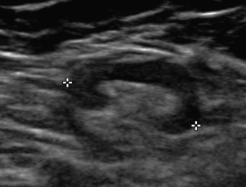
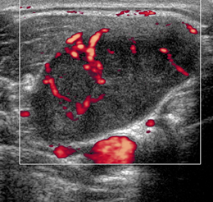
Fig. A – Ultrasound UZ – normal superficial lymph node of the neck – lymph node is not enlarged, has elongated shape, normal LT index, preserved hyperechoic central hilum
Fig. B - Ultrasound – pathological lymph node in patient with diffuse large-cell B-lymphoma – lymph node is enlarged, heterogenous ultrasound texture, hyperechoic hilum is not present, pathological peripheral vascularisation in Doppler mode

A
B

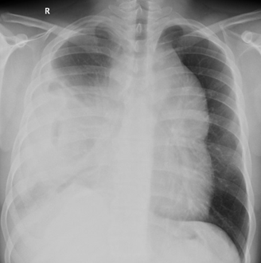
Fig. C – X-ray of the chest – enlarged shadow of the mediastinum cause by mediastinal expansion in patient with lymphoma, extensive right-sided fluidothorax
Fig. D – Contrast-enhanced CT of the chest in the same patient – huge pathological soft-tissue mass of the mediastinum, pleural effusion of the right
D
C

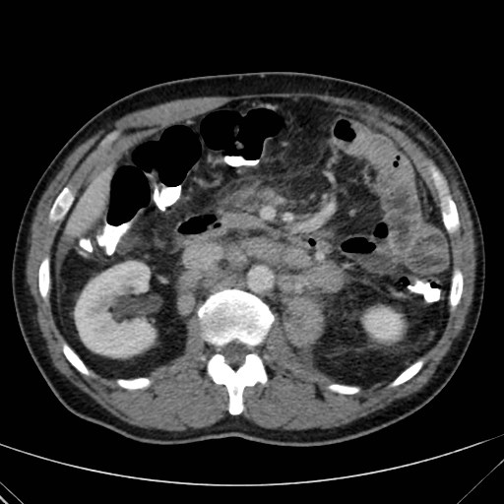
Fig. E - Contrast-enhanced CT (portal phase, axial plane) – retroperitoneal lymfadnoepathy in patient with chronic lymphatic leukemia
Fig. F – Contrast-enhanced CT (portal phase, axial plane) – multiple hypodense lesions in the spleen in patient with diffuse large-cell B-lyphoma
E
F

