This laboratory involves the collection of urine at various time intervals and measurement of its volume and specific gravity (an indication of osmolarity). There are four different protocols, each requiring a different volunteer.
KIDNEYS - LabTutor

Volunteer preparation
The establishment of the diuresis depends upon fairly rapid absorption of the water so it is important not to start with a full stomach. Just eat a light meal and drink normally in the 3 to 4 hours before the laboratory starts. In addition, avoid fluids containing caffeine (coffee, tea, cola drinks) for at least 3 hours prior to the laboratory.
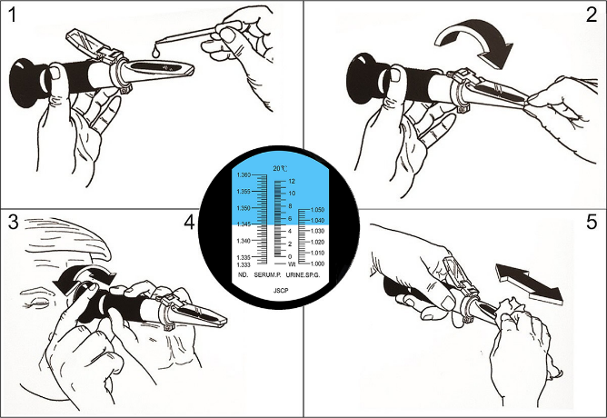
Be sure to note the time at which you last urinated prior to coming to the laboratory.

Refractometer measurement
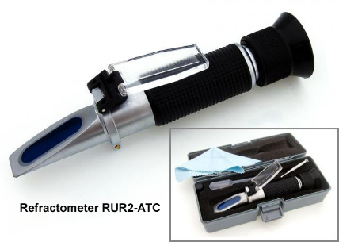
1. Preparation for measurement (handle the device with care and
don't touch optical lens). Set direction of the refractometer transparent
cup against the light, look into the eyepiece and sharpen the image to
improve readability. You will see a circular space with a scale.
2. Refractometer calibration.
Open the transparent cup, put 1 to 2 drops of the calibration solution
(distilled water) on the optical prism, close the cup and press it slightly
for the solution to spread perfectly over the surface of the optical prism
(without air bubbles and dry spots). Look into the eyepiece, the top of
the visor should be blue, the bottom white, and the boundary should go
through a calibration value of 1.3300 (left scale of the RI) If not, turn
the calibration screw until the desired condition is reached.
3. Measurement.
Open the transparent cup, clean the optical prism with the included cloth, then put 1 to 2
drops of the test liquid (urine) on it, close the up and slightly press it so that the liquid
can spread perfectly over the surface of the optical prism (without air bubbles and dry spots)
The measured value will be represented by the intersection of the blue-white boundary
on the right measuring scale (specific gravity).
4. Cleaning after measurement.
Clean the prism and the transparent cup with a damp cloth and carefully place the device
in to the case. To wet the cloth, use Desident CaviCide spray.

General procedures during the experiments for all volunteers
1. Open LabTutor - Kidneys and at the commencement of the experiment, note the time, collect your urine and measure its
volume. Keep a small sample for measurement of specific gravity.
2. Immediately after the collection of the first sample, drink the required solution (except control). Once you have drunk this
solution, do not drink anything else during the laboratory.
3. Continue to collect urine approximately every 20 minutes, noting the time at which the bladder is emptied to the nearest
minute.
4. It will be found most convenient for each subject to be his or her own timekeeper; there is no necessity for the subjects to keep
in step with each other. The essential thing is that the intervals between urination are accurately recorded.
Cautions
Do not volunteer to be a subject in this laboratory class if you are suffering from kidney or circulatory problems, have any other medical problem or are on any medications.
Urine is a potentially infectious body fluid. Therefore, students are directly responsible for all measurements of the volume and specific gravity of their own urine, and are required to clean up any spilt urine themselves.
Pour the urine into the toilet!

