# Recruitment and summation in skeletal muscle

## Key words:

Alpha motor neuron, motor unit, motor end-plate, action potential duration, excitation-contraction coupling, mor- phological and functional typology of muscle fibres, twitch, isometric and isotonic contraction, superposition, tetanic contraction, gradation of force of contraction in cardiac muscle

## aim:

The student should understand the physiological mechanisms of gradation of muscular contraction and the differ- ences in various types of muscles (skeletal, smooth, cardiac).

## Caution:

Although the current and voltage are quite low in this practical, they easily demonstrate the phenomena studied. nevertheless, stimulation may be perceived as uncomfortable sensation in hypersensitive subjects that would fade out soon. Subjects with cardiac pacemakers or with neurological or cardiologic problems should not volunteer in this practical. It is prohibited to carry out stimulation on other parts of the body than those described above.

**Follow the instructions in LabTutor,** these instructions are only indicative.

## XXVI. 1. Recruitment

### Procedure:

1. Clean the volar side of the wrist of the examined subject with soap solution and dry it.
2. Switch off the Isolated Stimulator on the PowerLab front panel (switch pointing down).
3. Start the acquisition programme rECrUITMEnT by a double click on the icon.
4. In the menu *Setup – Stimulator panel* open the mini-window with stimulus parameters (Fig.37): stimulation fre- quency (Max Repeat Rate) 0.5 Hz, stimulus duration (Pulse Width) 0.2 ms, stimulus intensity (Current) 2 mA.

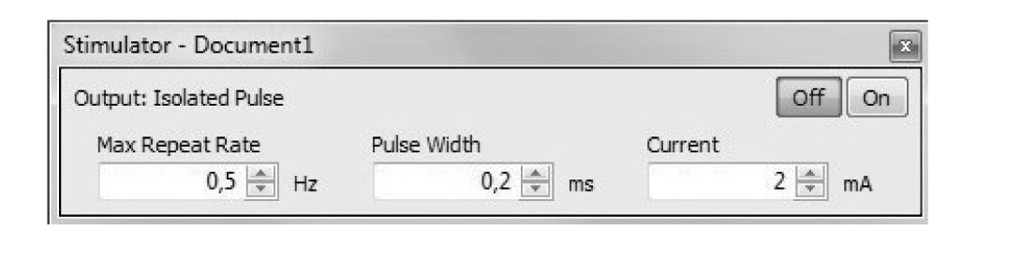

*Figure 37: Mini-window of Stimulator Panel*

1. Put a small amount of gel on both silver contacts of the bar electrode. Place the electrode at the volar side of wrist of the subject between the tendons of fl carpi radialis and palmaris longus (see Fig. 38). Both contacts must lie over the median nerve with cathode closer to thenar. The red dot on the electrode indicates anode (impulse is generated by cathode). In this phase of the experiment the bar electrode is held by the examined subject.

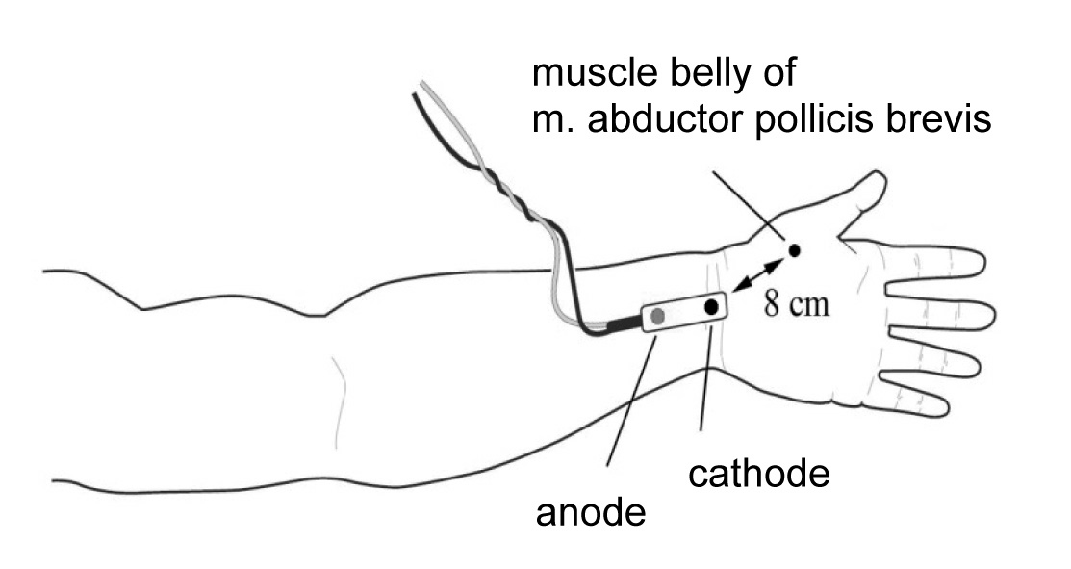

*Figure 38: Schematic picture of stimulation electrode position*

Set the Isolated Stimulator to the on position (switch pointing up).

1. Since the subjective perception of stimulation varies, adjust the stimulation parameters according to the in- structions of the examined subject.
2. Check the correct position of the bar electrode as follows: click STArT (do not record yet). Thereby a single stimulus of 2 mA is applied, perceived as a moderate sensation. note that somatosensory neurons have lower threshold for activation in comparison with motor neurons. Increase the intensity of stimuli in 2 mA steps until a clear motor response of thenar muscles (abductor and flexor pollicis brevis, opponens policis) is observed. Attach the electrode by Velcro fastener. If the electrode is placed more to the ulnar side, an undesirable contrac- tion of the muscles innervated by ulnar nerve may appear.
3. Turn the examined hand into semiprone position so that the muscle contraction would move the thumb verti- cally down. Place the forearm comfortably on the desk and ask the subject to relax all muscles. Put the fingers except the thumb under the plastic plate of the stand. Place the thumb gently on metal bands of the force trans- ducer and fix it to the metal bands (not to the plastic plate) by adhesive tape or Velcro.
4. In the mini-window *Stimulator panel* set the stimulation frequency to 2.5 Hz and the stimulus intensity to 1 mA. The subject should not observe the monitor. Turn on the recording mode  and press the button STArT. A train of four stimuli is now applied with a delay of 200 ms (indicated at the bottom channel *Stimulation*). The signal from the force transducer appears on the upper channel *Force.* The programme is recorded for a preset interval of 1 sec. In order to continue the stimulation, the button STArT must be pressed again. Each time you change the current, add a comment.
5. Increase the current by 1 mA and click START. Keep increasing the stimulus intensity until the first muscle contraction appears. Then lower it by 2 mA and continue with 0.5 mA increases until the *threshold intensity* (as a rule 3–8 mA) is achieved. Afterwards continue with 1 mA increases up to 20 mA. Avoid stimulation which provokes discomfort of the examined subject.
6. Save the record labelled “recruitment xy” where xy are the initials of the subject. Save as type Data Chart File (*.adicht).
7. Make a record of maximal intensity (Imax), the lowest intensity which has elicited full contractile response (of maximal force). Take a similar record of the threshold intensity (I ), the lowest intensity which has elicited

t

a contractile response. Both values are used in the next protocol.

1. Close the acquisition programme rECrUITMEnT*.*

### Evaluation:

Measure the force of contractions with increasing intensity of stimulation. Select 2nd – 4th twitch into a block (see Fig. 39). Average amplitude (mn) appears in the mini-window. Alternatively, in case of very low automatically undetect- able amplitudes you can measure them manually with cursor and marker and afterwards calculate the average.

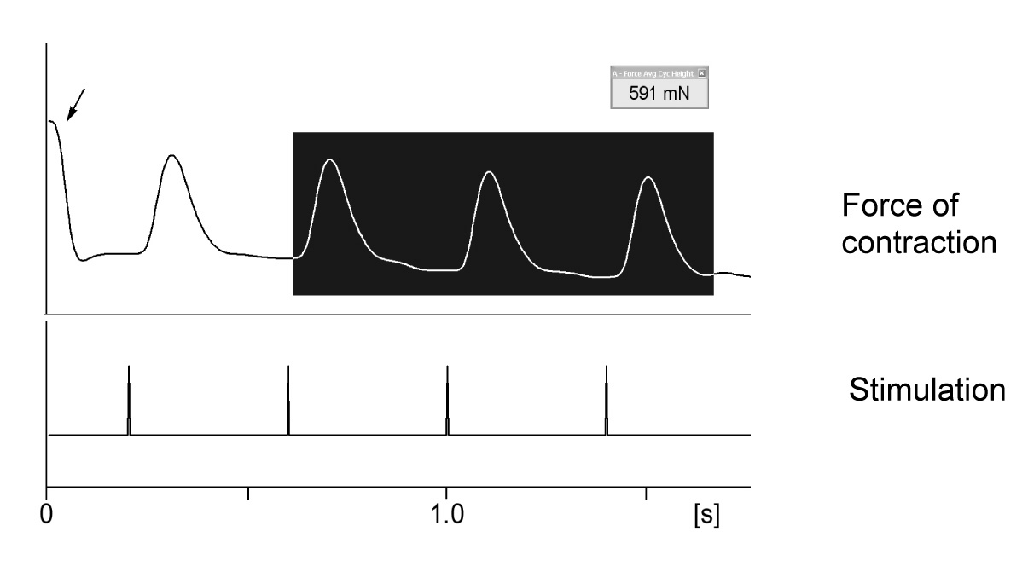

*Fig. 39. An example of recording. Black rectangle represents choice for average amplitude evaluation – force of muscle contraction. Corresponding value in mN appears in mini-window. Arrow shows an artefact from force sensor caused by starting the recording. At time 200 ms, the first one out of four stimulations starts.*

### Protocol, interpretation and conclusions:

Define the regulation of muscle contraction. Describe briefly the method employed. Make a copy of the record. Set up the table and graph of the force/intensity curve (mn/mA) ranging from 1 to 20 mA. Describe how the force of contraction depends on the stimulus intensity.

## XXVI. 2. Sumation

### Procedure:

1. The procedure described in paragraphs 1 – 9 of the previous exercise remains the same except that you start with the acquisition programme SUMMATIon by a double click on the icon.
2. In the mini-window *Stimulator panel* the parameters of stimulation appear: stimulation frequency 2 Hz, stimu- lus duration 0.2 ms, stimulus intensity 2 mA.
3. Set up the stimulus intensity to I

max

from the foregoing protocol. Switch on the saving mode.

1. Press STArT, two pulses of preset parameters are triggered and indicated on the bottom channel *Stimulation*. The first stimulus occurs with 200 ms delay after the onset of recording. The second simultaneous signal ap- pears on the upper channel *“Force”.* The programme is automatically recorded for 1 sec. For further stimula- tion press STArT again.
2. repeat stimulation at 7, 10, 15 and 20 Hz. Each time you increase the stimulation frequency, add a comment.
3. At 20 Hz decrease the intensity of stimulation to It and click STArT. Add comment.
4. Set the number of stimuli to 25 in the menu *Setup – Stimulator – Repeats* and close the window. In the menu

*Setup – Sampling – Fixed duration* set the duration of the record to 4 sec and close the window.

1. Adjust the frequency to 2 Hz and the intensity to I

. Click STArT. The record of the triggered train of pulses

max

automatically stops after 4 sec. Add comments about intensity and frequency of stimulation.

1. repeat the protocol from paragraph 8 using frequency 7, 10, 15 and 20 Hz. After the last stimulation, decrease the intensity to I , click STArT and add comment.

t

1. Switch off the stimulator and save the record under “summation xy” where xy are the initials of the subject*,* type Data Chart File (*.adicht).
2. Close the acquisition programme SUMMATIon.

### **Protocol:**

Make a copy of the records taken at various frequencies (2–20 Hz), both in a train of 2 and 25 stimuli.

### **Interpretation and conclusions**:

Describe the following phenomena: superposition, summation, smooth and incomplete tetanic contraction. De- scribe how the force of contraction depends on the stimulation frequency. Explain the difference in force of con-

t

traction at stimulation frequency of 20 Hz using I

max

on one hand and I on the other