HUMAN ORGANS

 | 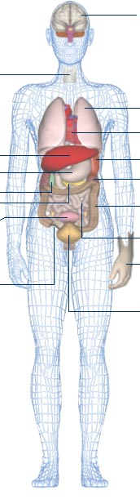 | 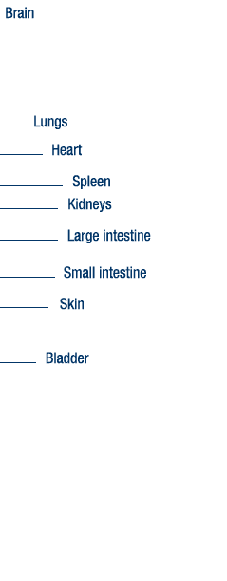

http://www.bbc.co.uk/science/humanbody/body/factfiles/organs_anatomy.shtml

