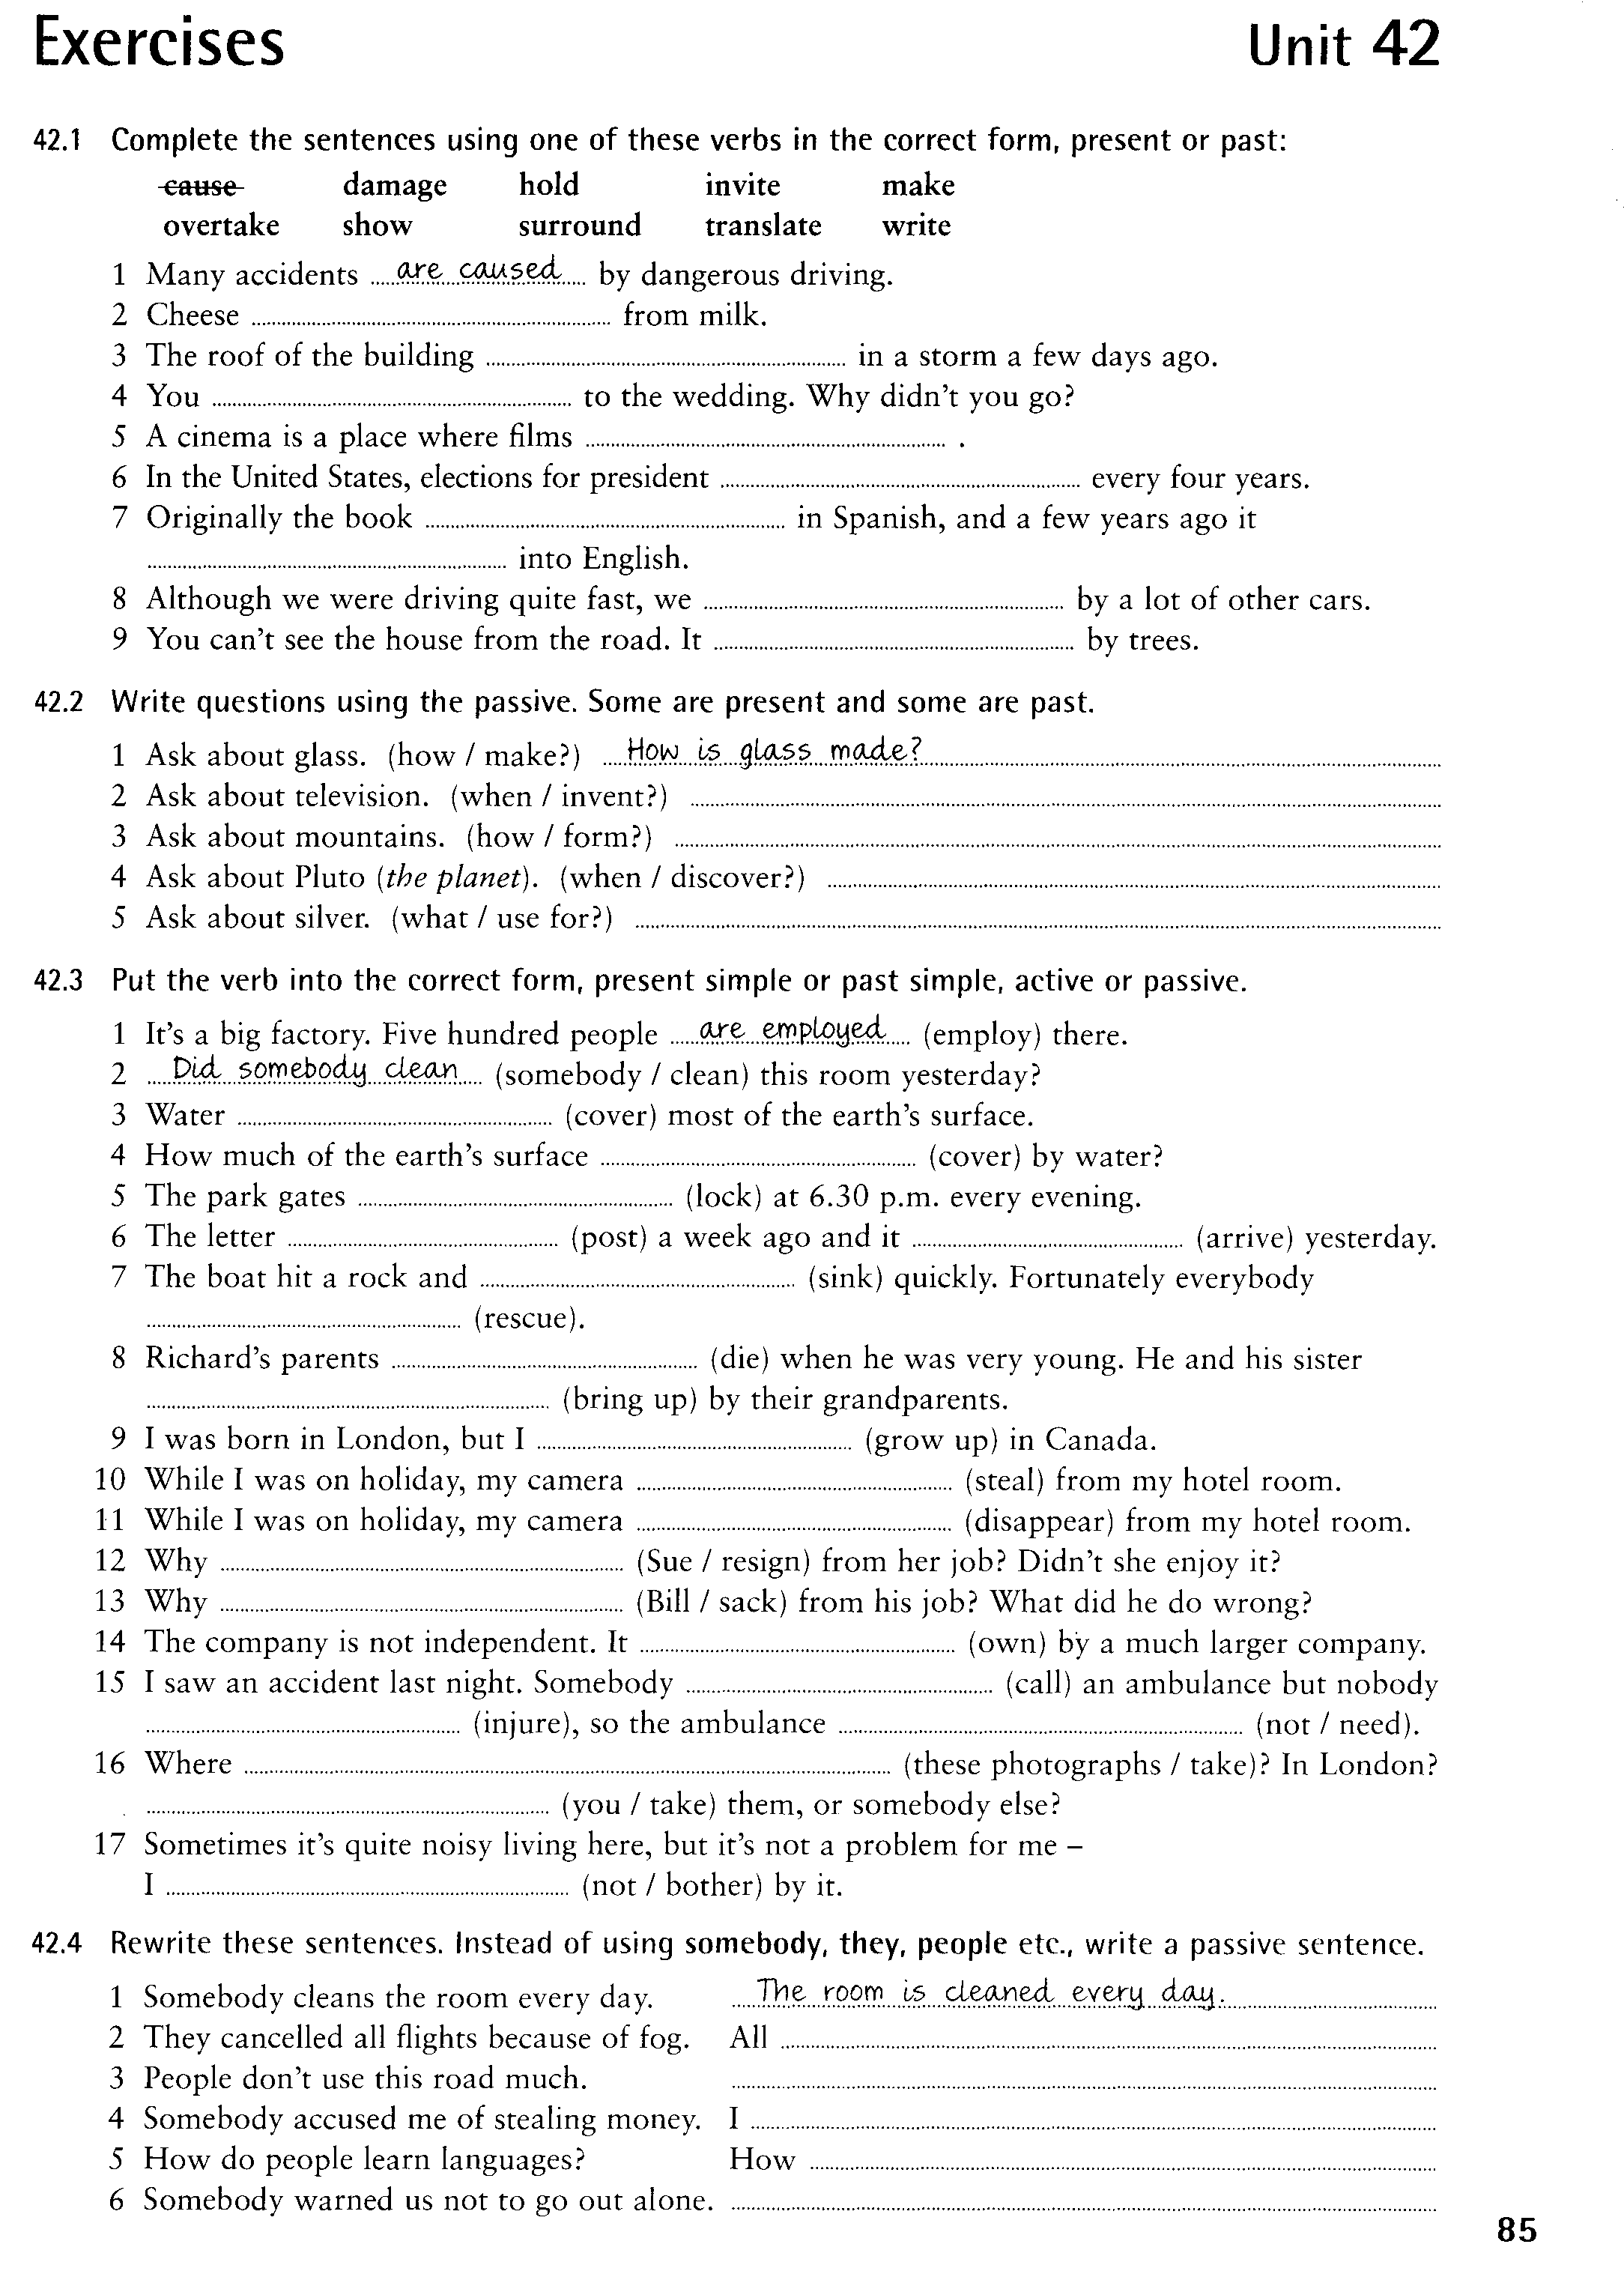

Murphy, R. English Grammar in Use: a self-study reference and practice book for intermediate students of English. 3rd edition. Cambridge: CUP 2004.

