Topic P06: Diagnostics of some more gram-negative bacteria (Neisseria, Moraxella, Bordetella, Legionella, Francisella…..)To study: Haemophilus, Neisseria, Moraxella, Bordetella, Legionella, Francisella (from textbooks, WWW etc.)
From spring term: Microscopy, culture, biochemical identification, agglutination

Table for major results of Task 1 to Task 4 (to be filled step by step):
Strain |  |  | K | L | M | N | P
Gram stain of a strain – Task 1b

Culture – task 2 | “Poor” BA (“KA”) Growth Y/N
Culture – task 2 | “Rich” BA+ (“KA+”) Growth Y/N
Culture – task 2 | Chocolat agar (“ČA”) Growth Y/N
Culture – task 2 | Description of colonies on BA+*
Task 3 |  | a) Oxidase test (+/–)
 |  | b) Indoxylacetate (INAC) test (+/–)
FINAL CONCLUSION (result of Task 4 – NeisseriaTest, or result of Task 1 for the strain proven not to be G– cocci)
*Use ChA (Chocolate agar) for bacteria not growing on BA+ (blood agar+)

Task 1: Microscopy of a clinical specimen and microscopy of strain

a) Observation of a urethral smear in gonorrhoea
Observe and Gram stained smear.
white blood cells
G– diplococci
________________________________________________
Pay attention not only for bacteria, but also for the macroorganism cells, especially leucocytes, and the position of bacteria in relation with the leucocytes. Mention, that cocci are not present in all white blood cells. Draw your result and draw lines connecting the description with the objects in your picture.
Note: Very simillar is also and smear from CSF in meningococcal meningitis.

b) Microscopy of suspicious strains – search for gram-negative cocci
There are slides with Gram-stained preparations on your table. Observe them and write your results to the table. Strain that is NOT G– coccus should not be used in tasks 3 and 4 (but in Task 2 it should be described, for comparison).

Task 2: Cultivation on agar media
Mark to your table, what bacteria grow on „poor blood agar“, „rich blood agar“ and chocolat agar. Oral species of Neisseria, but also Moraxella and majority of G+ cocci are able to grow on all media. Neisseria meningitidis („meningococcus“) can only grow on „rich“ blood agar. Neisseria gonorrhoeae (gonococcus) is not able to grow on blood agar at all, chocolate agar is needed. After that, describe the colonies on rich blood agar; the one not growing should be described on chocolat agar. Write all your results to the table.

Task 3: Basic biochemical tests in gram-negative cocci
Both tests will be done as a demonstration at a side table. Write your results to the table.

a) Oxidase test
Your teacher will touch several colonies of strains identified as G- cocci by the oxidase diagnostic strip. Blue colour should appear in several seconds, when positive. Draw a positive and a negative result.

b) Indoxylacetate test
The procedure is simillar as that of oxidase test, but the strip should be moistened in advance, the colour is rather blue-green and not blue and it is not visible immediatelly, but it is necessary to wait several minutes. Draw a positive and a negative result.

Task 4: Species diagnostics of Neisseria and Moraxella using biochemical tests

In strains, found to be gram-negative cocci, read the biochemical microtest (NEISSERIAtest by Lachema) inoculated one day before. Read it according to the scheme. The first well contains negative control, so the proper test starts in the SECOND well! Dropping of Lugol solution was allready done, you should not do it yourselves. Remark low biochemical activity of some Neisseria. Compare the result with cultivation conditions (the strain, found to be N. gonorrhoeae, shoud grow on chocolate agar only; the strain, found to be N. meningitidis, on chocolate and modified blood agar only).
Strain: | H | G | F | E | D | C | B | A
 | NEC |  |  |  |  |  |  |  |  | Code: | Identification:
 | × | 1 | 2 | 4 | 1 | 2 | 4 | 1
 | ×
Strain: | H | G | F | E | D | C | B | A
 | NEC |  |  |  |  |  |  |  |  | Code: | Identification:
 | × | 1 | 2 | 4 | 1 | 2 | 4 | 1
 | ×
Strain: | H | G | F | E | D | C | B | A
 | NEC |  |  |  |  |  |  |  |  | Code: | Identification:
 | × | 1 | 2 | 4 | 1 | 2 | 4 | 1
 | ×
Strain: | H | G | F | E | D | C | B | A
 | NEC |  |  |  |  |  |  |  |  | Code: | Identification:
 | × | 1 | 2 | 4 | 1 | 2 | 4 | 1
 | ×

Task No. 5 Susceptibility tests of G- cocci to antibiotics
Perform in vitro susceptibility testing of gram-negative cocci to suitable antibiotics.
Evaluate the diffusion disc susceptibility tests to antibiotics in strains found to be gram-negative cocci and that are pathogenous. Into the table, write the abbreviation of the antibiotics according to a card and for all tested strains measure the susceptibility zones. On your card, you have limit zones – according to them, interprete the zones as susceptible (S) resistants (R) and dubious (D).
Note: It is recommended to perform nitrocephin test as a proof of beta-lactamase, instead of diffusion disc test for testing susceptibility to penicillin (Neisseria) and ampicilin (Moraxella). To simplify the task for students, this recommendation were not taken into account.
Strain →
Antibiotic  (full name) | Zone ∅ (mm) | Interpr. | Zone ∅ (mm) | Interpr. | Zone ∅ (mm) | Interpr. | Zone ∅ (mm) | Interpr.

Task No. 6 Direct detection of antigens of causative agents of meningitis in the cerebrospinal fluid (demonstration of a diagnostic kit and observation of a videoclip)
Meningococcal meningitis is a severe disease. It is not possible to wait for culture, so we need a quick diagnostic method. Besides microscopy, latex agglutination is one very important method for this purpose.

a) Demostration of a latex agglutination kit
Observe the kit and write down the names of bacteria that can be found using this method.

b) Videoclip
Look at the videoclip. In our example, the pathogen was found to be __________________________________

Task No. 7 Diagnostics of Bordetella, Brucella, Legionella and Francisella

a) Culture diagnostics of Bordetella
There is a special medium for Bordetella pertussis, an a special way of inoculation is used here. Unlike many other bacteria, Bordetella is resistant to penicillin; so we start by making a drop of penicillin solution in the middle of the agar plate. The swab is mixed with the drop, and inoculated in a spiral form. Then the loop is used to make radial rays. Write down the name of the medium, and re-draw the way of its inoculation from your slideshow.

Name of the medium: ____________________

b) Demonstration of a culture medium for Legionella
Observe the culture medium for Legionella. Write down some data about it:
Abbreviation | What the individual letters of the abbreviation mean | Colour

c) Antibody detection in tularemia
On the side table you will find a wet chamber with the result of direct diagnostics of Francisella using aglutination. The wells wiht positive reaction show presence of aglutinate (larger target of irregullar shape), the wells with a negative reaction show bacterial sedimentation (smaller, intensivelly white round target). Fill in the following table.
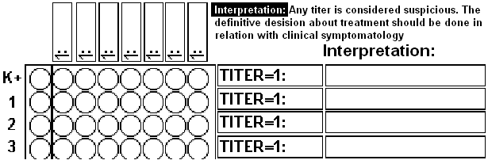

d) A Thought for Brucella
Diagnostics of Brucella is difficult and it is not easy in practice, as diseases caused by Brucella are not common in today Central Europe. Nevertheless, brucellosis still exists in many parts of the world. It is necessary to know at least, what is the connection between the species and the host animal.
What to do: Connect a picture of a typical host withe the name of a corresponing species of Brucella.

Brucella mellitensis Brucella abortus Brucella suis

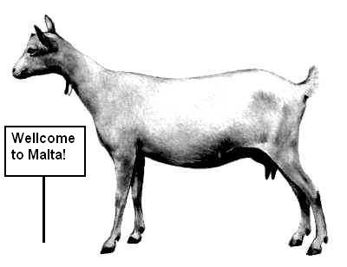
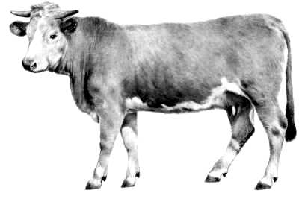
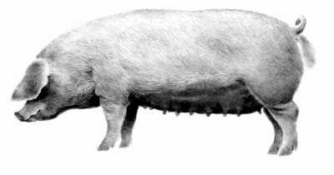

Check-up questions:
1. What are the most recommended specimens for gonorrhoea diagnostics? And how should they be transported to the laboratory?

2. When taking CSF specimen, can you see any differences between healthy person and a person with purulent meningitis? (Just at the pacient, not in the laboratory.)

3. Neisseria and Moraxella are both gram-negative. Does this mean that they grow on Endo agar?

4. What species of Neisseria are the less biochemically active? What sugars do they split?

5. What causative agent of meningitis is the most common one in pre-scholar age, what in teens, what in elder people?

6. What is the most typical source of tullaremia infection?

7. There exist also gram-negative cocci and bacilli, that were not studied in practical lessons, but may be important. Find in textbooks or www, what diseases are caused by following microorganisms:

a) Bartonella quintana

b) Bartonella hensellae

c) members od HACEK group (and write also the names of all bacteria belonging to this group).

