Topic P07: Diagnostics anaerobic bacteria
To study: Clostridium; spore non-forming anaerobes (from textbooks, WWW etc.)
From spring term: Microscopy, culture, biochemical identification, animal experiment, neutralisation

Table for major results of Task 1 to Task 4 (to be filled step by step):
Strain |  | K | L | M | N
Gram stain of a strain – Task 1b
(including eventual information concerning spore formation)
Culture – task 3 2 | Blood agar (“KA”) Growth Y/N
Culture – task 3 2 | VL agar (“VLA”) Growth Y/N
Culture – task 3 2 | VL broth Growth Y/N
Culture – task 3 2 | Description of colonies on BA/VLA*
FINAL CONCLUSION (result of Task 4 – ANAEROtest, or result of previous tasks for non-anaerobes)
*Use VLA (VL agar) for bacteria not growing on BA (blood agar)

Task 1: Microscopy of a clinical specimen and microscopy of strain

a) Observation of a clinical specimen
Observe and Gram stained smear.
________________________________________________________________________________
You will probably find a mixture of various bacteria, as it is typical for anaerobic infections, that usually not one microbe, but a mixture of them is responsible for an infection. Besides bacteria, you might see leucocytes (mostly polymorphonuclears), eventually epitelial cells, tissue detritus and so on.
Do not forget do describe your picture (use lines)!

b) Microscopy of suspicious strains
Anaerobic bacteria could be cocci or bacilli, Gram positive or Gram negative; so it is not different from other bacteria. On the other hand, anaerobes use to be much more pleomorphic. In genus Clostridium, the endospores are used as an important diagnostic sign. Try to find endospores in one of your strains (robust G+ rods).

Task 2: Anaerobic jar and anaerobic box
To obtain anaerobiose, three ways are used in the laboratory:

a) for liquid media, parafin oil is used as a barrier between the medium and the atmosphere
b) solid media are placed into an anaerobic jar, where oxygen is chemicaly replaced by a mixture of gases
c) solid media might be also placed into an anaerobic box; anaerobic atmosphere comes from a cylinder

Add your description to the pictures of an anaerobic jar and an anaerobic box (you will see a real anaerobic jar and pictures of both anaerobic jar and anaerobic box in the slideshow)
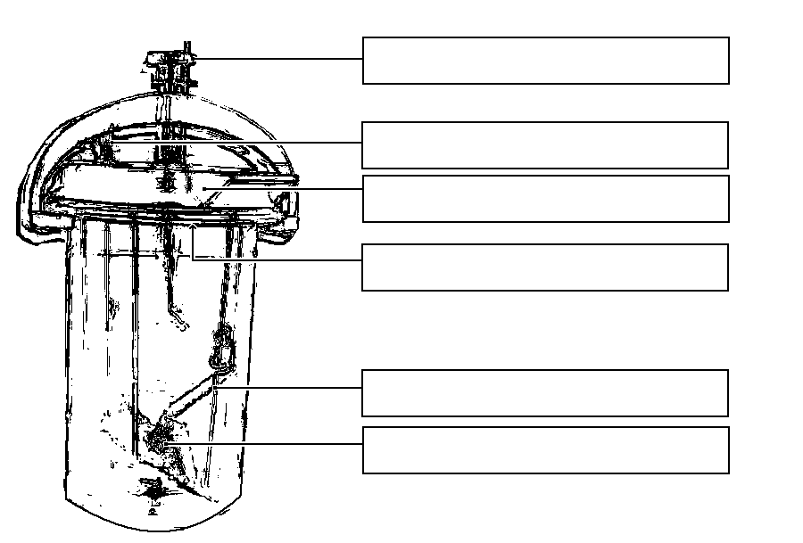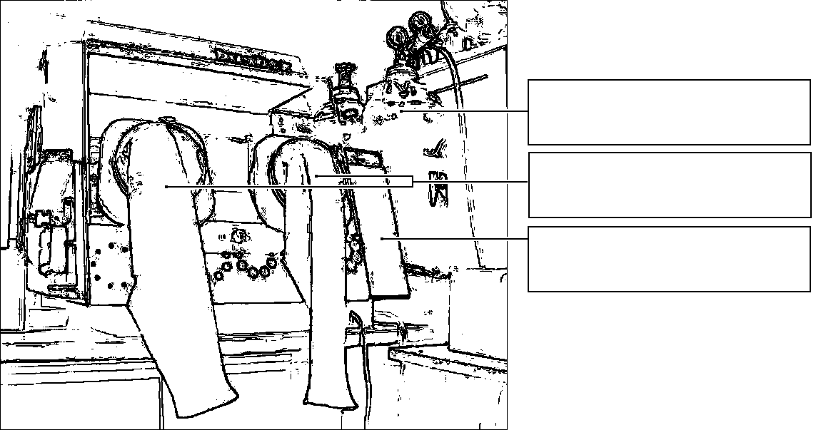

Task 3: Cultivation on agar media
Describe cultivation results of the given strains on both aerobic and anaerobic media

a) Aerobic culture on blood agar (BA)
Write down, whether bacteria do grow or not, and eventually describe the colonies

b) Anaerobic culture on VL agar (VL blood agar)
VL (blood) agar is simillar to blood agar, but it has decreased redox potential and it is cultured either in anaerobic jar or anaerobic box. Write down what strains do grow on it and describe those not growing on BA

c) Multiplication of anaerobic bacteria in VL broth
VL broth is used especially for multiplication of rare anaerobic bacteria. Check the presence of turbidity (= growth) in VL broth, write it to the table and compare with the results of part b)

Task 4: Species diagnostics of anaerobic bacteria using biochemical tests
In strains, found to be anaerobes, read the biochemical microtest (ANAEROtest 23 by Lachema) inoculated one day before. Read it according to the scheme. Attention! The codebook has four parts, so you have to find a proper part according to the microscopy. Results of „B“ and „A“ collumns are NOT used for code counting. So, you obtain 6 position code: only for results of tests in collumns H to C.
Strain: |  | H | G | F | E | D | C | B | A | Code:
 | 1 |  |  |  |  |  |  |  |  | Identification:
 | 2 |  |  |  |  |  |  |  |  | % of probability:
 | 4 |  |  |  |  |  |  |  |  | Typicity index:
 | Code
Strain: |  | H | G | F | E | D | C | B | A | Code:
 | 1 |  |  |  |  |  |  |  |  | Identification:
 | 2 |  |  |  |  |  |  |  |  | % of probability:
 | 4 |  |  |  |  |  |  |  |  | Typicity index:
 | Code
Notes:

Task No. 5 Susceptibility tests of anaerobic bacteria to antibiotics
Perform in vitro susceptibility testing of gram-negative cocci to suitable antibiotics.
Evaluate the diffusion disc susceptibility tests to antibiotics in strains found to be gram-negative cocci and that are pathogenous. Into the table, write the abbreviation of the antibiotics according to a card and for all tested strains measure the susceptibility zones. On your card, you have limit zones – according to them, interprete the zones as susceptible (S) resistants (R) and dubious (D).
Strain →
Antibiotic  (full name) | Zone ∅ (mm) | Interpretation | Zone ∅ (mm) | Interpretation

Task No. 6 Detection of toxins of clostridia
For clostridia we use various tests of toxin detection.

a) Demostration of toxin (lecitinase) of Clostridium perfringens
Clostridium perfringens lecitinase is a specific toxin that can be neutralized by a specific antibody. One halfth of your plate is treated by the antiserum (anti-lecitinase), the other is not. Toxic effect of the lecitinase can be seen as a precipitation area around a strain on the yolk agar; the „true“ toxin is neutralized by the antitoxin, other lecitinases are not neutralized. Draw the effect to the picture and add description.

b) Demostration of toxin of Clostridium tetani
Draw a picture of a mouse suffering from tetanus (from your slideshow). Remark position of extremities and tail.
a)
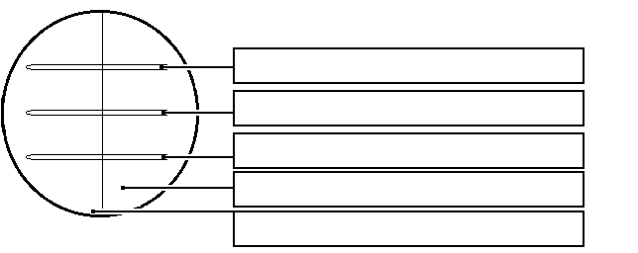
b)

Task No. 7 Demonstration of detection of anaerobic bacteria within facultative anaerobic flora

In practice (especially for vaginal swabs) it is often necessary to search for anaerobic bacteria among other bacteria. For this purpose we often use plates with discs. Amicacin is effective against G– bacteria, vancomycin against G+ bacteria, but anaerobes are often resistant. Draw and mark, in what place anaerobes are mostly observed. Remark, that on this plate, lactobacilli are seen quite often (tiny, grey colonies with viridation). They are microaerofilic, but the anaerobiose (that is not absolute) is suitable for their growth, more than aerobic conditions.

Check-up questions:
1. Where anaerobes are present in healthy organism? How can they come from here to other tissues to cause diseases?

2. What are principles of sampling and specimen tramsportation in case of suspicion for anaerobic infections?

3. What clostridia are typical by
a) ingestion of their neurotoxin?

b) neurotoxin spreading from a local inflammation?

c) histotoxin leading to gas gangrene (name at least one)?

d) pseudomembranous colitis?

4. Name at least three antibiotics suitable for anarobic infections treatment.

