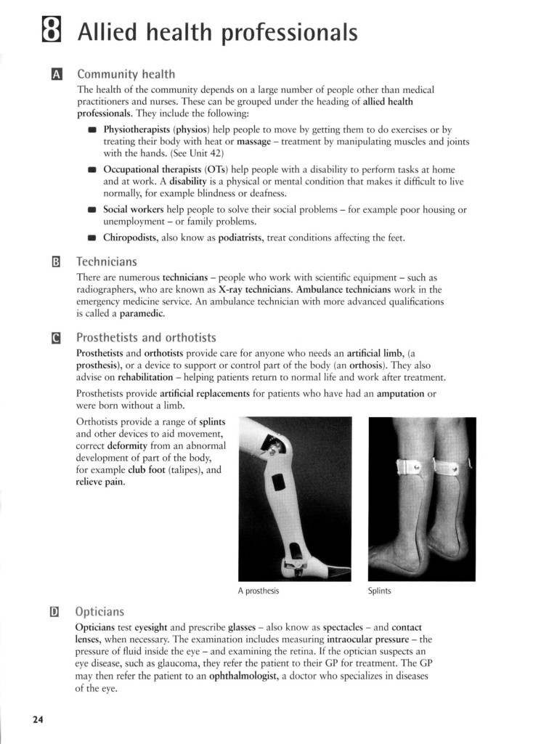

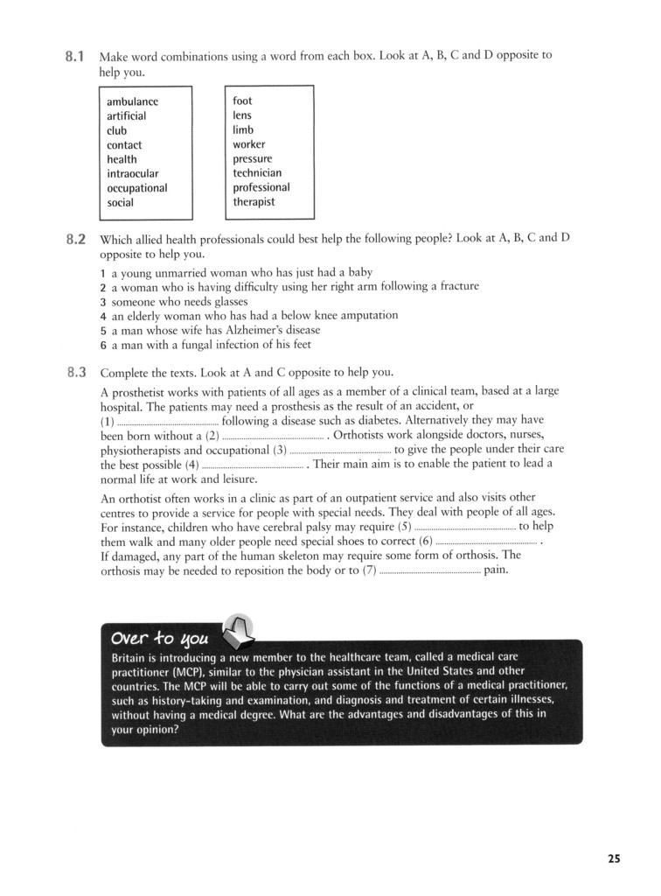

Taken from:
Glendinning, Eric H. and Ron Howard (2007) Professional English in Use - Medicine. Cambridge: CUP.

