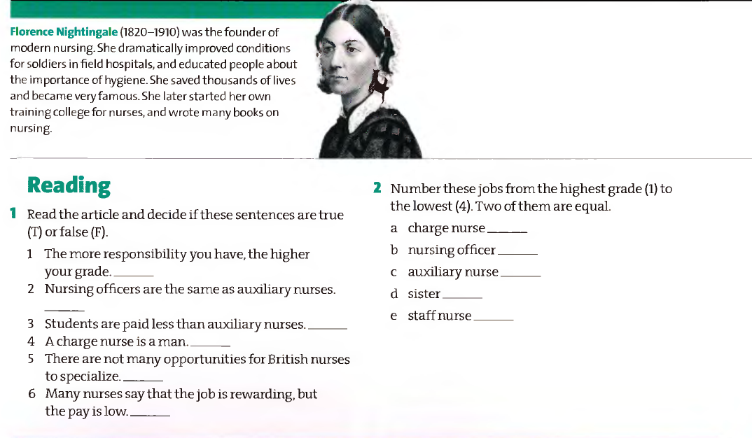
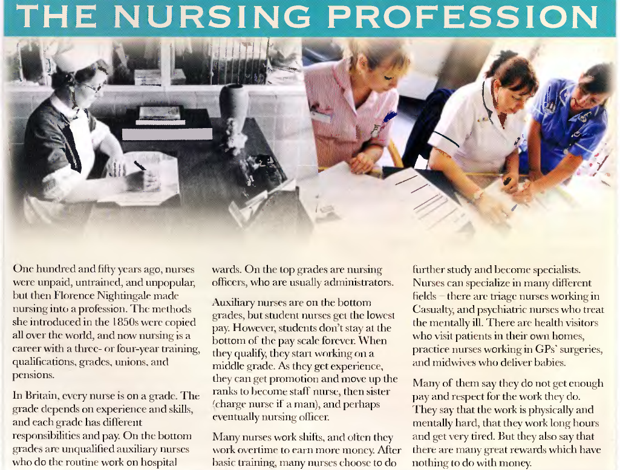

Taken from:
Grice, Tony (2007) Oxford English for Careers – Nursing 1. Oxford: OUP.

