Class I. cavity preparation and restorations

All pit and fissure restorations. They are assigned in to three groups.

- Restorations on occlusal surface of premolars and molars
- Restorations in foramina coeca – usually on occlusal two thirds of the facial and lingual surfaces of molars.
- Restorations on oral surface of maxillary incisors.

Materials: Amalgam, composite.

Amalgam:

Pertinent material qualities and propeties

Strength
Longevity
Ease of use
Clinically proven sucess

Indications

- Moderate to large restorations
- Restorations that are not in highly aesthetics areas
- Restorations that have heavy occlusal contacts
- Restorations that cannot be well isolated
- Restorations that extend onto the root surface
- Abutment teeth for removable partioal dentures

Contraindications

Aesthetically prominent areas of posterior teeth
Small moderate classes I. that can be well isolated

Clinical technique

- Acces to the caries
From the occlusal surface using the fissure bur (or diamond burs, see below).

- Outline

Ideal outline includes all occlusal pits and fissures. If crista transversa od obliqua are no affected, it is recommended no to prepare them.

- Resistance principles

3.1.Keep the facial and lingual margin extensionsas minimal as possible between the central groove and the cusp tips.
3.2. Extending the outline to include fissures, thereby placing the margins on relatively smooth sopund tooth structure.
3.3. Minimally extending into the marginal ridge without removing dentinal support.
3.4. Eliminating a weak wall of enamel by joining teo outlines that come close together
Enamel.
  - Nevel leave the enamel undermined
3.6. All corners are round, the bottom smooth.

- Retention principles

4.1. Prepare the box – the bottom is in dentin
4.2. Undercuts can be prepared, the proximal ridges must not be weakened!

- Removal of carious, infected, dentin and remaining defective enamel.

Removal of carious infected dentin is accomplish a discoid type spoon excavator or a slowly revolving , round carbid bur of appropriate size. Using the largest instrument that fits the carious area is sefest because it is likely to penetrate the tooth uncontrolably.

6. Finishing and polishing

The outline must be smooth – do it with the fine grit diamond bur.

These information are the most important one, they are sufficientfor the preclinical part ox the study.
The information can be found in the Sturdevandt´s book.
The principles of the preparation :

Notice the form of the cavity
Molar

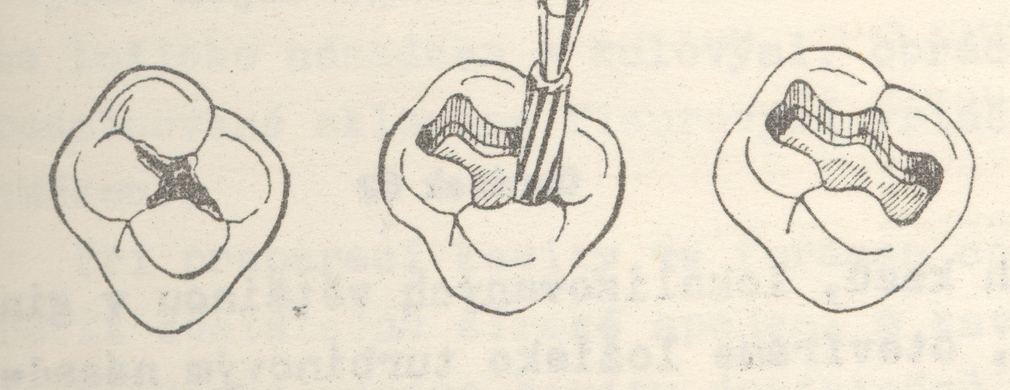

Premolar
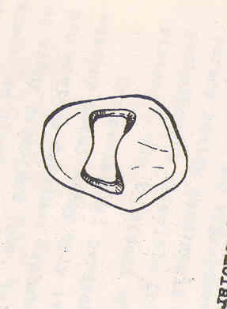

The outlines depend on morphology of the occlusal surface.

