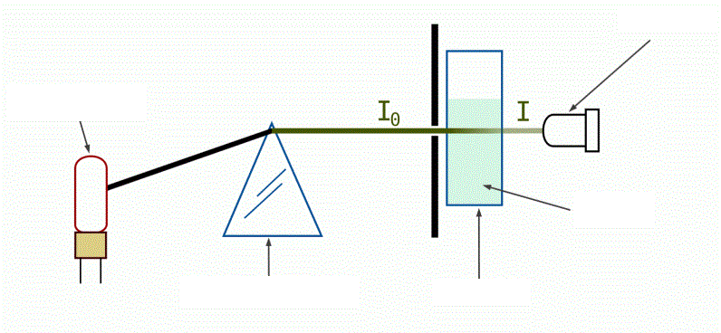
Spectrophotometry worksheet
Lead-in

Listening

A Listen and complete with ONE word:
Here’s how a spectrophotometer works. A _______(4) provides the source of light, the beam of light strikes the __________(5) grating which works like a prison and separates the light into its component wavelengths. The grating is rotated so that only a _________(6) wavelength of light reaches the exit slit. Then the light interacts with the sample. From this point, the _________(7) measures the transmittance and absorbance of the sample. Transmittance refers to the amount of light that ______(8) completely through the sample and strikes the detector. Absorbance is a _________(9) of light that is absorbed by the sample. The detector senses the light being transmitted through the sample and converts this information into a _______(10) display.

B Match the verbs with the nouns.
1 adjust a) the values/results
2 determine b) the cuvette
3 set c) transmittance
4 wipe d) the absorbance spectrum
5 close e) the key
6 press f) the control knob
7 select g) the spectrum
8 increase h) the wavelength
9 record i) the lid
10 plot j) the wavelength by 25nm

C Watch and put the step in order.
__ adjust the display to 100% transmittance
__ set the display to 0% transmittance
__ wipe the blank cuvette again and place it in the sample chamber
__ remove the cuvette with the blank solution
__ close the lid
__ press the mode control key to select transmittance
__ set the wavelength to 380nm
__ set the display mode to absorbance
__ increase the wavelength by 25nm to 405
__ wipe the blank cuvette

D Complete the expressions.
1 the transmittance for the sample at 405nm is _________%
2 the absorbance for the sample is _____________
3 record this in your __________ __________________
4 the steps are repeated up to ____________nm
5 we can plot the absorbance spectrum for ____________________

Reading
A Vocabulary warm-up: match the words on the left with their Czech equivalents:

1 wavelength a) odečtení absorbance
2 light beam b) propláchnout
3 measurement c) další pipetování
4 absorbance reading d) vlnová délka
5 pathlength e) světelný paprsek
6 life expectancy f) detekce sraženiny
7 pressure sensor g) délka dráhy (šířka kyvety)
8 clot detection h) životnost
9 flush i) tlakový senzor
10 further pipetting j) měření

B Read the text and fill in the gaps with the articles THE or ZERO ARTICLE:

For each cuvette slot, ___ (1) spectrophotometer measures ____ (2) light intensity at 12 different wavelengths. The light beam from ____ (3) halogen lamp passes through ___ (4) cuvette and then into a photodiode array where the measurements are made.
The spectrophotometer makes both ____ (5) absorbance and turbidimetric measurements (typically for clinical chemistry and specific proteins).
The absorbance readings are linear in ___ (6) range of 0.0 to 2.0 absorbance with less than 1 % deviation at a pathlength of 0.5 cm.
The measurement system uses blank positions on ___ (7) rotor to monitor the background signal for the electronic adjustment of drift.
The measurements are taken without removing the cuvette from the analyser rotor.
The life expectancy of the halogen lamp is 800 hours. The system informs you when you need to replace the lamp.
The spectrophotometer makes ___ (8) measurements at the following wavelengths:
340 nm * 480 nm * 552 nm * 652 nm
378 nm * 512 nm * 583 nm * 659 nm
409 nm * 520 nm * 629 nm * 800 nm

All wavelengths are measured at ____ (9) same time, but only one wavelength (for monochromatic measurements) or two wavelengths (for ___ (10) bichromatic measurements) are used.

Clot detection
For each sample probe, one pressure sensor for clot detection is mounted at the rear of the pipetting module. They detect clots during aspiration of samples, during the washing of probes, or when initialising the system.
When a clot is detected, the probe is flushed, and a message is displayed. The run continues but no further pipetting is done from the sample cup that led to clot detection or with the probe that is blocked. No results are printed for the sample cup associated with the clot.
When an aspirated clot clogs the probe and the automatic washing steps cannot remove it, the system stops sampling and goes into the standby mode as soon as all of the currently scheduled measurements are finished.

Read the text on clot detection and decide if these statements are TRUE or FALSE:

1 The pressure sensor is located at the back of the pipetting module.
2 The sensor finds clots only when probes are washed.
3 When the sensor detects a clot, the device sends a sound signal and stops working.
4 Clotted samples show no results.
5 The system stops immediately if there is a clot.

