***You should be able to answer these questions:***

1. What two main parts is the skeleton divided into? What do the parts consist of?

2. What are the main types of bones? Where can we find them?

3. Can you explain what ossification is?

4. What bones is the skull composed of?

5. How are upper extremities attached to the body?

6. What is the lower limb made up of?

7. What types of muscles do people have?

8. What function do smooth muscles have?

9. Can you explain what goose pimples are?

***Ex.1. Complete the following verbs in the correct form:***

1consists, 2 serve, 3 protect, 4 composed, 5 contains, 6 made, 7 divided, 8 comprises

**Skeletal system song:** see https://www.youtube.com/watch?v=uzxmKAWiN_U

***Ex. 2. Complete synonyms***

wrist, breast bone, chest/rib cage, upper jaw, neck, shoulder blade, backbone/vertebral column, knee, elbow (bone),

windpipe, collar bone, shin bone, finger, ankle bone, skull, lower jaw, thigh bone, gullet

***Ex. 3. Form adjectives***

thoracic, cranial, sacral, clavicular, fibular, femoral, costal

antebrachial, articular, coccygeal, patellar, bony, genicular, postural

Listening:

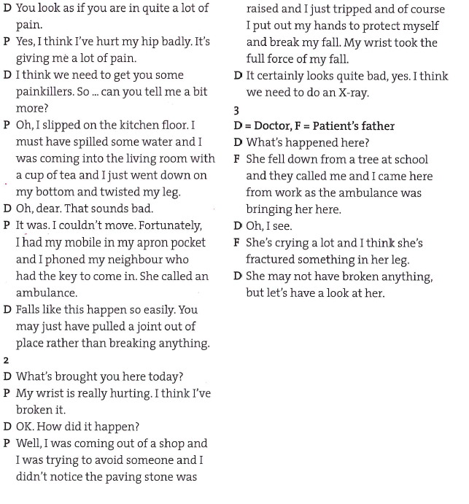

**Talking about the present**

1. So you **have taken** some painkillers, but they **don’t work**, and your arm **is** still **hurting** you just here.

2. My toe **is throbbing** with pain. I don’t know what **I’ve done**. It **looks** as if it’s broken.

3. **He’s had** several falls recently and he **has** several fractures, but he **isn’t** crying a lot.

4. 1) I have just slammed, 2) The X-ray has come back; 3) in case anything happens; 4) I am just waiting; 5) It mends/is mending; 6) Are you wearing… and Are you beginning… or Do you wear… and Do you begin…; 7) I have immobilized

**Check your spelling: Write these words in 3 person present simple, -ing form and past perfect form.**

For example:

Go: *he goes going has gone*

wash, want, sit, like, lie, travel, play, try, see

Go goes is going has gone Wash washes is washing washed

Sit sits is sitting has sat Like likes is liking has liked

Lie lies is lying lay lain Travel travels is travelling has travelled

Play plays is playing has played Try tries is trying has tried

See sees is seeing has seen

