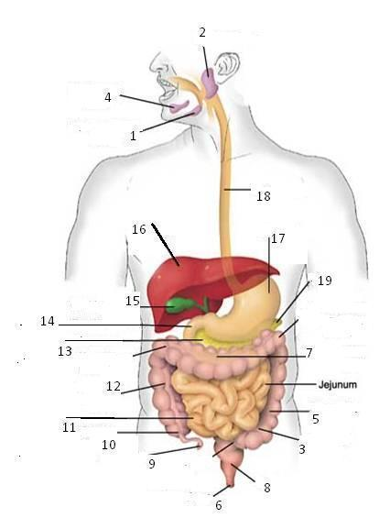
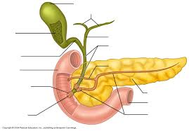
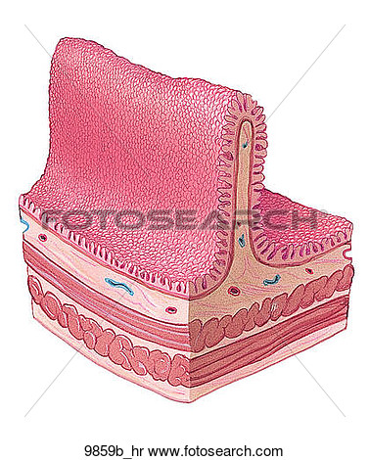
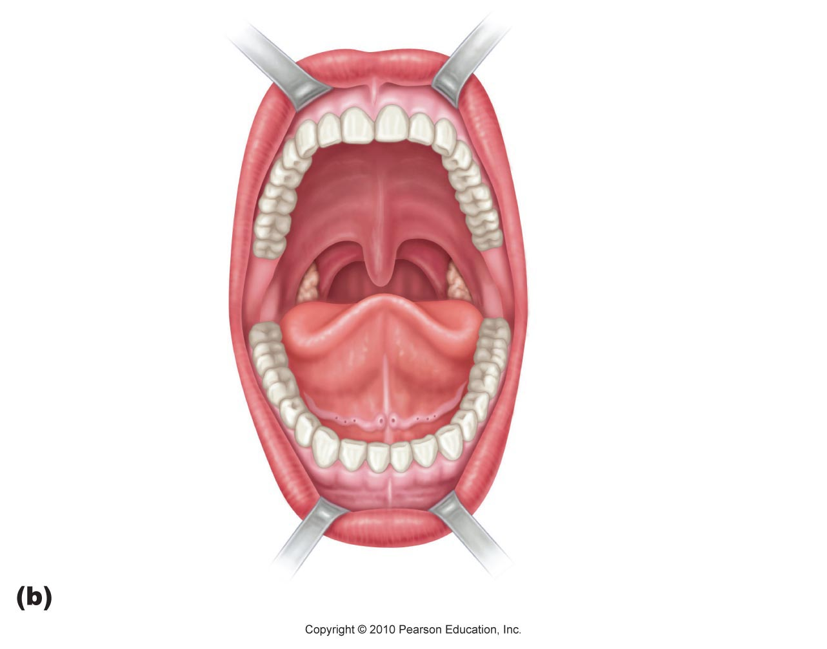
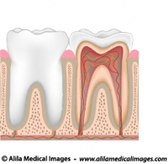
Name the individual parts of the digestive system.
Describe the digestive process.
What roles play enzymes and bile?
Describe the causes, symptoms and treatment of appendicitis, bulimia, anorexia, cirrhosis, gallstones, hepatitis, and ulcers.

Describe the anatomy of the mouth and teeth.

What are the causes, symptoms and treatment of cavities, dental plaque, gum disease, stained teeth, teeth grinding, bad breath, canker sores and dry mouth.

