PZ13 Clinical microbiology IV – examination of wound and bloodstream infections
To study: Your own protocols (especially Special bacteriology)

Wound infections

Task 1: Specimens in wound infections
Try to fill in the following table:
Type of wound | Superficial wound | Deep wound with amount of pus sufficient for being sent as a liquid | Deep wound with not sufficient amount of pus | Wound with pus, possibly containing anaerobic bacteria
Sampling method

When a specimen from a wound is send to the laboratory, it is very important to fill in the request form, especially to write 1) _____________________________ and 2) _____________________________________

Task 2: Indirect imprint method for superficial wound examination

a) Indirect imprint method – performing
A sterile filtration paper on is placed on a superficial wound. We let it for 10 seconds here, then using tweezers, we transport it carefully to a Petri dish with nutrient agar. After that, the filtration paper is sent together with the agar plate to the laboratory. In the laboratory the filtration paper is placed to two or three more media: agar with 10 % NaCl, chromogenic URI medium etc. After that, all media are cultivated overnight. Dental students do not perform this part practically.

b) Indirect imprint method – reading of results
Try to read the preliminary result of imprint method on URIchrom chromogenic medium using recounting scheme on your table and with the help of the key of colours of individual bacteria on the chromogenic medium. Attention! You have real results from real patients. Your result is not supposed to be the same as the result of your neighbour with another agar plate. Even the number of strains may be different. More precise determination and antibiotic susceptibility test would not be performed in this task.
The cultivation result of my imprint contained:
Likely group or genus of bacterium | Quantity (approx. number of colonies per 25 cm²)
1.

(2.)

(3.)

Clue for preliminary diagnostics: Staphylococci – white on URI, growing also on NACL, white colonies on blood agar; Haemolytic streptococci – haemolytic colonies on blood agar, not growing on NACL, on URI not growing or (S. agalactiae) pale turquoise blue. Enterococci have greyish colonies on blood agar and small, but rich turquoise colonies on URI. Enterobacteriaceae and G- non-fermenters – growing on Endo agar. Escherichia is pink on URI, Klebsiella is blue on URI, Proteus is yellow on URI, Pseudomonas is white or slightly green (because of its own pigmentation) on URI. All this is only preliminary, the algorithms from previous practicals are valid!

Task 3: Deeper wound swab result
In the case of a wound swab, there is no “common flora”. That is the main difference between wound swab and e. g. swabs from respiratory ways: it is not necessary to search for a pathogen among the normal flora.
On the other hand, we mostly use more culture media to detect all possible pathogens, even if they would be in a mix of them. Besides blood agar and Endo (or McConkey) agar we usually use also blood agar with 10 % NaCl and blood agar with amikacin in order to search for streptococci and enterococci (but none of these media is used in our task). In other situations there is one pathogen only, and even in small amounts, so we have to multiply it in a liquid medium (broth). Also this medium is not present in our task.
Fill in the form again.
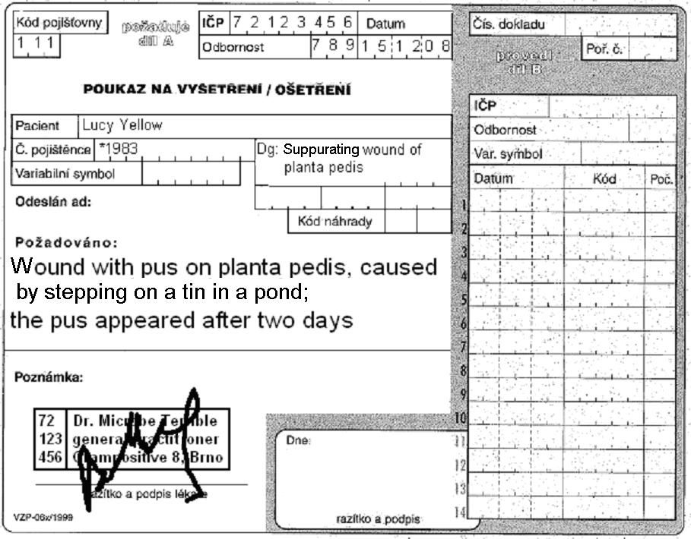

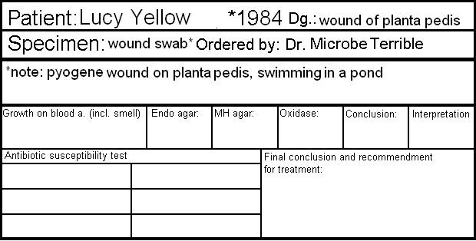
Antibiotic susceptibility test
Piperacillin+tazobactam (TZP) | S ≥ 18  R < 18 |  | Ciprofloxacin  (CIP) | S ≥ 25  R < 22
Gentamicin  (CN) | S ≥ 15  R < 15 |  | Ceftazidime  (CAZ) | S ≥ 16  R < 16
Ofloxacin  (OFL) | S ≥ 16  R < 13 |  | Colistin  (CT) | S ≥ 11  R < 11
write S = susceptible, R = resistant, eventually I = intermediary
*result of this test is also valid for doxycycline
Final conclusion and recommendation for treatment: _______________________________________________

Bloodstream infections

Task 4: Blood cultures – processing
Describe the use of three types of blood culture vessels.
Fill in which data should not be missing on the order form in the case of blood culture (only “material type/examination type” field)
Explain:
Why is absolute sterility in blood culture samples more necessary than in any other blood specimens (e. g. those sent for biochemical examination)?

How many blood cultures should be taken and why?

Fill in the missing fields in the description of blood culture processing and examination according to the video clip and the teacher’s explanation.
A blood culture vessel arrives in the laboratory. Here it is put into a ___________________________________. The positive result is demonstrated by _____________________ and ______________________________. When the cultivation is positive, a smear is prepared and the content of the vessel is ____________________ onto the blood and Endo agar. Also, a preliminary _____________________________ test is performed directly from the specimen; as the inoculum is not standardized here, its results are only _________________________.

Task 5: Blood cultures – microscopy of a positive specimen
The cultivator for blood cultures revealed a positive result. For preliminary treatment, a Gram stained smear is performed from the contain of the vessel. Observe the result and write it. Attention! The slides have origin in real blood cultures of different patients. Therefore your result may be simply different from that of your neighbour with a different slide.

Blood culture contained gram-positive – gram-negative* cocci – bacilli* arranged in _________________**
* delete as appropriate **only for cocci (pairs, chains, clusters…) or G+ bacilli in palisades

Task 6: Blood cultures – cultivation result
Observe cultivation result of a positive blood cultures inoculated on solid media. Suggest more methods for detailed diagnostics of bacteria. Try to assess preliminary antibiotic susceptibility. Also here you are not supposed to have the same results as your neighbour.
Name of medium
Growth Y/N, appearance of colonies

More tests of more detailed determination: _______________________________________________________

__________________________________________________________________________________________

Preliminary name of the microbe: ______________________________________________________________
Preliminary antibiotic susceptibility testing
Name of the set of antibiotics:
Antibiotic | Susceptibility Interpretation | Measured size | Result (encircle) | Antibiotic | Susceptibility Interpretation | Measured size | Result (encircle)
1. | R <  S ≥ |  | S–I–R | 4. | R <  S ≥ |  | S–I–R
2. | R <  S ≥ |  | S–I–R | 5. | R <  S ≥ |  | S–I–R
3. | R <  S ≥ |  | S–I–R | 6. | R <  S ≥ |  | S–I–R

Task 7: Blood cultures – interpretation
Look at interpretation for results of two different patients.

John White, *1942, elevated temperature and inflammatory markers, three blood culture specimens sent to the laboratory | Joe Black, *1945, elevated temperature and inflammatory markers, three blood culture specimens sent to the laboratory
I Central venous catether. Time to detection 10 hours, finding: Staphylococcus hominis, susceptible to oxacilin, tetracycline, vankomycin, resistant to erythromycin, klindamycin, co-trimoxazole. | I Central venous catether. Time to detection 8 hours, finding: Staphylococcus epidermidis, susceptible to oxacilin, resistant to tetracycline, vankomycin, erythromycin, klindamycin, co-trimoxazole.
II Peripherial catather. Time to detection 13 hours, finding: Staphylococcus hominis, susceptible to oxacilin, tetracycline, vankomycin, resistant to erythromycin, clindamycin, co-trimoxazole. | II Peripherial catather. Time to detection 26 hours, finding: Staphylococcus hominis, susceptible to oxacilin, tetracycline, vankomycin, erythromycin, clindamycin, co-trimoxazole, no resistance observed
III Venepunction. Time to detection 13.5 hours, finding: Staphylococcus hominis, susceptible to oxacilin, tetracycline, vankomycin, resistant to erythromycin, clindamycin, co-trimoxazole. | III Venepunction. Time to detection 38 hours, finding: Staphylococcus epidermidis, susceptible to oxacilin, co-trimoxazole, vankomycin, resistant to tetracycline, erythromycin, clindamycin.
Likely interpretation:  Probably bacteriaemia | Likely interpretation:  Probably pseudobacteriaemia

