Topic P07: Diagnostics of anaerobic bacteria
To study: Clostridium; spore non-forming anaerobes (from textbooks, www etc.)
From spring term: Microscopy, culture, biochemical identification, animal experiment, neutralization

Table for major results of Task 1 to Task 4 (to be filled step by step):
Strain |  | K | L | M | N
Gram stain of a strain – Task 1b
(including information concerning possible spore formation)
Culture – task 3 2 | Blood agar (“KA”) growth Y/N
 | VL agar (“VLA”) growth Y/N
 | VL broth growth Y/N
 | Description of colonies on BA/VLA*
FINAL CONCLUSION (result of Task 4 – ANAEROtest, or result of previous tasks for non-anaerobes)
*Use VLA (VL agar) for microbes not growing on BA (blood agar)

Task 1: Microscopy of the clinical specimen and microscopy of the strain

a) Observation of a clinical specimen
Observe a Gram-stained smear.
________________________________________________________________________________
You will probably find a mix of various bacteria, as it is typical for anaerobic infections, in which usually not one particular microbe, but a combination of them is responsible for an infection. Besides bacteria, you might see leucocytes (mostly polymorphonuclears), possibly epithelial cells or tissue detritus and so on.
Do not forget to describe your picture (use the arrows)!

b) Microscopy of suspicious strains
Anaerobic bacteria can be cocci, bacilli or spirals, Gram-positive or Gram-negative, so in their shape, they are not different from other bacteria. On the other hand, anaerobes tend to be much more pleomorphic. In the Clostridium genus, the shape, dimension and localization of endospores are used as an important diagnostic sign. Try to find endospores in one of your strains (robust G+ rods).

Task 2: Anaerobic jar and anaerobic box
Anaerobiosis can be obtained using three ways in the laboratory:
a) For liquid media, paraffin oil is used as a barrier between the medium and the atmosphere.
b) Solid media are placed into an anaerobic jar, where oxygen is chemically replaced by a mixture of other gases.
c) Solid media may also be placed into an anaerobic box; the mixture of other gases comes from a pressure cylinder (bomb).

Add your description to the pictures of an anaerobic jar and an anaerobic box (you will see a real anaerobic jar and pictures of both an anaerobic jar and an anaerobic box in the slideshow).
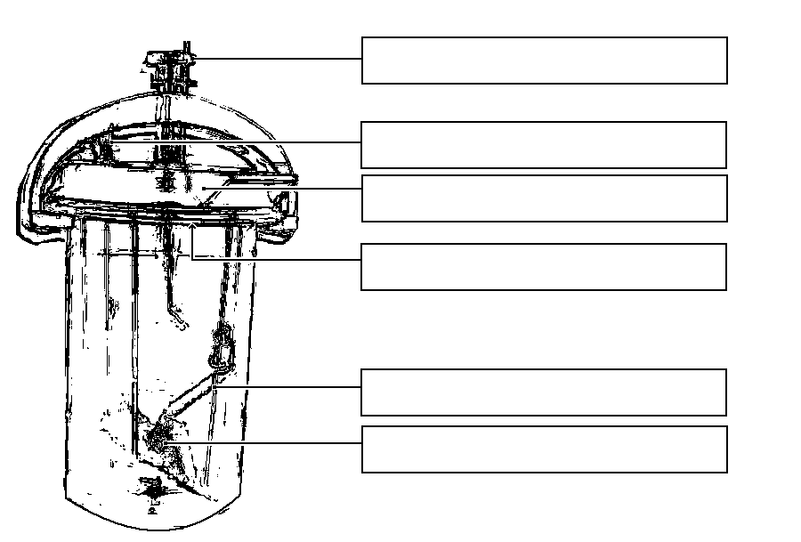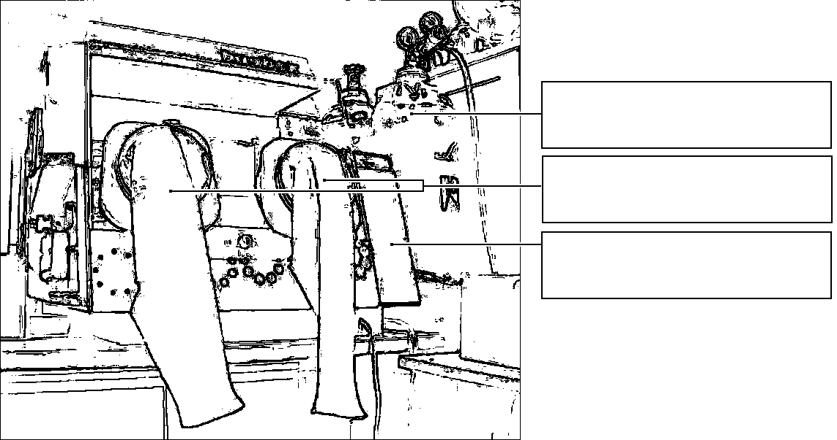

Task 3: Cultivation on agar media
Describe cultivation results of the presented strains on both aerobic and anaerobic media.

a) Aerobic culture on blood agar (BA)
Write down whether the bacteria grow on it or do not grow, and possibly describe the colonies.

b) Anaerobic culture on VL agar (VL blood agar)
VL (blood) agar is similar to blood agar, but it has a decreased reduction-oxidation potential and it is cultured either in the anaerobic jar or anaerobic box. Write down which strains are able to grow on it and describe those not growing on BA

c) Multiplication of anaerobic bacteria in VL broth
VL broth is used especially for the multiplication of rare anaerobic bacteria. Check the presence of turbidity (i.e. the growth) in VL broth, write it in the table and compare with the results of Part b)

Task 4: Species diagnostics of anaerobic bacteria using biochemical tests
In the strains found to be anaerobes read the biochemical microtest (ANAEROtest 23 Erba-Lachema) inoculated two days prior. Read it according to the scheme. Attention! The codebook has four parts, so you have to find a proper part according to the microscopy. Results of “B” and “A” columns are NOT used for code compiling. Therefore, you obtain a 6-position code only from the results of the tests in columns H to C.
In the second of our strains you would get two variants of result. Suppose that the strain was already tested for penicillin susceptibility and was found to be susceptible. Therefore it is not a (primary resistant) Bacteroides.
Strain: |  | H | G | F | E | D | C | B | A | Code:
 | 1 |  |  |  |  |  |  |  |  | Identification:
 | 2 |  |  |  |  |  |  |  |  | Probability %:
 | 4 |  |  |  |  |  |  |  |  | Typicality index:
 | Code
Strain: |  | H | G | F | E | D | C | B | A | Code:
 | 1 |  |  |  |  |  |  |  |  | Identification:
 | 2 |  |  |  |  |  |  |  |  | Probability %:
 | 4 |  |  |  |  |  |  |  |  | Typicality index:
 | Code
Notes:

Task 5: Susceptibility tests of anaerobic bacteria to antibiotics
Anaerobic bacteria were tested using diffusion disc test, but it was proven that diffusion disc test is not sufficiently reliable for anaerobic bacteria. Recently, according to EUCAST recommendation, infections caused by anaerobic bacteria are either treated without in vitro testing, or, especially for serious infections, E-tests are used for in vitro testing.
Evaluate E-test for an anaerobic bacterium. Draw and evaluate the result.
Do not forget that, although principally similar to the diffusion disc test, E-test is a quantitative test. The concentration values are written directly on the strip. The site where the margin of the zone crosses the strip shows us the MIC (minimal inhibitory concentration) value.
Read an E-test for a given strain. Draw one of the results, evaluate all results.
Tested strain
Tested antibiotic / antimycotic
MIC value
Breakpoint:
Conclusion (strain is susceptible/resistant to given antibiotic)

Task 6: Detection of clostridial toxins
In clostridia, for toxin detection we use various tests.

a) Demonstration of the Clostridium perfringens toxin (lecithinase)
C. perfringens lecithinase is a toxin that can be neutralized by a specific antibody. One half of your yolk agar plate has been treated with the antiserum (anti-lecithinase), the other has not. The toxic effect of the lecithinase can be seen as a precipitation area around the examined strain; the particular toxin is neutralized by the antitoxin, other lecithinases are not. Draw the effect into the picture and add description.

b) Demonstration of the Clostridium tetani toxin
Draw a picture of a mouse suffering from tetanus (from your slideshow). Remark the position of the extremities and of the tail.
b)

a)

c) Detection of the Clostridium difficile A and B toxins and it’s structural antigen
Pseudomembraneous colitis due to Clostridium difficile toxins is very serious, especially in hospitalized patients.
Cultivation of the pathogen may be performed using special cultivation media, but it is rather recommended to perform testing for toxins and structural antigen instead. It is important, that a specimen of stool in a container (e. g. not rectal swab) is sent to the laboratory for testing.
The testing is performed by means of an immunochromatographic test similar to those performed in the J08 practical, but more complex: it checks both production of clostridium of clostridium antigen and toxins. It is essential in practice to send a genuine piece of stool (NOT rectal swab) to the laboratory.
The tests consists of two parts, in both cases the positivity is marked by the presence of a blue line:
(1) antigen testing and
(2) testing of both A and B toxins TOGETHER (the positive line means presence of A or B or both toxins).
Interpretation of the test:
Toxin positive, antigen positive  (Situation 1) | In case of corresponding symptoms, Clostridium difficile infection (CDI) may be considered proven and treatment necessary. After treatment re-testing is not needed; clinical course predicts better the effect of treatment.
Toxin negative, antigen positive  (Situation 2) | In case of corresponding symptoms, (CDI) may be still considered possible or even likely, as toxin result is not sure enough. So treatment may be considered useful according to individual consideration of clinical status*
Toxin negative, antigen negative  (Situation 3) | CDI is considered very unlikely
Toxin positive, antigen negative | Laboratory mistake
Absence of three dots(control) | Invalid test
*It is also recommended to try to cultivate the strain of Clostridium difficile (from the same stool specimen) and then to repeat the test with the strain used instead of the stool specimen.

Observe the result of the Clostridium difficile (CD) antigen and Clostridium difficile A + B toxins detection in stool specimens X, Y and Z and write down the results:
Patient | Controls | CD A + B toxins | CD antigen | No. of situation (1/2/3)
X | OK – not OK | positive – negative | positive – negative
Y | OK – not OK | positive – negative | positive – negative
Z | OK – not OK | positive – negative | positive – negative

