**HPT 30.9.2019**

**A**

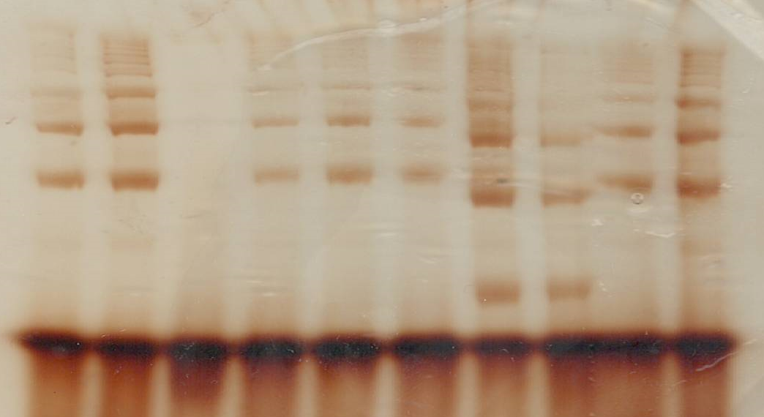

**1 2 3 4 5 6 7 8 9 10**

**A**

|  |  |
| --- | --- |
|  | Fenotyp Haptoglobinu |
| **1** | 2-2 |
| **2** | 2-2 |
| **3** | 1-1 |
| **4** | 2-2 |
| **5** | 2-2 |
| **6** | 2-2 |
| **7** | 2-1 |
| **8** | 2-1 |
| **9** | 2-2 |
| **10** | 2-2 |

**HPT**

**B**

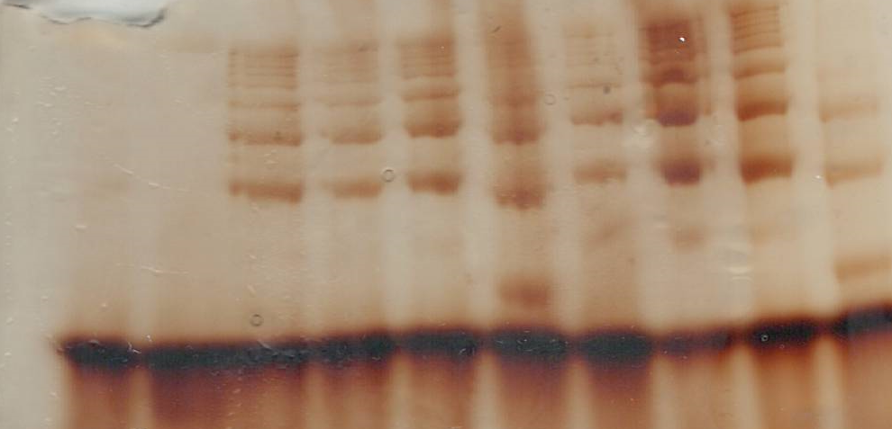

**1 2 3 4 5 6 7 8 9 10**

**B**

|  |  |
| --- | --- |
|  | Fenotyp Haptoglobinu |
| **1** | 1-1 |
| **2** | 1-1 |
| **3** | 2-2 |
| **4** | 2-2 |
| **5** | 2-2 |
| **6** | 2-1 |
| **7** | 2-2 |
| **8** | 2-2 |
| **9** | 2-2 |
| **10** | 2-1 |