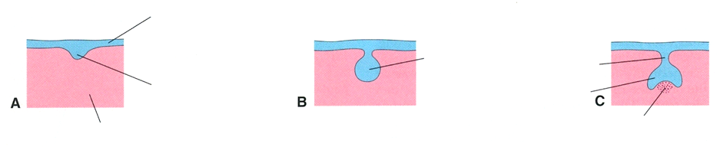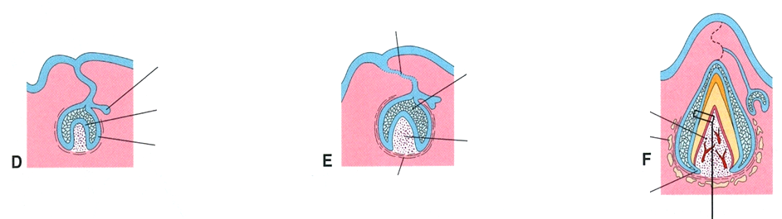
Assign the structures with correct labels
Oral epithelium Mesenchyme (ectomesenchyme) Dental lamina Dental bud Dental papilla Enamel organ primordium of permanent tooth Inner enamel epithelium Outer enamel epithelium Stellate reticulum Ameloblasts Odontoblasts Degenerating dental lamina Dental follicle Bone Dental pulp Cervical loop (epithelial root sheet of Hertwig) Dental cap Bell stage Periodontal ligament

Assign the structures with correct labels
Oral epithelium Mesenchyme (ectomesenchyme) Dental lamina Dental bud Dental papilla Enamel organ primordium of permanent tooth Inner enamel epithelium Outer enamel epithelium Stellate reticulum Ameloblasts Odontoblasts Degenerating dental lamina Dental follicle Bone Dental pulp Cervical loop (epithelial root sheet of Hertwig) Dental cap Bell stage Periodontal ligament

