2. Stroke

According to WHO is stroke defined as a „neurological deficit of cerebrovascular cause that persists beyond 24 hours or is interrupted by death within 24 hours“. The symptoms stem from the affected part of the brain.
Etiologically, stroke can be divided into hemorrhagic (15%) and ischemic (85%).
The cause of ischemic stroke is occlusion of the cerebral artery by thrombus in atherosclerotic cerebral arteries, less common causes include embolism (eg in the left atrial thrombus) or occlusion of the artery by thrombus in vasculitis. The cause of spontaneous intracranial hemorrhage is rupture of the cerebral artery aneurysm, arteriovenous malformation, tumor or coagulopathy.

Diagnostic algorithm:
The initial imaging method for stroke is CT without the application of a contrast agent to rule out intracranial hemorrhage (ie, to rule out hemorrhagic stroke).
Freshly coagulated blood is hyperdense to brain tissue (70-90HU vs 35HU) and is clearly visible on native CT.

1. Non-traumatic intracranial hemorrhage
is most often represented by intracerebral hematoma or subarachnoid hemorrhage.
In case of intracerebral hematoma located at typical locations for spontaneous intracerebral hemorrhage, no further imaging is required. Decision between surgical or conservative treatment is based on the size, location and expansive behaviour of the hematoma (contralateral shift of midline structures, edema around the hematoma, brain herniation).
Typical sites of spontaneous intracerebral hemorrhage include the area of the nucleus lentiformis, thalamus, cerebellum, and brainstem. The most common etiology of spontaneous intracerebral hemorrhage is hypertension. In atypical localizations of intracerebral hematoma, it is appropriate to supplement the CT angiography of cerebral arteries to exclude vascular malformation. Tumor masked with high density of blood may not be distinguished by CT angiography. Such tumor is often diagnosed perioperatively, in an attempt to evacuate an intracerebral hematoma.

In the presence of non-traumatic subarachnoid hemorrhage on native CT, CT angiography of the cerebral arteries should be performed to display aneurysm or arteriovenous malformation as a source of bleeding. In case of a rupture of an aneurysm, in addition to subarachoid hemorrhage, an intracerebral hematoma may form simultaneously and prolapse into the ventricular system (hemocephalus). In case of hemocephalus, the cerebral aquaduct (Sylvii) can be blocked by coagulating blood and hemocephalus may develop.
Subarachnoid hemorrhage (SAK) is divided into spontaneous and traumatic. The most common cause of spontaneous SAK is a rupture of the aneurysm. It manifests clinically as a sudden, severe pain from full health (patients report the worst pain they have experienced), it may be accompanied by vomiting and impaired consciousness.

2. Cerebral ischemia
may have a completely normal finding on native CT in the first 12 hours. If no bleeding is present on CT, intravenous thrombolysis can be initiated in indicated cases. To verify the vascular occlusion before possible mechanical thrombectomy, it is again necessary to perform CT angiography of the cerebral arteries.
In cerebral ischemia of unclear age, the so-called CT perfusion of the brain is sometimes performed, which displays the infarct itself (already dead brain tissue) and the surrounding penumbra (ischemized but still viable brain tissue, which can be saved by treatment).

Immediate sign of cerebral ischemia include the relatively rare " dense artery sign" (hyperdense thrombus asymmetrically on the affected side - most often in a.cerebri media). Sometimes there are early signs of ischemia (within 6 hours) such as blurred contours of gray and white matter and blurred contours of cerebral gyri or nucleus lentiformis due to edema. Gradually, in the acute phase (24 h - 1 week), the ischemic area becomes clearly hypodense due to progressive edema, sometimes expansive manifestations are expressed (surrounding edema, contralateral shift of midline structures, etc.). In the subacute phase, the edema gradually disappears and the density of the affected area increases, the appearance on CT may even return to normal. In the chronic phase, the affected area is replaced by glia, on CT it is hypodense and atrophic (reduction of brain tissue volume, focal enlargement of subarachnoid spaces or adjacent brain chambers).

In case of clinical doubt in a normal finding on non-contrast CT, ischemia may be confirmed or excluded by non-contrast brain MRI. The key sequence for imaging early cerebral ischemia is DWI (diffusion weighting image) - evidence of restricted diffusion in the ischemic area can be observed just minutes after stroke due to inactivity of ion pumps on cell membranes (these contribute to the formation of gradients necessary for diffusion).

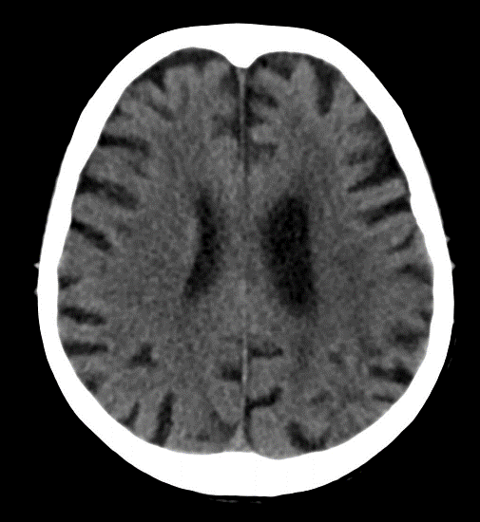
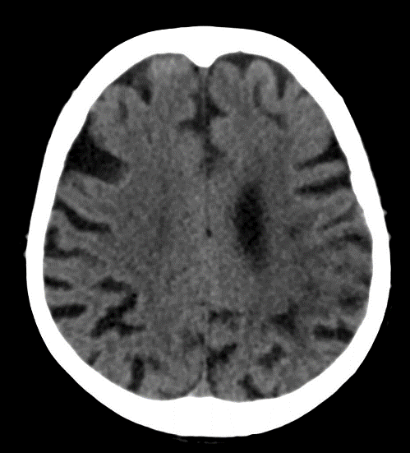
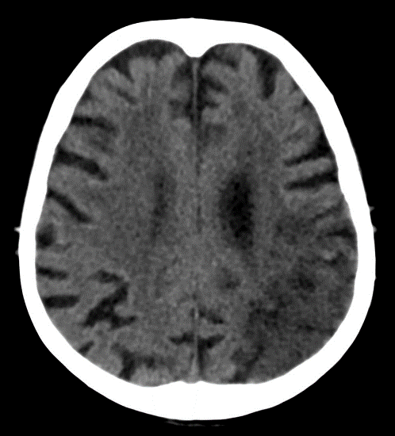
A
3h
28h
77h
Fig. A - Development of ischemic stroke in the region of the left a. cerebri media on non-contrast CT. No fresh ischemic changes are detectable on CT 3 hours after the onset of symptoms. After 28 hours, there are blurred contour of the gyri parietally on the left - the onset of cytotoxic edema. After 77 hours, developed ischemic changes in the form of hypodense area, blurred gyri and reduction of subarachnoid spaces due to edema caused by ischemia.

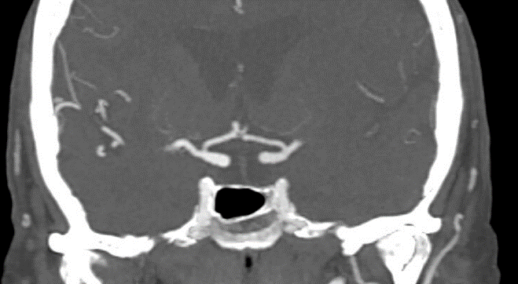
Fig. B - CT angiography, coronal plane – occlusion of a.cerebri media on the left. Mechanical thrombectomy was indicated.
Fig. C – Direct angiography displays corresponding occlusion of left a. cerebri media, image before mechanical thrombectomy. Arrows indicate an amputated stump of a thrombus-closed artery.
C
B

D
E
MRI displays early ischemia in the region of a.cerebri anterior bilaterally (more extensive on the right). In initial phase the ischemia is characterised by hypersignal restricted diffusion on DWI sequence of MRI - Fig. E, which corresponds to low signal regions on ADC maps - Fig. D. MRI was indicated because of not specific symptoms and normal finding on CT.

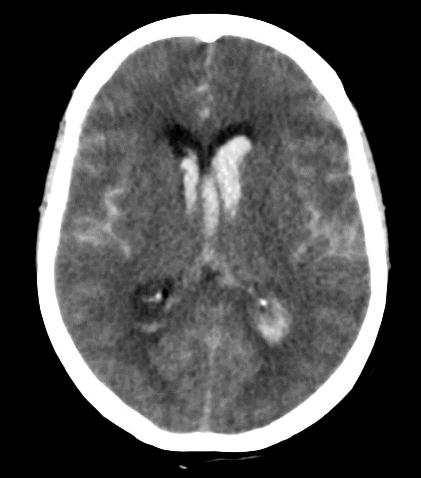
Patient with sudden intense headache with consequent impaired consciousness.
Fig. F – extensive subarachonidal hemorhage (black arrow) on non-contrast CT with hematoma (not visualised) and hemocephalus (white arrow).
Fig. G – CT angiography displays small aneurysm (white arrow) on a.communicans anterior, which was the cause of subarachnoidal hemorhage.

F
G

