6. Pancreatitis

Inflammation of the pancreas can be divided into acute and chronic.

Acute pancreatitis
Acute pancreatitis is a relatively common disease that can occur in mild form, but in severe forms it can have a mortality of 2 to 15% (due to MODS, secondary infected collections). After recovery, the condition may manifest as endocrine (diabetes mellitus) or exocrine insufficiency.

Etiology: Biliary and metabolic (alcoholic) etiology is responsible for 70 to 80%, the rest is idiopathic acute pancreatitis.

Acute pancreatitis is now clinically defined as an acute inflammatory disease of the pancreas with various manifestation in surrounding tissue and distant organs. During the initial phase, the process is dynamic, pancreatic or peripancreatic ischemia, edema, necrosis of the gland and surrounding fat, tissue liquefaction, and the formation of fluid collections is typical. In the next phase, the disease in a milder form either disappears (edematous pancreatitis without necrosis) or tends to stabilize (but not normalize) or progress and enter a prolonged course lasting weeks to months (in the case of necrotizing pancreatitis). Clinically it is manifested by abdominal pain, vomiting, laboratory leukocytosis, amylase elevation.

Importance of imaging methods:

X-ray
A simple scan of the abdomen or chest is irrelevant for the diagnosis. X-rays can show signs of acute inflammation of the pancreas, such as effusion in the lungs, distension of the stomach and colon with gas, but these are not specific to the diagnosis at all.

Ultrasound
Ultrasonography can be used to evaluate changes in the parenchyma of the pancreas - in the case of inflammation, the gland is swelled - the gland enlarges and is relatively hypoechoic (compared to normal pancreas). Complications of acute pancreatitis such as fluid collections in the gland itself, around the pancreas, vascular changes such as thrombosis in the splenic, portal, and mesenteric vein (using the Doppler mode) can also be displayed. However, morphological changes of the pancreas at initial examination in patients with acute pancreatitis cannot be detected in most patients (ie, an ultrasound finding on the pancreas may be normal). The main significance of ultrasound with laboratory-detected hyperamylasemia is to demonstrate or rule out diagnoses other than inflammation of the pancreas and to determine the etiology of pancreatitis. The biliary etiology may be indicated by dilatation of the bile ducts, direct evidence of gallstone in the distal choledochus or in the proximal bile ducts, or the presence of small stones in the gallbladder. In these patients, the cause of pancreatitis can be addressed by endoscopic retrograde cholangiopancreaticography (ERCP) with extraction of gallstones from bile ducts. In another etiology (metabolic, idiopathic), the indication of ERCP would mean an increased burden for the patient and we would risk possible complications of ERCP (perforation, aggravation of the degree of pancreatitis).

CT
Computed tomography is the most accurate imaging method for assessing the degree of pancreatic involvement. Despite the fact that it is possible to recognize signs of inflammation on CT already at the initial symptoms (enlargement of the gland, decrease in density, swelling of peripancreatic fat, fluid collection), CT is important especially for accurate assessment of the extent of necrosis . Due to the time course of pancreatitis and gradual necrotization of the gland, it makes sense to indicate CT for staging of acute pancreatitis up to 48-72 hours after the first symptoms. On CT, we classify acute pancreatitis according to CTSI (CT Severity index) as mild (in case of gland enlargement and swelling of the surroundings), moderate (collection around the gland, necrosis up to 30% of the gland) and severe pancreatitis (necrosis of more than 30% of the gland). This most severe form has up to 17% mortality. Patients with mild pancreatitis may be transferred from intensive care units.

MR
MR can be used in patients who cannot get an iodine contrast agent (allergic reactions or reduced renal function), the yield of the assessment of the severity of pancreatitis is the same as CT. MRCP sequences can be used to assess the pancreatic duct as well as the bile ducts (highly sensitive to the presence of stones).

Chronic pancreatitis
Chronic pancreatitis often develops gradually and may not be the result of acute pancreatitis. It is characterized by fibrosis, calcifications, and changes in the pancreatic duct (enlargement and stenosis). The parenchyma may be atrophic or enlarged. The most accurate assessment of the severity of the disease is on endosonography, changes in the pancreatic duct on ERCP or alternatively on MRCP.

X-ray
In chronic inflammation, calcifications can be detected in the gland, but again with very low sensitivity.

UZ, CT
The most convincing signs of chronic pancreatitis are calcifications in the gland (CT has a high sensitivity), irregular duct enlargement, gland atrophy. Imaging methods are used to monitor patients and rule out complications such as the development of pancreatic cancer in the field of chronic inflammation.

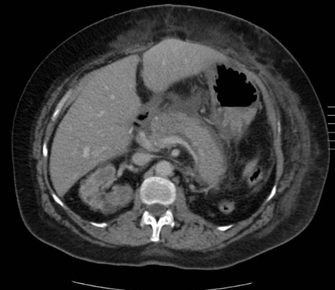
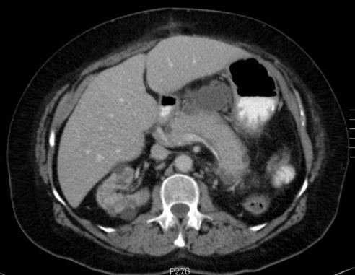
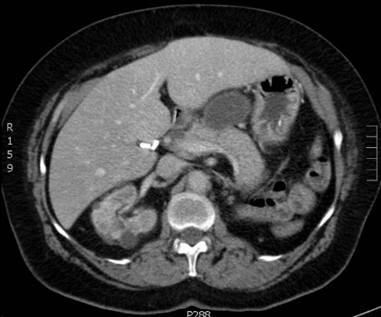
Female, 58 years, moderate acute pancreatitis – CTSI score=3
Fig. A – Contrast-enhanced CT (portal phase)72 hours from initial symptoms,pancreas is enlarged, swelling of peripancreatic fat, peripancreatic fluid collection in omental bursa, inflammatory changes of subcutis
Fig. B - Contrast-enhanced CT (portal phase)2 weeks from initial symptoms, partial regression of peripancreatic inflammatory changes
Fig. C - Contrast-enhanced CT (portal phase)6 weeks from initial symptoms,development of pancreatic pseudocyst, no signs of inflammation any more

A
B
C

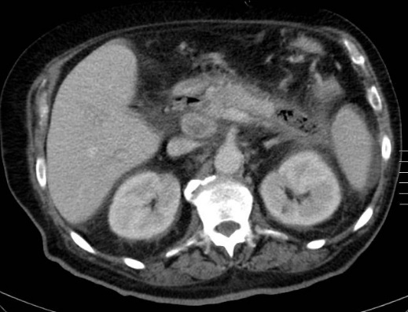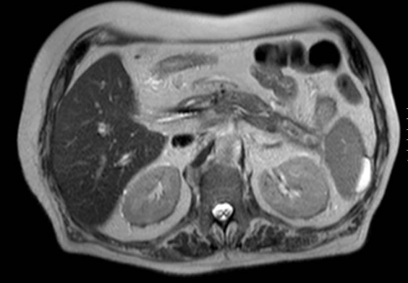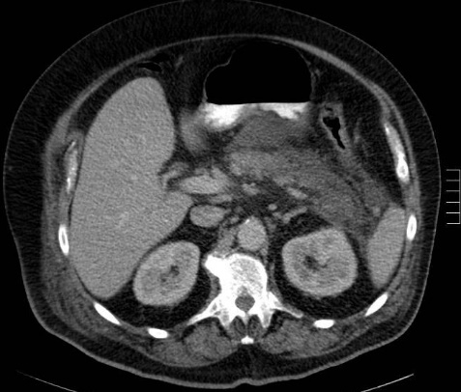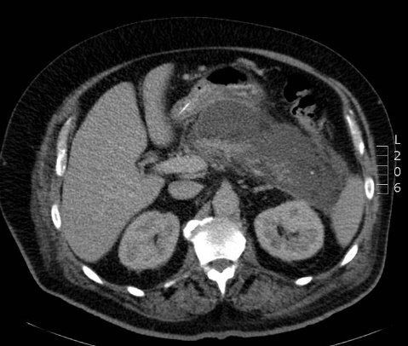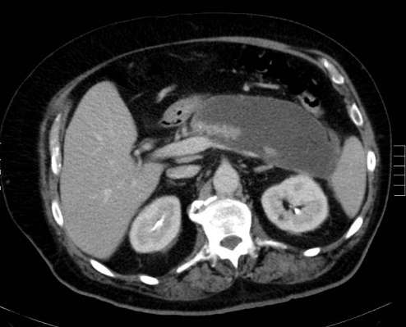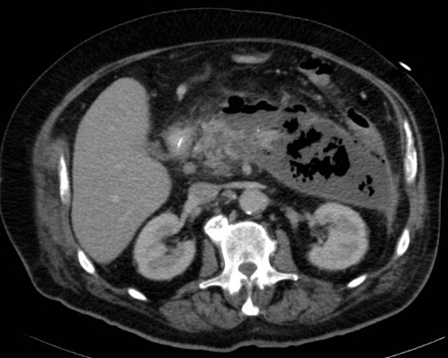
Male, 75 years, severe acute pankcreatitis – CTSI score
Fig. D - Contrast-enhanced CT (portal phase)72 hours from initial symptoms – necrosis of 40-50% of the pankreas, swelling of peripancreatic fat
Fig. E - Contrast-enhanced CT (portal phase)2 weeks from initial symptoms – partial regression of peripancreatic inflammatory changes
Fig. F - Contrast-enhanced CT (portal phase)6 weeks from initial symptoms – development of peri- and intrapancreatic fluid collections – liquefative necrosis of the pankreas
Fig. G - Contrast-enhanced CT (portal phase) after 8 weeks– enlargement of peripancreatic fluid collections, gas bubbles in the collections – corresponds to infected necrosis of the pankreas
Fig. H - Contrast-enhanced CT (portal phase) after 4 months – regresiion of pancreatic fluid collection, exacerbation of actue inflammation, small fluid collection adjacent to spleen
Fig. I – MRI after 7 months (T2 weighted image) – regression of inflammatory changes, small collection adjacent to spleen persists
regrese zánětlivých změn, malá kolekce u sleziny přetrvává

D
E
F
G
H
I

