8. Peritoneal irritation, peritonitis

Peritonitis is a serious inflammatory disease, a type of acute abdomen. It often arises as a complication and result of other inflammation in the abdominal cavity, such as appendicitis.
In terms of extent, peritonitis can be divided into focal and diffuse.
Focal peritonitis is limited to the vicinity of an inflammatory changed organ (e.g. pericholecystitis, perimetritis). Diffuse peritonitis is spread throughout the abdominal cavity.

Peritonitis is manifested by permanent abdominal pain exacerbated by movement and coughing, contraction of the abdominal muscles (défense musculaire), arrest of intestinal activity (paralytic ileus). Due to the large area and resorption capacity, peritonitis rapidly develops into sepsis. Peritonitis is a serious medical condition accompanied by fever and shock. These symptoms are particularly noticeable in diffuse peritonitis. The laboratory findings include leukocytosis, alterations in liver tests, and changes in the internal environment.
In terms of duration, it can be acute or chronic. Examples of chronic peritonitis are tuberculous peritonitis, inflammation around chronic inflammatory deposits, post-radiation plastic peritonitis.
Depending on the nature of the inflammation and effusion, peritonitis is described, as serous, purulent, hemorrhagic, sterkoral, urinary. Primary peritonitis occurs in the absence of intra-abdominal disease (hematogenously, lymphogenically, e.g. so-called spontaneous peritonitis in portal hypertension), secondary occurs as result of intra-abdominal disease, tertiary is connected with abdominal surgery. Cured peritonitis can result in peritoneal adhesions, which are one of the causes of ileus.

Peritoneal irritation includes symptoms accompanying peritonitis (défense musculaire, Pleniés sign, Blumberg’s sign, Rovsing’s sign, Murphy’s sign).

Imaging methods usually allow to display only indirect signs of peritonitis, which include free fluid in the abdominal cavity and inflammatory changes of the intra-abdominal organs (especially in cholecystitis, diverticulitis and appendicitis).
Direct signs of focal peritonitis (enhanced and hypervascularized peritoneum) are rarely seen on imaging methods.

X-ray of the abdomen in upright or supine position
Imaging of pneumoperitoneum (free air in the abdominal cavity visible as a crescent-shaped clearing under the diaphragm in erect position, eventually under the abdominal wall in the lateral supine position), ileus (dilatation of intestinal loops in supine position- normal width of small bowel is up to 3 cm, colon up to 6 cm and caecum up to 9 cm).

Ultrasound of the abdomen
Ultrasound is a sovereign method for imaging free fluid in the abdominal cavity. Thickening of peritoneum is usually not visualised in routine clinical practice. Ultrasound allow to monitor indirect signs of pneumoperitoneum such dilated bowel loops (ileus, an extensive meteorism reduces ultrasound visibility), inflammation of organs (especially cholecystitis, diverticulitis, appendicitis and colitis), accompanied by abdominal fat swelling (increased echogenicity). The pain provoked by the pressure of the ultrasound probe helps to identify the affected area.

CT of the abdomen
CT of the abdomen serves to clarify inconclusive ultrasound and X-ray\ findings, but it is also recommended in cases of negative ultrasound and X-ray and significant clinical suspicion of acute abdomen. In patients in poor clinical condition (and obese) who would be at risk of delay, it is advisable to consider CT as the first-line imaging method (skip X-ray and ultrasound).
In developed peritonitis, direct signs of peritonitis (enhancing thickened peritoneum with fluid collections between bowel loops) are also visible on CT.

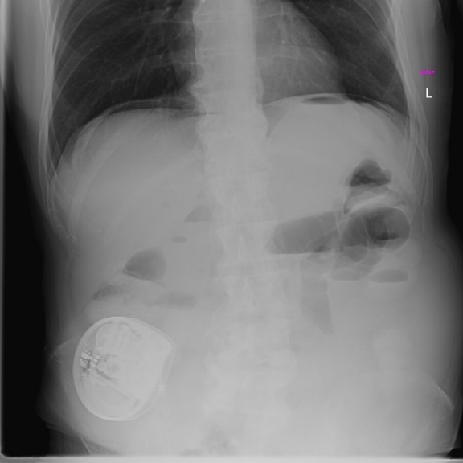
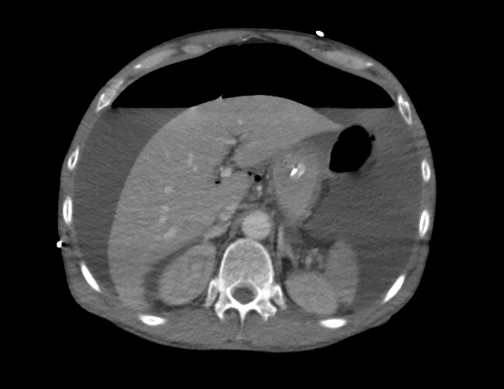
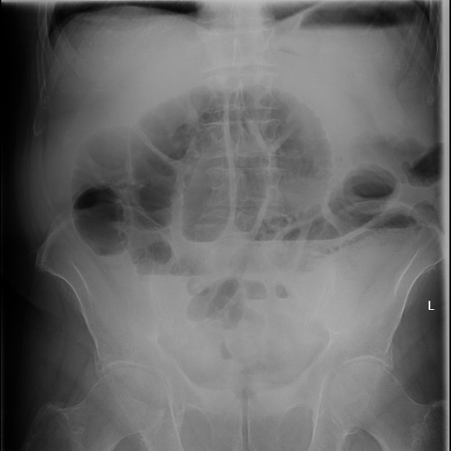
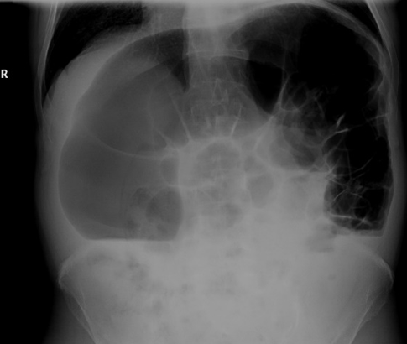
Fig. C - Pneumoperitoneum on X-ray in upright position
Fig. D - Pneumoperitoneum and ascites on CT
C

D

Fig. A – Small bowel obstruction on X-ray
Fig. B – Large bowel obstruction on X-ray

A

B

