# 11. Polytrauma

Polytrauma - refers to the simultaneous injury of at least two body systems, of when the impairment of at least one of them, or a combination thereof, endangers basic vital functions.

## **Summary**:

The basic triage investigation polytraumatized patients on imaging:

**Hemodynamically unstable patient:**

* ultrasound examination FAST / eFAST (Focused assessment with sonography for trauma / extended FAST) - we look for the presence of free fluid (blood)
* in case of need possible indication of dedicated “vital” X-ray images
* possibility of immediate surgical revision

**Hemodynamically stable patient:**

* whole-body CT in patients with moderate to high suspicion of trauma
* Ultrasound + observation in patients with a low level of suspected injury (according to clinical condition)

Imaging methods play a crucial role in excluding or confirming injury and in determining the type and severity. **CT and ultrasound (FAST) play a dominant role.**

## **Imaging methods in polytrauma in more detail:**

*Injuries are the most common cause of death under the age of 45! (maximum at the age of 15-29 years, men 3 times more often). Overall, it is the 3rd most common cause of death after cerebrovascular diseases and cancer. Almost 50% are injuries caused by traffic accidents.*

*In developed countries, in polytraumatized patients, there is a smooth transfer from prehospital care (emergency medical service) to hospital care through emergency admission, where the so-called traumatic team (teamleader (coordinator), anesthesiologist / emergency doctor, traumatologist, radiologist + counselors, nurses) is waiting for the announced reception of the patient.*

Management of traumatic patients is based on the standardized protocol ATLS (advanced trauma life support) - The American College of Surgeons. Implementation - its adherence leads to a demonstrable increase in chances of survival, reduction of morbidity and mortality. However, from the point of view of radiology, the management of traumatic patients based on ATLS is neither perfect nor up-to-date!

**ATLS from a radiological point of view:**

Primary examination - diagnosis and treatment of life-threatening injuries

Secondary examination - deals with remaining injuries

**Primary examination:**

ABCDE mnemonic is determining the order of diagnosis and treatment!

**A** = "Airway" Ensuring continuity of the respiratory tract and the protection of the cervical spine - **without imaging methods.**

**B** = "Breathing + Ventilation" - diagnosis of tension or open pneumothorax, massive hemothorax - clinical diagnosis with subsequent immediate treatment! **Additionally, chest X-rays can be used here - injury detection + position of catheters / drains.**

**C** = "Circulation with hemorrhage control / shock assessment" - clinical signs of internal bleeding / shock **- imaging methods: FAST, or X-ray of the chest and pelvis**. Other possible causes of hemodynamic instability - cardiac tamponade, heart contusion, spinal cord injury. In case of persistent instability, damage control surgery (immediate surgical revision) or co-participation of **radiological intervention methods** – possible embolization of bleeding arteries of parenchymal organs, pelvis, aortic dissection (radiological intervention methods are not mentioned in the ATLS protocol).

**D** = "Disability : Neurological status" - **CT in secondary examinations**

**E** = "Exposure / Environmental control" - hypothermia, burns… - **without imaging methods**

Adherence to the above order of diagnosis and treatment is crucial - airway obstruction kills the patient before pneumothorax, bleeding into the abdominal cavity kills the patient before subdural hematoma!

**Imaging methods in the primary examination:**

**Ultrasound - FAST** (Focused Assessment with Sonography in Trauma)

This is a very fast, non-invasive examination, performed at the patient's bedside, with an accuracy of 86-97 % depending on the experience of the examiner. Ultrasound is a good screening method for the evaluation of hemodynamically unstable hypotensive patients. Its aim is to exclude, resp. confirm **bleeding into the abdominal, thoracic, and pericardial cavities**. We are looking for the presence of free fluid. A positive finding is found at approximately > 500ml of blood in the peritoneal cavity. **A negative finding does not rule out intraperitoneal bleeding!** FAST has a limited informative value in the assessment of parenchymal organ injuries!

*Design:*

*1. Subxiphoid view of the heart - visualisation of 2 heart chambers (right ventricle + left ventricle) - assessment of the pericardial cavity*

*2. Right upper quadrant (from oblique intercostal approach) - assessment of the Morison space (hepatorenal angle) and the base of the right lung.*

*3. Left upper quadrant (from an oblique intercostal approach) - assessment of the splenorenal recess, the space between the spleen and the left kidney plus the left base of the lungs.*

*4. Suprapubic region - always imaging in two planes - assessment of Douglas space (resp. rectovesical space) and urinary bladder*

*5. Ultrasound examination* ***eFAST*** *(extended FAST) extends the protocol for examination of both hemithoraxes to detect / exclude pneumothorax (from anterior intercostal approach) - absence of physiological pleural sliding in B mode = “lung-sliding”, in M-mode change of usual linear granular record „ sea over the sand "to only linear (" sea only ").*

**Plain radiographs and so-called "vital X- rays":**

**Rarely,** when the patient is hemodynamically unstable and unable to undergo a CT scan, it is possible to perform targeted X-rays initially(see below). Under no circumstances should these imaging interrupt or delay resuscitation or therapeutic steps! After stabilization of the patient, the finding is objectified on CT.

**1.Anteroposterior chest X-ray** - suspected hemo / pneumothorax, especially in hypotensive or hypoxic patients - sensitivity is limited! Finding of caudal ribs fracture is an indirect sign of possible liver or spleen injury. **Can be used to verify the position of catheters and drains!**

**2. Anteroposterior pelvic X-ray** - in **hypotensive patients with clinical signs of pelvic injury** (complicated fractures as a source of significant bleeding - association with pelvic artery and vein injuries) - pelvic binder loading. Not in stable patients.

**3.Lateral projection of the cervical spine** (possibly in combination with anterioposterior and transoral (Sandberg) projections) - lateral projection reaches a sensitivity of 85% in detection of fractures. We do not perform in hemodynamically stable patients able to undergo CT examination. Still important **in hemodynamically unstable patients unable to undergo CT scan!** In case of severe neck deformity / neurological deficit - in case of extensive incongruence, traction loading as prevention of further spinal cord damage during further handling or transport.

*X-rays are performed in the emergency department using a mobile X-ray device. It is a digital device with a display that allows you to view the captured image immediately. The disadvantage is the poorer quality of images, images often in non-standard projections for limited patient cooperation, summation artifacts from the surface - splints, clothing, other materials, more time-consuming.*

**Secondary examination:**

" Head -to- toe " examination - "from head to toe". ATLS - does not address details.

The following imaging methods are used:

* **CT** (whole body / selective)
* targeted X-rays (limbs)
* MR

**CT**

**The "whole body" CT protocol** includes examinations of the **brain and cervical spine, thorax, abdomen, and pelvis.** Its use increases the chance of survival in polytraumatized patients*.* The protocol must meet the basic requirement to identify injuries that require surgical / percutaneous intervention, ie large vessel injuries, active bleeding, unstable spine fractures, diaphragm rupture, mesentery or gastrointestinal injuries. The most commonly used whole-body **CT protocol** consists of a **non-contrast examination of the head and neck** (brain haemorrhage and bone trauma are clearly visible on non-contrast CT scans), and **contrast-enhanced examination of the chest, abdomen and pelvis in one post-contrast phase** (multiphase examination - simultaneous enhancement of arteries, veins and parenchymal organs) - *allows to evaluate defects in contrast enhancement during contusion / laceration of parenchymal organs, contrast leakage during rupture of larger vessels, absence of contrast enhancement of bowel wall e.g. in case of mesentery injury*).

The presence of a radiologist during a full-body CT examination is necessary – radiologist immediately provides information on the nature and severity of injuries to other members of the trauma team, either verbally or in writing. This is followed by detailed report with precise description of traumatic changes.

We do not use the whole-body CT protocol in patients with low-energy trauma, thus preventing unnecessary radiation exposure of the patient!

**MR**

One of the indications for performing **acute MR** in the traumatology is the suspicion of **injury to the spinal cord and discoligamentous system**, because CT examination to evaluate the conditions in the spinal canal and ligament is insufficient. During spinal cord contusion, we can observe changes in the MR signal (bleeding, damage) with functional consequences of various degrees. Spinal cord compression can occur due to ductal hemorrhage, epidural / subdural hematoma, dislocated fragments of a fracture, vertebral dislocation. The most severe spinal cord injury is spinal cord transection.

**MR of the head is not indicated in an acute condition.** The examination may be performed only in the second period, after the stabilization of the patient's condition. The indications most often include the diagnosis of **diffuse axonal injury** (DAP) or injuries in the area of the posterior cranial fossa and brainstem.

**Radiological vascular interventional procedures**

One of the indications for acute endovascular procedure is the **cessation of traumatic bleeding** - especially retroperitoneal bleeding and bleeding in the pelvis, liver, spleen. Techniques of endovascular hemostasis use the possibility of embolization of injured vessels, or implantation of a stentgraft (e.g. in case of aortic dissection or ruptured aortic aneurysm).

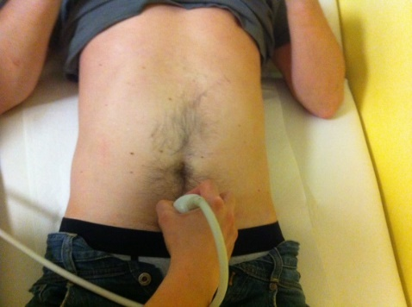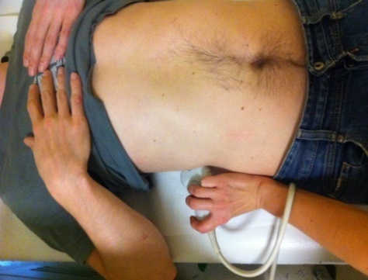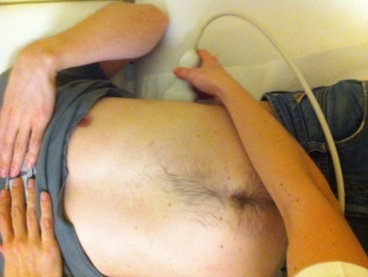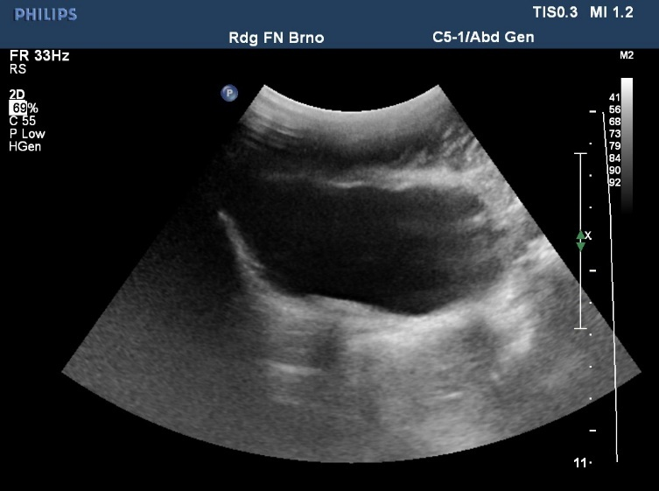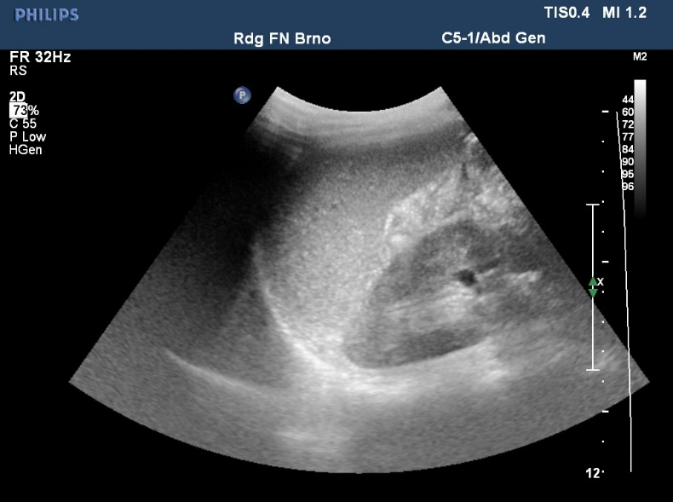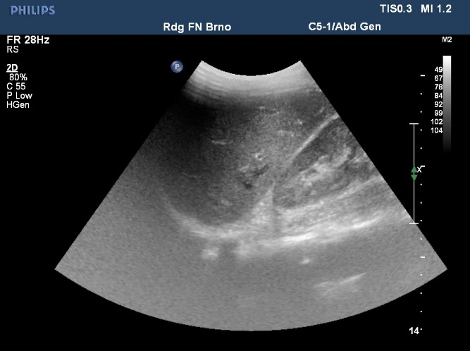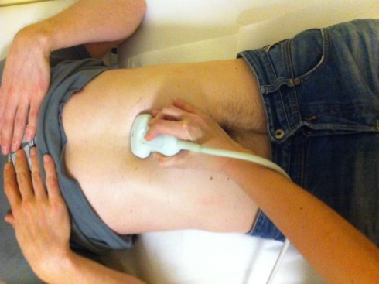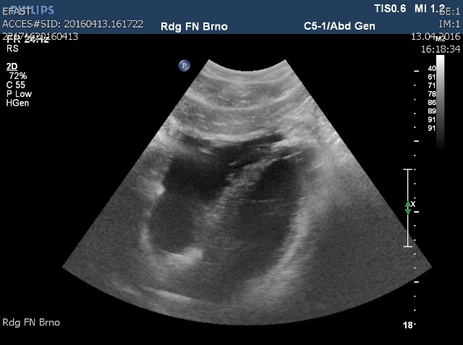

**A**

**B**

**C**

**D**

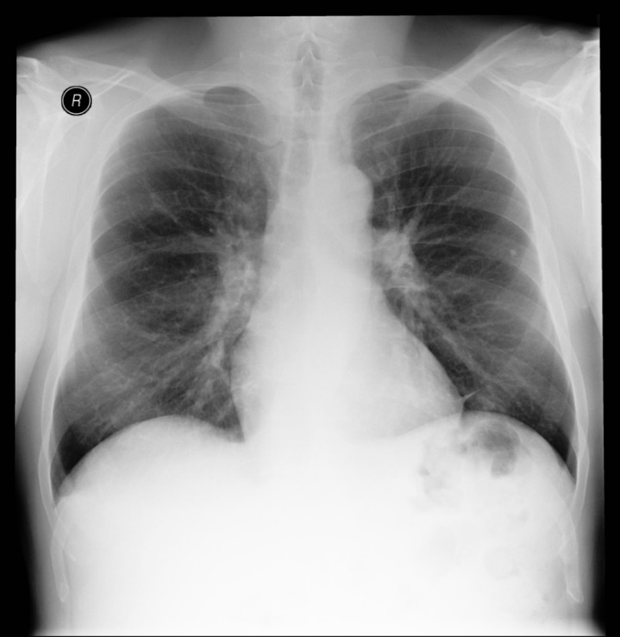

Comparison of quality of chest X-ray from transportable (**Fig. E**) and stacionary X-ray machine (**Fig. F**). Picture **E** has lower quality, artifacts from surface are present (ECG leads). Indicated to confirm position of central venous catheter.

**E**

**F**

**FAST ultrasound**

**Fig. A –** Subxiphoid view displaying two heart chambers, for evaluation of pericardial fluid.

**Fig. B** **–** Visualisation of Morrison space and right lung basis from oblique intercostral approach on the right.

**Fig. C –** Visualisation of splenorenal recess and left lung basis from oblique intercostral approach on the right.

**Fig. D –** Suprapubic view for evaluation of Douglas space (resp. retrovesical space in males) and urinary bladder.