16. Imaging of esophageal injury
Table 1. Etiology of esophageal perforation
Etiology | Incidence (%)
Iatrogenic | 59
Spontaneous | 15
Foreign body | 12
Trauma | 9
Surgical injury | 2
Tumor | 1
Other causes | 2
Oesophageal injury is most often iatrogenic (up to 59%) during frequent diagnostic and therapeutic endoscopic procedures, see Table 1. The risk of injury ranges from hundredths of percent during flexible endoscopy to 1-5% during dilatation of achalasia or sclerosing of esophageal varices. The most common site of injury during endoscopy is the area of the Kilian triangle (the muscle layer is missing there), less so in other physiological weaknesses of the esophageal wall. The surgical perforation of the esophagus can occur during a hiatal hernia surgery, fundoplication, vagotomy etc. Spontaneous perforation can occur in case of extensive vomiting against contracted m.cricopharyngeus, which will greatly increase the pressure in the esophagus and transmural rupture of the wall occurs - it is called Boerhaave syndrome.

Symptoms of perforation vary depending on the etiology. Chest pain, dysphagia, shortness of breath, epigastric pain are commonly present. From a radiological point of view, subcutaneous emphysema is important, because it can be detected on an X-ray of the chest, abdomen or cervical spine (according to the literature, the development of detectable emphysema takes at least 1 hour from the rupture).
Oesophageal perforation is an acute and life-threatening condition. Its early diagnosis and treatment reduce morbidity and mortality. When the esophagus is perforated into the mediastinum, mediastinitis and sepsis develop. Spontaneous perforations have the highest mortality (up to 36%).
The decision on the initial imaging method depends on the overall condition of the patient. In patients cooperating with suspected minor perforation, the method of choice will be esophageal fluoroscopy, while in patients who do not cooperate and patients in a generally poor condition with suspected major perforation, CT is the method of choice.

Esophageal fluoroscopy
Most sensitive method in the first 24 hours is esophageal fluoroscopy with iodine contrast agent. Barium contrast agent can be used to increase sensitivity only in case of a negative finding on the fluoroscopy with iodine contrast agent (barium leakage can cause mediastinitis !).
False negativity of the esophageal fluoroscopy is at least 10% in the acute stage (edema and inflammation of the esophageal wall initially prevent the leakage of contrast medium outside the lumen). For this reason, esophageal fluoroscopy can be repeated in case of clinical suspicion on esophageal perforation.

Chest CT
Another option is to perform a chest CT, which in some cases can replace the esophageal fluoroscopy (non-cooperation, fluoroscopy intolerance). CT should be performed after oral administration of a contrast agent (as a CT esophagogram , we can see possible leakage of contrast agent outside the lumen of the esophagus; on this initial CT scan is no contrast intravenously) and after intravenous contrast administration (allows better differentiation of mediastinal organs, displays possible abscess). Typical findings on CT are pneumomediastinum, thickening of the esophageal wall, esophagealopleural fistula (contrast in the lumen of the esophagus allows better visualisation of fistula), pleural effusions and a possible paraesophageal abscess. CT can also be used, for example, to navigate percutaneous drainage of an abscess.

Surgical, endoscopic, or conservative treatment is chosen based on the extent of perforation and the overall condition of the patient.

Flexible endoscopy in the diagnosis of perforation is not routinely performed due to the risk of further esophageal injury, but it can be used for smaller and non-severe perforations for local treatment of the finding (implantation of clips).

Conservative treatment consists of stopping the oral food supply, parenteral nutrition, administration of broad-spectrum antibiotics and possible drainage of collections. Surgical treatment ranges from closing the perforation to complete resection and esophageal replacement. Another treatment option is to bridge the perforation with a coated stent that is implanted endoscopically or under fluoroscopic control.

Another example of an esophageal injury is esophageal burns due to accidental fluid substitution or suicide attempt. The extent of esophageal damage is initially assessed endoscopically. Imaging methods play an important role in detecting complications. Early complications include perforation and mediastinitis, the role of imaging methods being discussed above. A common late complication is post-inflammatory esophageal stenosis, which can be best seen on the esophageal fluoroscopy. These stenoses (like other non-tumor stenoses) can be dilated with a balloon under fluoroscopic control.
Oesophageal burns are also a predisposition to esophageal cancer. In the diagnosis of esophageal cancer is utilised endoscopy (allows visual evaluation of the tumor and perform biopsies), transesophageal endosonography (examine how deeply into the wall of the esophagus tumor grows), and contrast-enhanced CT or PET / CT (assess tumor spreading outside the esophagus, regional lymphadenopathy, and distant metastasis).

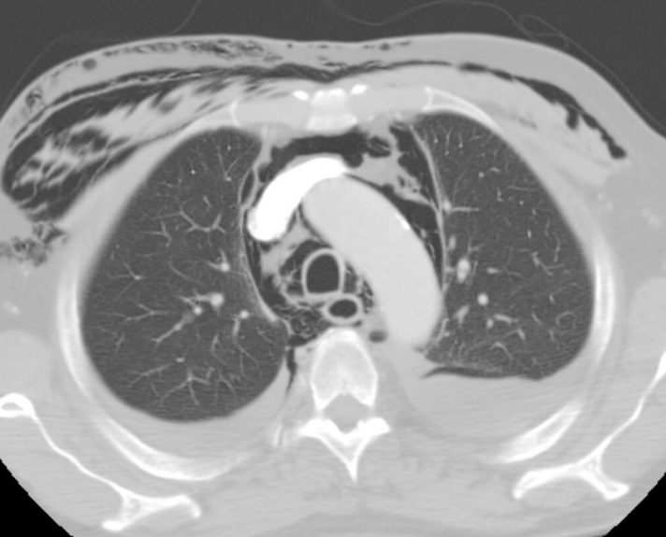
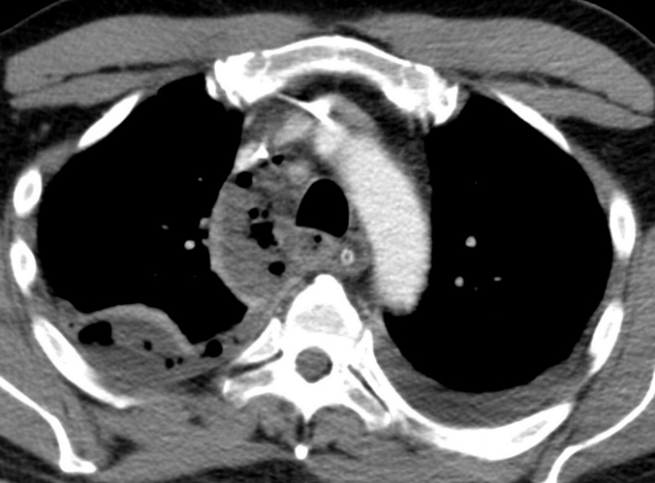
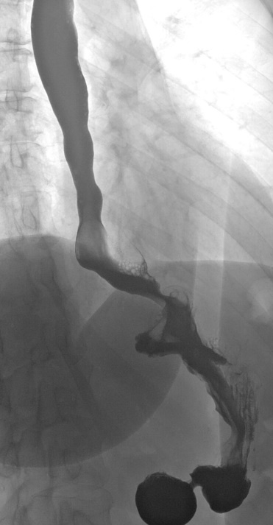
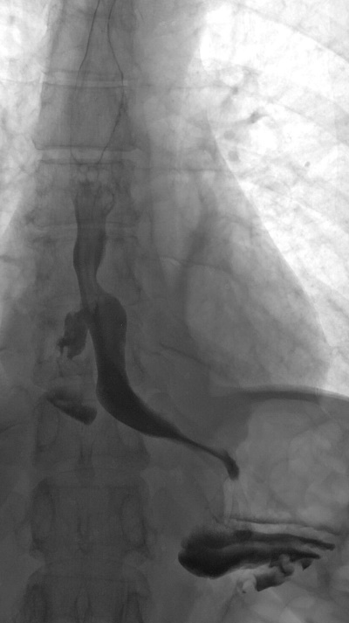
Fig. C - CT of the chest in lung window show massive pneumomediastinum and subcutaneous emphysema after spontaneous perforation of the esophagus caused by extensive vomiting– Boerhaave syndrome.
Fig. D – CT of the chest after contrast administration (see dense aorta) in soft tisue window display fluid collection with air bubbles in the mediastinum (right paratracheal region) – it was an abscess following mediastinitis caused by leak of esophagujejunal anastomosis.

C
D
Fig. A – Esophageal fluoroscopy with iodine contrast display leak of contrast in the distal esophagus. The patient is after Heller myotomy.
Fig. B – After surgical treatment control fluoroscopy show no leak any more.
A
B

