21. Focal liver lesions and diffuse liver disease

The basic imaging method for liver disease is ultrasonography (US). If a focal lesion is detected on ultrasound, the lesion may be further evaluated with an intravenous contrast agent (“gas microbubbles”). CT is a standard in the evaluation of a focal liver lesions. CT enables quick assessment of both the focal liver lesion and possible the primary tumor when finding a liver metastatic. CT also serves to objectify the location of the lesion before surgery. CT is normally performed without intravenous contrast and in one to three postcontrast phases (arterial, portovenous and late phases ). MR is mainly used to answer special diagnostic problems (high soft tissue contrast of basic sequences, use of diffusion weighted sequences, hepatospecific contrast agents).
Imaging methods suitable for the diagnosis of focal liver lesion (UZ, CT, MR) have their general advantages and disadvantages. The great advantage of ultrasound is the possibility of contrast agent administration (CEUS - Contrast Enhanced Ultrasound) immediately when pathological lesion of liver is found. CEUS significantly increases the specificity of the etiology of the lesion (i.e. distinguishes benign from malignant and determines whether there is a typical picture of e.g. hemangioma, FNH-focal nodular hyperplasia, hepatocellular carcinoma or another lesion). Under ultrasound, similarly to CT, a targeted biopsy of lesions of unclear etiology can be performed. Another advantage of CEUS is the ability to monitor the enhancement of the lesion in real time and not only at the time of scanning in CT and MR (i.e. on CEUS we have not only arterial, portovenous and late phase, but a continuous record of enhancement of the lesion and surrounding liver parenchyma).
Similar to CT, postcontrast examinations in arterial, portovenous and late phases can be performed on MR. A great advantage is the possibility of application of a hepatospecific contrast agent, which is taken up in hepatocytes. It is thus possible to distinguish lesions with functional hepatocytes from lesions without them (e.g. differentiation of FNH, which is formed by normal hepatocytes from fibrolamellar HCC; both tumors occur in the non-cirrhotic lliver in young people).
Within the differential diagnosis of focal liver lesions, it is appropriate to divide patients into 3 groups:
1. Patients with an accidental finding of a lesion without known primary tumor.
2. Patients with a lesion in the liver with a known primary tumor.
3. Patient with a lesion in the cirrhotic liver.

1. Patients with an accidental finding of a lesion without a known primary tumor.
In patients without known malignancy with an accidental lesion smaller than 15 mm, almost all liver lesions are benign. Any lesion in the non-cirrhotic liver in these patients is considered benign unless its malignancy is confirmed. For unclear findings, it is possible to add contrast ultrasound, possibly also other imaging methods and optionally control in 6 months.

2. Patients with a lesion in the liver with a known primary tumor.
Patients with known primary malignancy have up to 50% likelihood to develop malignancies in the liver. Therefore, in this group of patients, each lesion should be considered potentially malignant unless its benign nature is confirmed.
If a patient with a known tumor has a liver lesion, the diagnostic procedure depends on the next planned treatment. If histological verification of the lesion affects the treatment protocol, then in case of uncertainty it is necessary to add a biopsy or PET (preferably PET/CT, because it is assumed that the malignant lesion will be metabolically active and the benign will be not) or perioperative ultrasound examination. If the finding of the lesion does not affect the treatment, a control with an interval of approximately 3 months is more appropriate. If the size of the lesion (or its number) changes, we can simultaneously assess the effect of the treatment. Where surgical resection is not possible, the radiologist may suggest other treatment options in indicated cases, such as percutaneous ablation or transarterial embolization or chemoembolization.

3. Patient with a lesion in the cirrhotic liver.
Because approximately half of the lesions found in patients with liver cirrhosis are subsequently classified as HCC (hepatocellular carcinoma), any lesion in the cirrhotic liver is considered malignant unless benignity is confirmed. At the same time, however, up to 50% of lesions smaller than 2 cm detected in the US are not HCC. These are mostly large regenerative nudules and dysplastic nudules. Patients with liver cirrhosis should be monitored regularly for the risk of HCC, liver ultrasound is recommended every 6 months. CEUS, CT or MR with the administration of a contrast agent is suitable for unclear findings on ultrasound.

Diffusion processes of the liver
Steatosis - an increased amount of fat in the liver is the most commonly reported pathology of the liver. It is most often caused by unhealthy lifestyle, diabetes, medication, event. experienced liver disease. It is manifested by diffusely increased echogenicity (so-called "bright liver," brighter than the parenchyma of a healthy kidney), decrease in density on CT, the presence of fat on specific MR sequences. Less common are localized forms, so-called focal steatosis. Unlike fibrosis and cirrhosis, steatosis has doubtful prognostic significance (only minority of cases progress to fibrosis and cirrhosis).

Fibrosis - proliferation of connective tissue of the liver. It can develop from steatosis and progress into cirrhosis, but it is still a reversible process. Increased liver stiffness can be detected in the so-called US elastography, a method that monitors ultrasound impulses when pressure is applied to liver tissue. Another suitable method is MR elastography. It is not possible to reliably distinguish fibrosis from steatosis on common ultrasound, CT or MR.

Cirrhosis. Cirrhosis is usually detectable on ultrasound, CT and MR only in a relatively advanced stage, when a typical nodular structure of the liver is already present. Other typical features of advanced cirrhosis are hypertrophy of the 1st liver segment and the left liver lobe and decreased size of the right liver lobe. We can also detect indirect signs of cirrhosis - ascites, portal hypertension and portovenous anastomoses and splenomegaly. In the terrain of cirrhosis, there is an increased risk of hepatocellular carcinoma (HCC), its diagnosis at an early stage is hampered, especially in ultrasound, by a significant inhomogeneity of the liver parenchyma due to regenerative changes. To reliably rule out malignancy in cirrhotic terrain, MR with a hepatospecific contrast agent is indicated, but due to its availability and cost, it cannot be performed as a screening.

Theoretical background of imaging of focal liver processes:
In ultrasound normal liver parenchyma has echogenicity comparable to cortex of healthy kidneys. The anechoic branches of the portal vein and hepatic veins contrast well with the hepatic parenchyma. In obese patients, the whole liver may not be reliably assessed by ultrasound.
CT can be performed without intravenous contrast or after administration of a contrast agent. For the evaluation of the skeleton, urolithiasis, interstitial lung disease or intracranial hemorrhage, the non-contrast examination is sufficient, i.e. the application of a contrast agent will not provide any additional information. For the evaluation of focal lesions, it is appropriate to perform both, non-contrast scan and 1 to 3 postcontrast scans. Post- contrast scans differ depending on the time of their execution from the application of the contrast agent (in other words, how far the contrast agent manages to reach since the intravenous application). The arterial phase is characterized by a good contrast filling of the arteries, at the same time hypervascularized lesions (e.g. some liver metastases, HCC) and the renal cortex are enhanced, otherwise the organs of the abdominal cavity are poorly enhanced and relatively difficult to assess. Postcontrast CT of the abdomen is most often performed in the portovenous phase, i.e. at a time when the portal vein and the liver parenchyma (the liver is 80% supplied from the v.portae) and other organs of the abdominal cavity are well enhanced. In case of an unclear finding, it is sometimes necessary to perform the late phase, when the contrast agent is present mainly in the venous system. In the late phase are frequently enhancing cholangiocellular carcinomas due to the high proportion of connective tissue, and benign lesions are often enhancing too. The fact that the lesion is enhancing or not may be decided on the basis of changes in the density in non-contrast and postkostrastním image. If the densities are approximately the same non-contrast and postcontrast (change up to 10-15 HU), then the lesion does not enhancing (e.g. hematoma, cyst). If the densities are on non-contrast CT lower than on post-contrast CT, then the lesion is enhancing and, depending on the nature of the enhancement, it is possible to decide on its malignant or benign nature.

Characteristics of selected liver foci :
Benign - hemangioma, usually without clinical signs, accidental finding. In the US, it typically looks like a sharply demarcated, hyperechoic lesion. It never behaves expansively. They can be multiple. The diagnosis can be confirmed by administering a contrast agent on US (“gas microbubbles”), which is a method with high specificity and sensitivity. After the administration of contrast agent, the hemangioma show enhancement from the periphery towards the center, and in the late phase it remains hyper/isoechogenic compared to the surrounding liver parenchyma. In case of ambiguity, MR can be added.

Focal nodular hyperplasia (FNH) - is a consequence of the hyperplastic response of hepatocytes to the presence of pre-existing vascular malformation. Larger FNHs typically have a central scar, but sometimes, especially in smaller ones, central scar may not be present. In the US, it appears as a demarcated hypoechoic lesion, sometimes with a visible central scar, after administration of contrast it show enhancement from the center (the scar may remain unsaturated). MR is indicated for detailed assessment. Typical FNH is enhancing in the arterial phase and especially in the hepatospecific phase (it contains hepatocytes which accumulate hepatospecific contrast agent).

Liver abscess - with elevated inflammatory markers and abdominal pain, it is necessary to think about a possible liver abscess. An abscess is a collection of fluid with an enhancing wall and swelling of surroundings. It can be visualised on ultrasound, but to investigate its extent and consider further treatment, CT with contrast administration is indicated (possibility of drainage of the abscess under CT). Some abscesses have a characteristic appearance on imaging methods, such as the Klebsiella abscess. Abscess-like liver lesions form the echinococcal parasite, that also have a characteristic image on imaging methods.

Malignant hepatocellular carcinoma (HCC) often arises in the cirrhotic liver, which complicates its early diagnosis due to the nodular terrain of the liver. It can be solitary, multifocal or in diffuse form. Manifestation vary according to its size: smaller tumors are usually hypoechogenic/hypodense, larger inhomogeneous and hypervascularized with areas of necrosis and bleeding. Slow-growing HCCs are usually surrounded by a fibrous capsule. Vascular invasion is common. After the administration of contrast, it shows initial enhancement in arterial phase and wash out in portal and late phase (relatively hypodense to surrounding liver parenchyma). On MR, HCC is characterized by low signal intensity in T1 and high in T2 weighted image. With the exception of the infiltrative type, pathognomonic is the lesion in cirrhotic liver, which is hypervascularised in the arterial phase and washes out in late or portal phase.

Cholangiocellular carcinoma - originates in the bile ducts, typically in elderly patients. The central form (in the area of bile duct bifurcation, the so-called Klatskin tumor) is associated with bile duct dilatation, the peripheral form can form a large tumorous lesion without dilatation of the bile ducts. It usually appears as a hypovascularized tumor. After the administration of contrast, in the arterial phase it is practically unenhancing, in portovenous phase it may have similar density to the surrounding liver parenchyma and subsequently it washes out.

Metastases - the most common malignancy of the liver (metastasis of colorectal cancer, tumors of the stomach, pancreas, lungs, breast). They are usually multiple. They are most often hypoechogenic/hypodense compared to the surrounding liver parenchyma, but they can also be hyperechogenic/hyperdensive (e.g. metastasis of renal cell carcinoma). ON ultrasound, hypoechoic border ("target image") is typical, the contours are blurred, the shape is not regular. Decisive is the examination with intravenous contrast, when the arterial phase may be enhancing and in portal and late phase remain hypoechoic hypodense compared to the liver parenchyma.
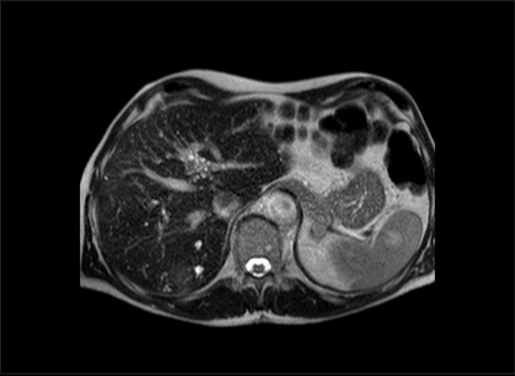
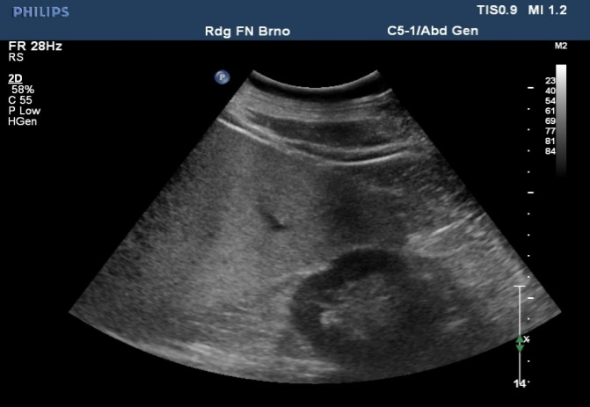
Fig. B – Cirrhosis in ultrasound
Fig. C - Cirrhosis in CT
Liver of decreased size, irregular contours, ascites.
C
B
FNH in MR: T1 (Fig. D), T2 (Fig. E) weighted image and enhancement in hepatospecific phase (Fig. F).

D
E
F
Fig. A – Ultrasound – steatosis, diffusely increased echogenity of the liver compared to parenchyma of healthy kidney

A
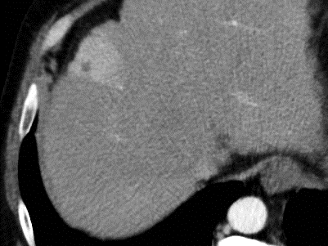
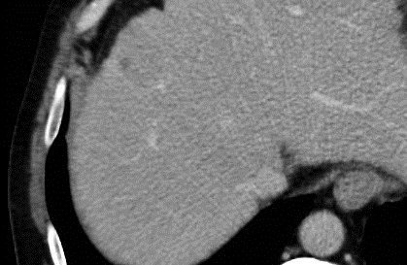

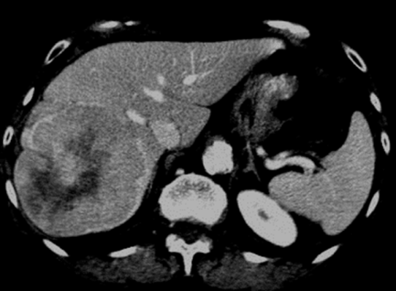
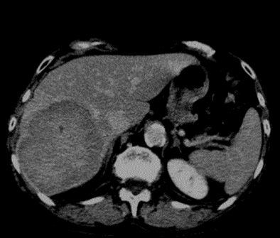
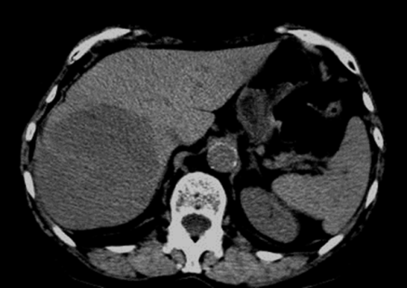
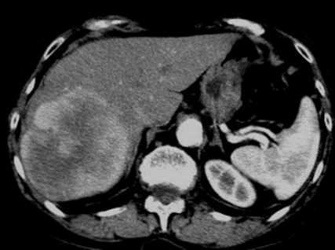

G
H
I
J
HCC in CT
Fig. G - Hypodense in non-contrast CT
Fig. H - Enhancing in arterial phase
Fig. I - Initiation of wash out in portal phase
Fig. J - Washed out in late phase

Appendix (source desertation MUDr.Bohatá Ph.D.):
Graph 1: Proposed procedure in patients with an accidental finding of a lesion without a known primary tumor
Accidentally detected lesion in patients without a predisposing disease such as primary malignancy or liver cirrhosis
The finding will not affect further treatment
Investigation may be terminated
No clear signs of benignity, uncertain nature of the lesion
Additional method (CEUS-CT-MR-PET/CT)
The finding will affect further treatment
Follow-up, documentation
Benign
Malign.
Uncertain nature
Biopsy
Treatment
Benign appearance
No signs of malignancy

Graph 2: Proposed procedure in patients with known primary tumor
Lesion (tumor) in the liver + history of malignancy
Screening ultrasonography
Finding of focal liver disease
No lesion found
Regular follow-up
Characterisation of the lesion
(US-CEUS-CT-MR-PET/CT)
metastasis
uncertain
benign
Number, segments, size, resectability
Surgery
Percutaneous ablation, TACE
Non-surgical treatment
biopsy
Therapy effect controls

