# 1. Headache

Headache (headache) is a symptom. Headache can be divided into primary and secondary, acute and chronic.

**Primary**- they do not have a known organic basis, imaging methods are used to rule out another cause

**Secondary**- they appear as a manifestation of another disease that has an organic basis, in differential diagnosis imaging methods can be used

Imaging methods should always be used if the headache is newly developed and progressively worsening, a headache of extreme intensity (the patient has never experienced such pain), in elderly patients and if the headache is accompanied by neurological symptoms or a change in consciousness (including confusion).

Initially, for acute headaches, we perform a native CT of the brain to rule out bleeding or expansive manifestations. If there is a presence of subarachnoid hemorrhage of non-traumatic etiology on CT, CT angiography of the cerebral arteries follows to determine the source of the hemorrhage (usually an aneurysm, less often AV malformation). For chronic headaches, MR is the method of choice. MR is also used to investigate unclear findings or expansions on CT (MR distinguishes basic types of tumors, abscesses, ischemia, etc.).

### Primary headaches

These include migraine, tension headache, cluster headache. Typically, there is **normal finding on** **imaging methods. Imaging methods serve only to rule out organic causes of pain.**Imaging is not necessary for chronic primary headache, and also for acute headaches typical of migraine or tension headaches without neurological deficits. We use magnetic resonance imaging only in the case of chronic headaches with new accompanying symptoms or with increasing frequency of the symptoms.

**Migraine**is a chronic disease, manifested by recurrent headaches, usually unilateral, distinguishing the presence of aura / without aura. Accompanying symptoms include nausea, vomiting, anorexia, phonophobia, photophobia, osmophobia. It usually lasts 4-72 hours, it disappears spontaneously.

**Tension headaches**are usually dull, pressure, diffuse, they are permanent, slightly fluctuating in intensity. Usually gradual onset, lasting hours to days. Vomiting is not present, nausea is quite rare. Often accompanied by depression and anxiety, sleep disorders are common.

**Cluster headaches**are uncommon primary headaches. It is a syndrome of accumulated headaches - accumulated in the localization (always around one eye), or accumulation of bouts of pain over time. The pain has a different length of time, most often from 4 to 8 weeks, then the pain disappears, the condition calms down and the patient is completely without problems.

### Secondary headaches

**Sinusitis**is an inflammation of the paranasal sinuses, often infectious, most often affecting the maxillary sinuses. It arises as a complication of rhinitis, ev. inflammation of the teeth. The most common symptom is a headache, followed by a patol. secretion, temperature.

**Imaging algorithm - X-ray image of the head in semi-axial projection***(with the mouth open, the head rests on a pad)***on the paranasal sinuses to confirm / refute the dg. A typical finding is the level at the fluid (pus) / air interface (Fig. A) . In young patients, the method of choice is MR.**

**Orbitocellulitis**arises as a possible complication of sinusitis, when the infection spreads to the orbit. It begins as pain behind the eye, then presents with ophthalmoplegia and loss of visual acuity.

**Imaging algorithm - MR of paranasal sinuses resp. orbit with the application of a contrast agent (CT can be used in case of unavailability of MR) , to confirm / exclude fluid collection in the orbit**(presence of abscess - collection with saturating wall), edema of intraorbital fat and extraorbital soft tissues is also present (Fig. B)

**Intracranial expansion**is manifested by headaches in about 50% of tumors (primary and metastatic), most often as tension pain, less as migraine, often other symptoms are present (nausea, vomiting, neurological deficit).

Intracranial expansion can be divided according to various criteria into **extraaxial**(meningioma, more rarely metastases - eg melanoma) and **intraaxial**(most primary tumors, most metastases). Furthermore, it is possible to divide according to frequency into **solitary**(most primary tumors) and **multifocal**(typically meta, there may be meningiomas, schwannomas in neurofibromatosis type I), division according to localisation into **supratentorial**(adults: meta, glial tumors - astrocytoma , oligodendroglioma, glioblastoma; children: astrocytoma, ganglioglioma, DNET, PNET) and **infratentorial**(adults: meta, hemangioblastoma; children: medulloblastoma, ependymoma, juvenile pilocytic astrocytoma).

The presence of structural changes as calcifications, cysts or the fat component, helps to differentiate some tumors.

*The presence of calcifications (high density on CT = hyperdense) may occur in intraaxial TUs such as oligodendroglioma ( 90% ), astrocytoma (20%), ependymoma (50%), ganglioglioma (40%). Of the extraaxial TUs, calcifications occur in meningioma ( 25% ), craniopharyngeoma (90%), chordoma, chondrosarcoma.*

*The cystic component (low density on CT = hypodense) may have craniopharyngeal, pilocytic astrocytoma, hemangioblastoma. The fat component (negative densities on CT = markedly hypodense) is typical for lipoma, dermoid cyst, possibly teratoma.*

**Imaging algorithm - initially usually native CT to exclude bleeding and assessment of expansive manifestations**(in cases where expansion is not known and MR is not available, eg within 24 hours ), **then MR to investigate unclear findings, exclusion or characterization of tumors - satiety, edema, relationship to structures, (Fig. C, D, E)** 

*Advanced imaging methods, such as MR spectroscopy or MR perfusion, serve to further characterize the tumor (distinguishing between low-grade and high-grade tumors).*

### Headaches associated with vascular disease of the brain

**Subarachnoid hemorrhage**example. BC and ruptured **aneurysm of the**intracranial arteries. It manifests itself as a sudden, sharp pain from full health (patients report the **worst pain they have experienced**), it may be accompanied by vomiting, a disorder of consciousness . The diagnosis is made in native CT of the brain ( blood density in the subarachnoid spaces), the source of bleeding is demonstrated by subsequent CT angiography (aneurysm or arteriovenous malformation).  See also **Stroke**(CMP) see question 2.

**Raft thrombosis**occurs in hypercoagulable conditions of various etiologies ( bacteremia , sepsis , cancer , pregnancy and the puerperium, disseminated intravascular coagulopathy, collagenosis, trauma,… ), or as a complication of local infection ( sinusitis , otitis media ). The most commonly affected are the superior sagital sinus, the transverse sinus and the cavernosus sinus . Raft thrombosis is manifested by headache in combination with neurological symptoms.

**Imaging algorithm - CT of the brain natively to exclude bleeding**(possible finding of dense rafts - similar significance as dense artery sign in CMP - see question 2) **+ demonstration of thrombosis on MR venography (usually natively, kl is applied only to unclear findings; Fig. H) , CT venography only when MR is unavailable**

**Cervicogenic pain is**caused by a dysfunction of the cervical spine (cervicocranial syndrome). It is caused by long-term static overload in a number of sedentary professions or some movements of the cervical spine. The pain usually starts in the neck or back of the head and can shoot or stab areas of the head. There is also increased tension in the neck muscles and trapezoids and the pain of the occipital nerve outlets during palpation.

**Imaging algorithm - X-ray of the cervical spine (AP and lateral projection) + functional images**(ie images in the forward bend and tilt to assess vertebral body displacements and spinal development)**, MR of the cervical spine**

**Neurovascular conflict**is caused by the compression of the cranial nerve by a vessel at the site where the nerve is most vulnerable: in the area of ​​its central (glial) myelination, which extends into the periphery of the cerebral nerve a few millimetres from the brainstem. Compression of the central segment of the facial nerve is clinically manifested by facial hemispasm.

**Trigeminal neuralgia**is one of the most intense and destructive pains to be encountered. Impairment of **VIII. cranial nerve**innervating the inner ear, where both the center of hearing and balance are located, causes chronic tinnitus or imbalance with dizziness and falling to the affected side (vertigo), or both components can be expressed simultaneously

**Imaging Algorithm**- MR with high resolution to display the conflict

Note: MR is suspected of neurovascular conflict in a large proportion of asymptomatic patients, and therefore the finding should always be correlated with the patient's clinic.

**Temporal arteritis**is a chronic systemic vasculitis of the middle-sized and large vessels affecting the lamina elastica interna. They usually have slow progress, initially are typical general symptoms (fever, fatigue, loss of appetite, headaches , weight loss), later symptoms of the affected vessels: palpation pain in the a. temporalis, claudication of the jaw muscles, diplopia, loss of vision, etc. .   

**Imaging algorithm**- ultrasound of the temporal region - thickened wall of the temporal artery (Fig. J)

**Headaches related to head injuries***- see the issue of head and neck trauma.*

**Imaging algorithm:**

**Skull X-ray**does not assess intracranial hemorrhage, only skeletal changes with very limited sensitivity can be evaluated, therefore it **is not indicated**

**CT of the brain non-contrast - exclusion of bleeding**(epidural, subdural, subarachnoid hemorrhage, contusion lesions, possibly axonal injury), skeletal fissures.

**MR of the brain non-contrast - significance in susp. diffuse axonal injury, indicated minimally (Fig. K)**

Note: Diffuse axonal injury (DAP) usually results from the patient's clinic, ie. a relatively insignificant finding on CT of the brain does not correspond to the patient's low level of consciousness (usually found after several days in the ICU, when the initially suppressed patient does not "wake up from artificial sleep", with normal laboratory findings, normal intracranial pressure and cardiopulmonary compensation).

A

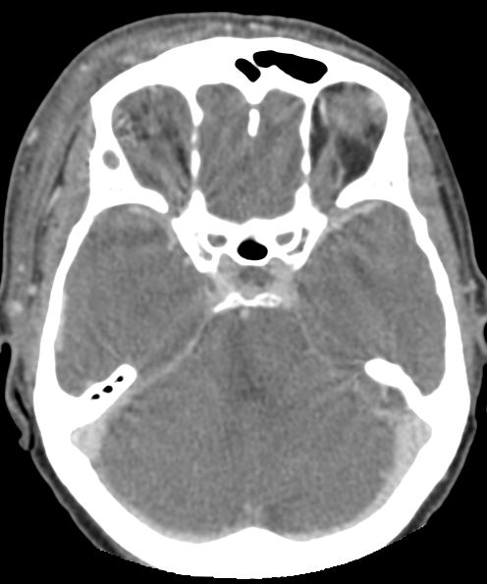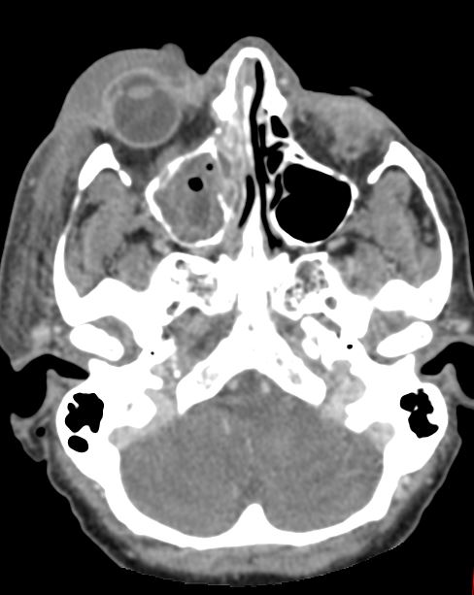

B

**Fig. A** – X-ray, semiaxial view, fluid-level in the right frontal sinus (**black arrow**), image of acute sinusitis

**Fig. B** - **CT** of orbits after contrast administration , extensive periorbital oedema right (white arrow), swelling of intraorbital fat on the right (dense structures intraorbitally; black arrow) and swelling of orbital muscles – orbitocellulitis and maxillar sinusitis on the right

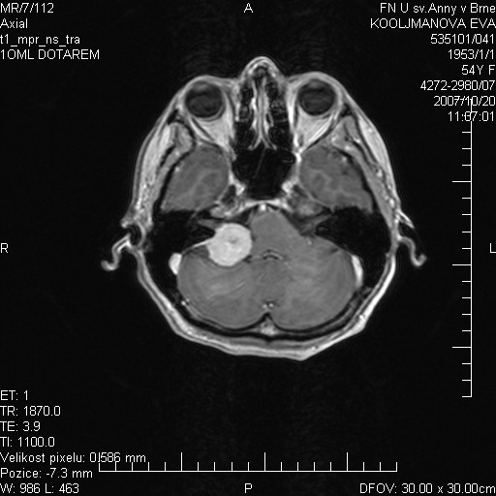

C

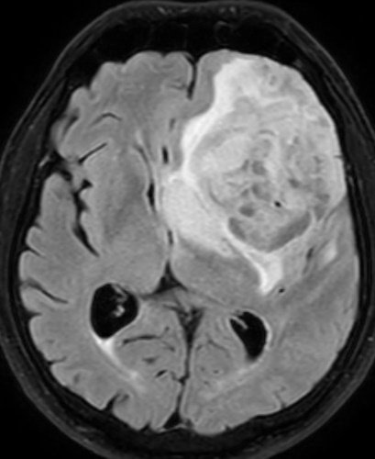

D

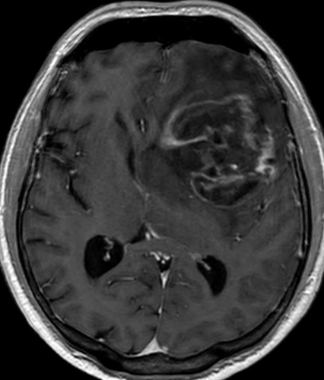

E

**Fig. C** - **MRI**, T1 weighted image after contrast adminitration, meningioma in posterior cranial fossa near petrous part of temporal bone (**white arrow**), homogenoust contrast enhancement, enhancement of adjacent dura mater

**Fig. D** - **MRI** T2 flair – inhomogenous tumor surrounded with vasogenic oedema in the left frontal lobe (hypersignal – white) causing contralateral shift of midline structures (histologically confirmed glioblastoma)

**Fig. E** - **MRI** T1 after contrast administration – central necrosis and enhancing peripheral parts of a tumor, typical for high-grade gliomas, identical patient as in Fig. D