12. Shortness of breath

Shortness of breath (dyspnea) is described as an intense tightening in the chest, air hunger, difficulty breathing, breathlessness or a feeling of suffocation. It is a subjective symptom of many diseases. The causes of shortness of breath can be various, but most often pulmonary or cardiac.
The main causes of pulmonary or cardiac dyspnea include heart congestion, pulmonary embolism, emphysema, atelectasis, pneumothorax and interstitial lung processes.
The basic imaging method in the diagnosis of dyspnea that follows clinical examination is a chest X- ray. It is used to evaluate heart congestion, fluid effusions, atelectasis, pneumothorax, and a rough assessment of interstitial lung processes.
Only if there is a clinical suspicion of pulmonary embolization, the CT angiography (with intravenous contrast), perfusion lung scintigraphy or echocardiography are imaging methods of choice.
If interstitial lung disease or pulmonary emphysema are suspected or there is uncertain finding on chest X-ray, high-resolution CT (HRCT) of the chest is recommended. HRCT allows detailed assessment of pulmonary parenchyma. Non-contrast CT is usually sufficient to assess interstitial changes.

Heart congestion
Heart congestion is the result of insufficient cardiac output due to heart failure or fluid overload. The most common cause of heart congestion is left heart failure with increased pressure in pulmonary veins and capillaries. On chest X- ray can be distinguished 3 degrees of heart congestion.
Note: Right-sided heart failure most often occurs in long-term left-sided heart failure or lung disease, which leads to high pulmonary artery resistance (various etiologies of pulmonary hypertension, e.g. advanced COPD). If it is not the result of left heart failure, then there is no congestion in the small circulation.
Ist degree of heart congestion is sometimes called redistribution, hyperemia, venostasis. When the pressure in the pulmonary veins increases, the blood vessels dilate in the cranial parts of the lungs. This cannot be assessed in the supine image, where the apicocaudal gradient of blood distribution is not visible (Fig. 1).
Note .: In erect position, in a normal state due to gravity, the blood vessels in the upper fields are narrowest and in the lower fields the widest. In supine position the gravitational gradient of blood distribution is ventrodorsal. The pathological distribution of blood, especially in the supine position, is therefore very difficult to assess without comparison with previous documentation. The evaluation of the 1st degree of heart failure is very subjective.
IInd degree: Interstitial edema or accumulation of fluid in the interstitium. Typical are blurred contours of blood vessels (the reason of blurring is the fluid in the interstitium in the vicinity of blood vessels), which are visible to the periphery, centrally are enlarged hyperemic hila (Fig. 2). Kerley lines are present (fluid in interstitium), fluid enters the pleural cavity from the interstitial spaces – fluid effusion.
Note: Kerley B-lines correspond to thickened interlobular septa (on X-rays are best seen in subpleural are of the lung bases), they can occur not only during congestion (thickening due to fluid), but also in interstitial lung disease (thickening due to the presence of inflammatory cells, connective tissue, and also tumor cells in carcinomatous lymphangiopathy).
IIIrd degree: Alveolar edema. The most severe form of heart congestion. With a further increase in pressure in the pulmonary veins, fluid enters not only the interstitium, but also the alveoli. This manifests as lung opacification with mostly symmetrical perihilar distribution – batwing pattern (Fig. 3).
Note: Alveolar edema is a consolidation of the lung parenchyma in a broader sense (i.e. the air in the alveoli is replaced by something else - in alveolar edema with fluid). Therefore, the suspicion of alveolar edema of cardiac etiology is mentioned in X-rays only if other signs of congestion are present and the image is symmetrical.
As many as 1/3 of patients with heart congestion have fluid present in the pleural cavity, often bilaterally. In congestion or pulmonary edema caused by left heart failure, there is also dilation of the heart shadow.

Pulmonary embolization
Pulmonary embolization is a part of thromboembolic disease, the most common source of emboli is the deep veins of the lower limbs, in women possibly also the pelvic veins. Chest X-ray is often negative or with a non-specific finding.
Direct and indirect signs of pulmonary embolism can also be observed on X-ray (regional oligemia, image of lung infarction, dilated pulmonary artery, effusion, etc.). Due to low sensitivity of chest X-ray (approx. 10-20%), the attempt to rule out pulmonary embolism only on the basis of a chest X-ray is now a non lege-artis procedure.
In case of clinical suspicion of embolization and elevation of D-dimers (above 0.5 mg / l), CT angiography is indicated for the detection of embolism. CT angiography is the basic imaging method in acute cases. It reliably detects emboli in major pulmonary trunks, segmental and sometimes subsegmental branches. The embolus is displayed as a defect of contrast filling of the pulmonary arteries (Fig. 4). Scintigraphy is used to a limited extent due to its low availability (usually not available 24hours/day, must be available radiopharmaceutical). Scintigraphy is the method of choice in patients allergic to iodine, with impaired renal function or in the absence of venous access, it is also indicated in patients with a normal chest X-ray (on the contrary, in case of pathological chest X-ray, pulmonary angiography is preferred).

Pulmonary emphysema
Pulmonary emphysema is an irreversible enlargement of airspaces distal to the terminal bronchioles and the destruction of the alveolar walls. In advanced emphysema, on chest X-ray will be visible an increased transparency of the lungs, a low-positioned and flattened diaphragm, and a relative accentuation on the hila (Fig. 5). In most cases, however, it can be diagnosed only with HRCT (Fig. 6). HRCT allows to distinguish between individual types of emphysema (centrilobular, paraseptal, bullous and paracicatrical).

Atelectasis
Atelectasis refers to collapse or incomplete expansion of pulmonary parenchyma, leading to a reduction in lung volume. The cause is usually obstruction of the bronchus (e.g. by a tumor or mucus plug) or compression from the outside, most often by effusion, then it is called compressive. On chest X-ray there is a homogeneous mostly wedge-shaped opacification (Fig. 7 and 8). Larger atelectasis can be accompanied by a shift of the mediastinum and hilum towards the atelectasis and a higher position of the diaphragm on the affected side. Infections, so-called post-obstructive pneumonias, often occur behind obstruction.

Pneumothorax
Pneumothorax is abnormal collection of air in the pleural cavity most often in caused by chest injuries (especially in fractures of the ribs), less often iatrogenic (e.g. after the insertion of a central venous catheter or after pleural punctures). The combination of air and fluid in the pleural cavity is called pneumofluidothorax. The basic imaging method is chest X-ray. On chest X-ray pneumothorax is represented by a thin line along the chest wall, peripherally of this line are no vessels and there is high transparency (Figs. 9 and 10). In supine images, a smaller pneumothorax located ventrally may not be visible. Tension pneumothorax is a condition in which, due to the valve mechanism, air enters the pleural cavity during inhalation and does not escape when exhaled, the pressure in the pleural cavity rises , the mediastinum is moved contralaterally, the diaphragm on the affected side is low, the solution is urgent drainage. Pneumofluidothorax is represented by a fluid level in an upright chest X-ray.
There is a negative pressure in the intact pleural cavity, so the fluid rises along the chest wall and never forms a horizontal "fluid-level." In pneumofluidothorax, this low pressure is abolished, and therefore a horizontal "fluid-level" is created at the fluid-air interface.

Interstitial lung processes
Interstitial lung processes affect the pulmonary interstitium. It is a group of diseases of various causes (e.g. infectious, inhalation) and includes a wide group of interstitial pneumonias, pulmonary fibrosis, sarcoidosis, and pneumoconiosis. From imaging methods, we use chest X-rays (Fig. 11) and especially HRCT (Fig. 12). HRCT allows us to best assess the type of lung parenchyma involvement. The basic pathologies described on HRCT include ground glass opacities, bronchiectasis (excessive enlargement of the bronchi) or honeycombing (functional lung parenchyma is replaced by non-functional cysts).
The ground glass opacities is a descriptive term describing the higher density of the lung parenchyma with still readable bronchial and vascular markings (i.e. the density is higher than usual, but not enough to obscure the blood vessels and bronchi). In consolidations (replacement of air in the alveoli with pathological content), the vascular and bronchial pattern is usually obscured.

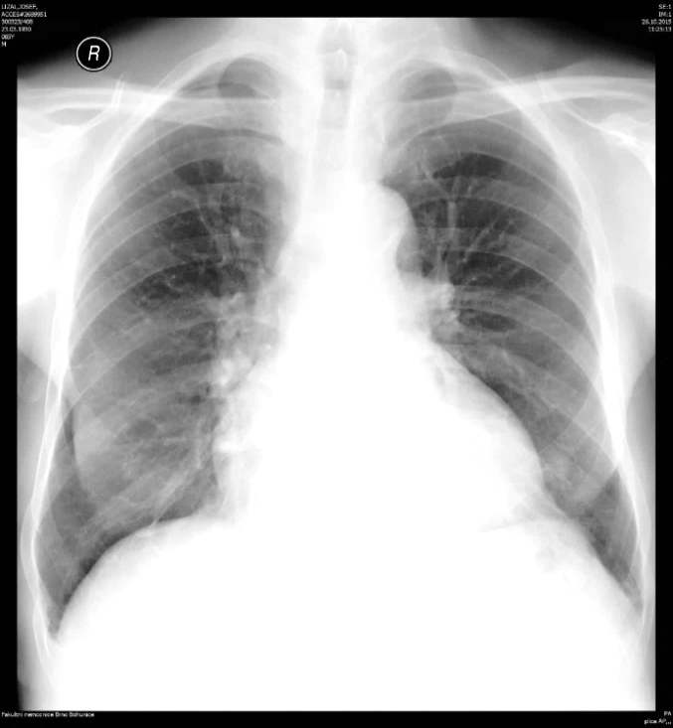
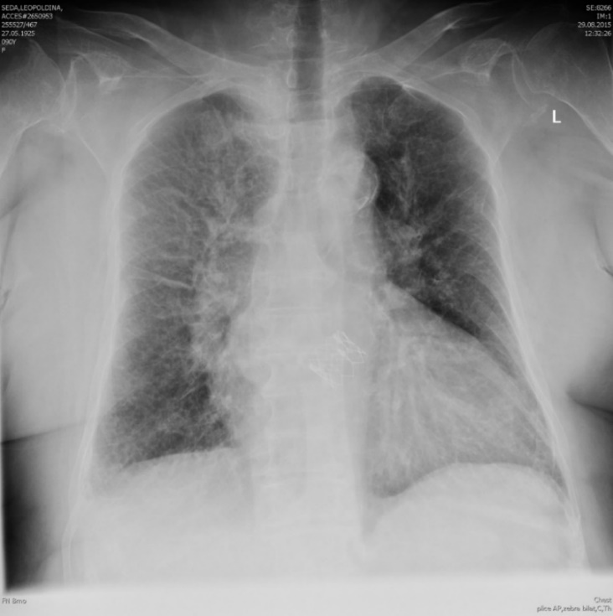
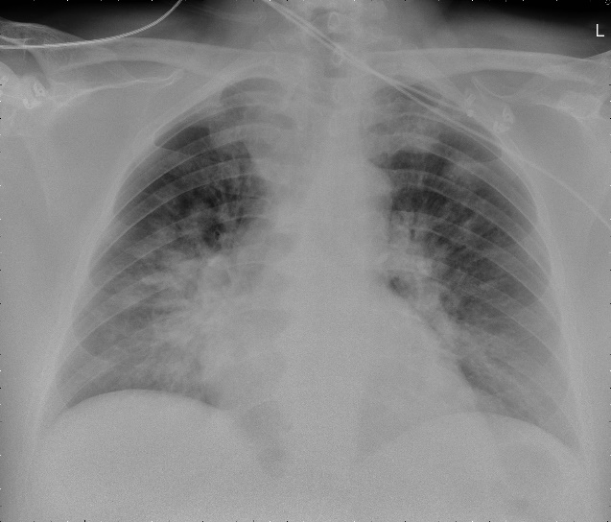
Fig. A - Chest X-ray, upright, heart congestion 1st degree, increased size of upper lobe vessels due to blood redistribution, dilated heart shadow.
Fig. B - Chest X-ray, supine, interstitial lung edema, 2nd degree of heart congestion, blurred contours of prominent vessels, hyperemic hila.
Fig. C - Chest X-ray, supine, alveolar edema. Lung opacification in a batwing pattern (perihilar region).
A
B
C
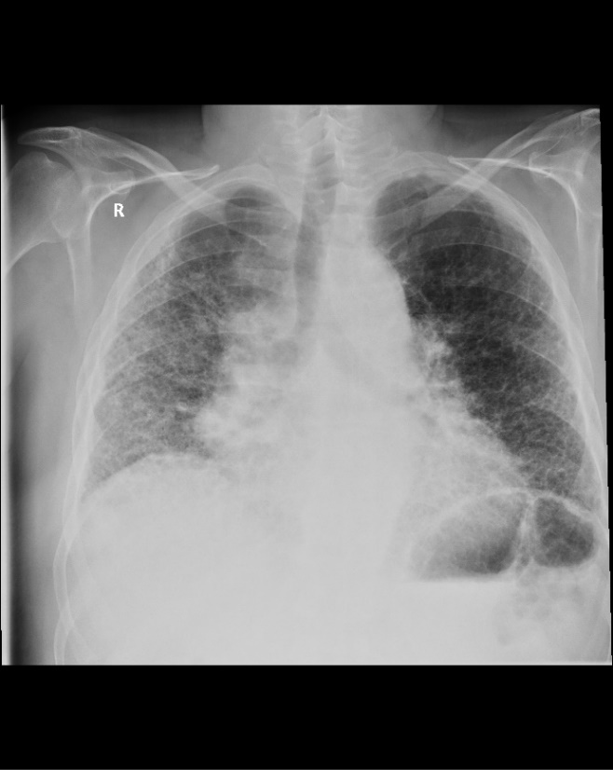
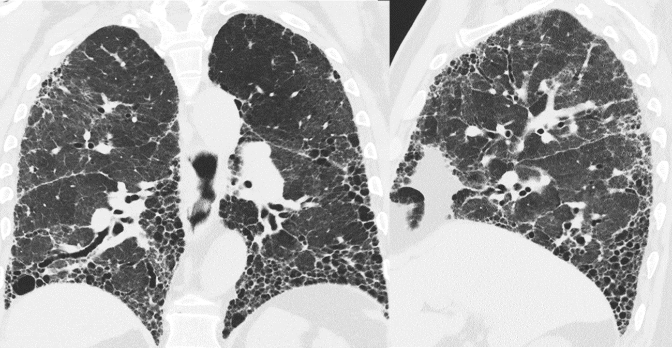
D
Fig. D – Chest X-ray, upright, patient with idiopathic lung fibrosis, reticulonodular interstitial pattern
Fig. E - HRCT of the chest, coronal plane. Advanced lung disease in patient witch idiopathic lung fibrosis, bronchiectasis, honeycombing.
E
Fig. F - CT- angiography, axial plane, filling defect occluding the left pulmonary artery (white arrow).
F

