1. Name the main parts of teeth and dental tissues in the picture below:

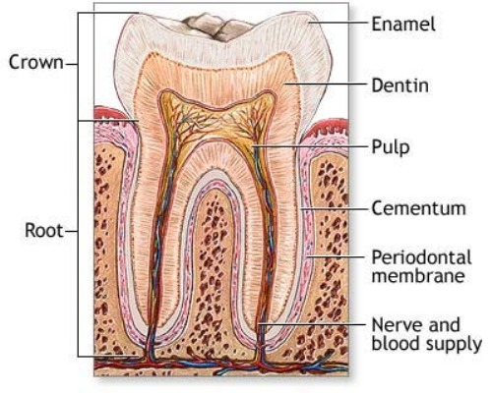

2. Write down all possible symbols of

Upper canine left

First upper (maxillary) molar right

Second lower (mandibulary) incisor left

3. Name the teeth:

+4

4 -

16

27

6-

7+

4. Gypsum is

- calcium sulphate
- calcium sulphate dihydrate
- calcium sulphate hemihydrate

5. Describe the mechanism of setting of gypsum.

6. The setting time of gypsum influence
- spatulation
- temperature of water
- both

7. Dental caries
a) is caused by microbs on oral mucosa
b) is caused by microbs producing acids from sugar, these microbs are in dental biofilm
c) microbs do not play a key role, the most important thing is sugar uptake

8. Class II. acc to Black is

- pit and fissure caries
- caries on proximal surfaces premolars and molars
- caries in cervical srea

9. Habitually clean areas are:

10. Principle of setting of composites is

- polymerization
- acid-base reaction
- crystallization

11. Principle of connection berween hard dental tissues and glassionomer is

- micromechanical
- macromechanical
- chemical

12. The material of the firs choice for clas II. acc to Black is

- amalgam
- glassionomer
- composite

13. The gear of the blue coded handpiece is

- 1:5 to fast
- 1:1
- 2,7 :1 to slow

14. Red coded diamond bur is
- extra coarse
- coarse
- standard
- fine

15. Tick temporary filling materials:

Glassionomer cement, guttapercha, zinkoxidphosphate cement, composite, zinkoxideugenol cement, amalgam, wax.

15. Conditioning is a step by

- making amalgam filling
- composite filling
- glassionomer filling

16. Enamel contains

- 70% inorganic substances, 20% organic substances, 10% water
- 98% inorganic substances, 2 % organic substances and water
- 50% Hydroxylapatit and 50% keratin

17. Zinkoxieugenol cement is

- a temporary filling material only
- a permanent filling material
a temporary filling material, it can be used also for root canal filling in deciduous teeth

18. Main components of composites are

a) organic matrix (Bowen’s monomer and other dimetacrylates) and inorganic filler (aluminiumsilicate glass, silica particles and others) bonded together with a silane
b) dimethacrylate resin with addition of inorganic particles without any chemical bonding
c) methylmatecrylate mixed with silica particles

19. The most suitable material for the V. class cavity which si situated out of enamel is

a) composite
b) glasionomer
c) amalgam

20. When and why do we use a conditioner?

21. How thick must be the amalgam filling on the occlusal surface?

22. What is PBI index?

23. What does it mean extension for prevention?

24. What is recurrent caries?

25. Which instruments do we use for excavation of carious dentin?

