- Following pictures show one tooth.
Write down the name of this tooth using three possible symbols
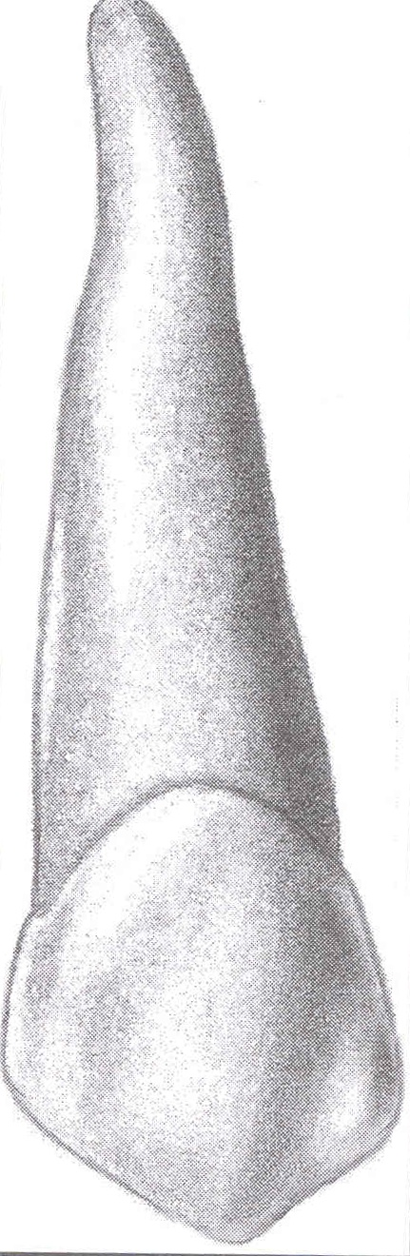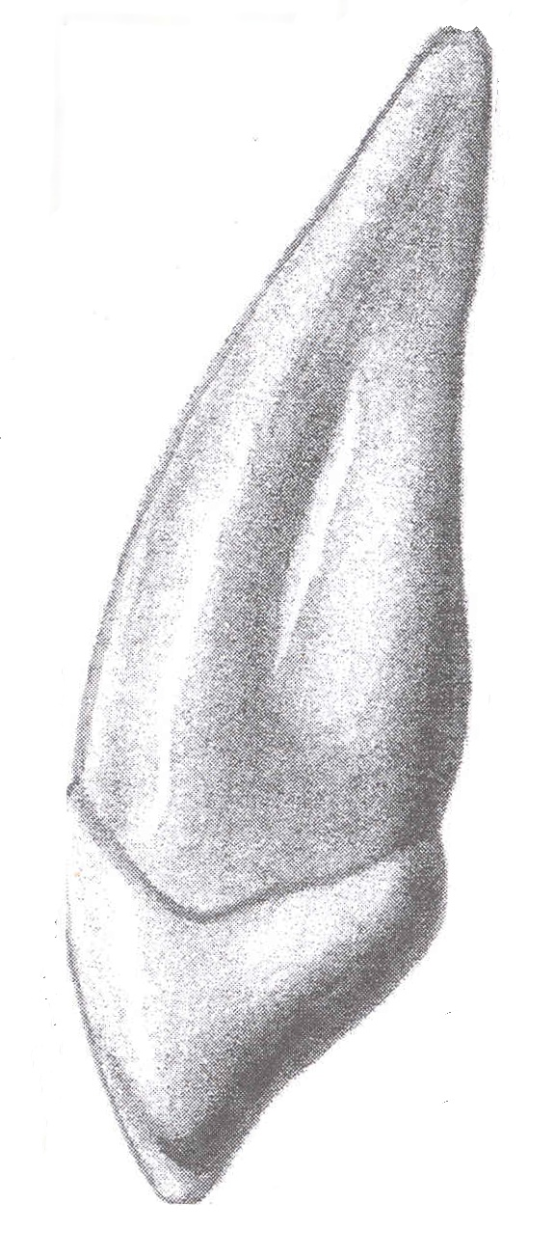

- Describe typical signs of deciduous dentition

- Enamel contains

- 70% inorganic substances, 20% organic substances, 10% water
- 98% inorganic substances, 2% organic substances and water
- 50% Hydroxylapatit and 50% keratin

- Treatment of the cavitated caries lesion

- is based on intensive fluoridation
- is based on preparation and filling
- depends on lost of minerals

5. According to its history dental caries can be

a) superficialis, media and pulpae proxima
b) penetrating or undermining
c) acute or chronic

6. Habitual clean areas (places) are:

7. Tick the temporary filling materials

Wax, composites, zinoxideugenol cement, zinkoxidphosphate cement, amalgam, guttapercha, gypsum, glasionomers.

8. Glassionomer cement is

- a temporary filling material only
- a permanent filling material
- a temporary filling material, a material for base, luting material and sometimes also a
root canal filling material.

9. The most suitable material for the V. class cavity which si situated out of enamel is

a) composite
b) glassionomer
c) amalgam

10. Maximum rpm in electromotors is

a) 40.000
b) 400.000
c) 160.0000

11. Main components of composites are

a) organic matrix (Bowen’s monomer and other dimetacrylates) and inorganic filler (aluminiumsilicate glass, silica particles and others) bonded together with a silane
b) dimethacrylate resin with addition of inorganic particles without any chemical bonding
c) methylmatecrylate mixed with silica particles

12. For which fillings (classes) is necessary to use the matrix band?

13. Square is a symbol for

- H-file
- K-File
- Reamer

14. Describe the technique of circumferential filing:

15. Infiltration anaesthesia is suitable for

a) all maxillary teeth
b) lower anterior teeth
c) lower molars

16. Instruments for extractions are:

17. Asepsis is a procedure

- of killing of all pathogens
- which does not allow any microbs penetrete into the operation field
- cold sterilization

18. Class II. according to Voldřich is

- a dental arch with gaps
- a reduced dental arch
- a reduced dental arch with gaps

19. Biological factor is

a) comprehension of factors influencing the quality of the abutment tooth
b) the periodontal status of the abutment tooth
c) the quality of the endodontic treatment of abutment teeth

20. Premolars are pilots

- class 1
- class 2
- class 3

21. Casting model is

- made of an investment material
- of a special casting material
- of a wax

22. Major connector

- a part of the metal framework for the transmission of occlusal forces
- a part of the clasp made of wire
- a part of the metal framework for its retention

23.The parts of removable denture Class II. are

- metal framework, arteficial teeth teeth and acrylic base
- abutments, pontic and clasps
- abutments and pontics

24. The direct method of fabrication of dentures

- requires taking of impressions
- can be done without any impression
- is suitable for removable dentures

25. The instrument in the picture below is

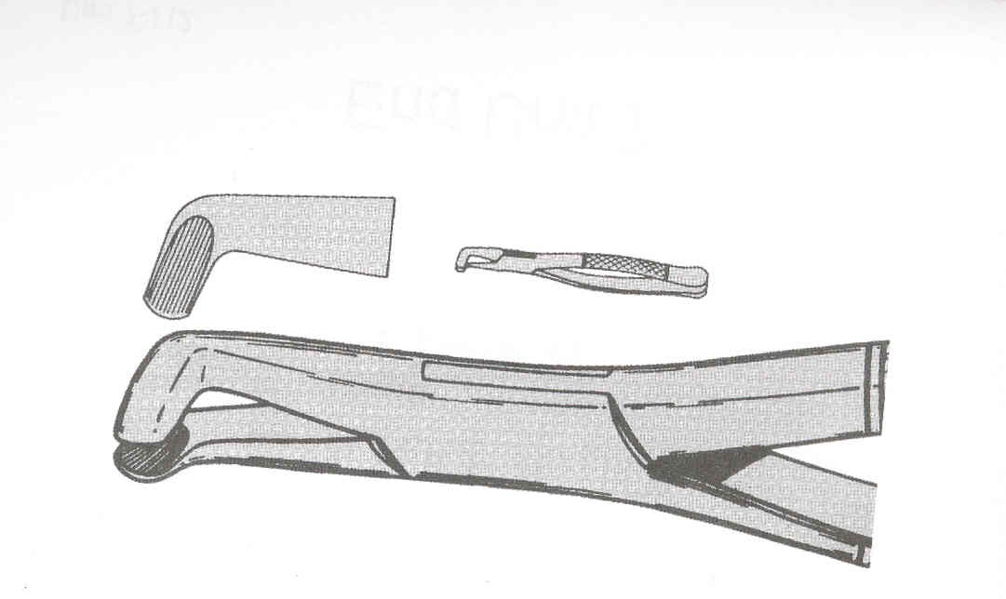

- extraction forceps – for maxillary molars
- extraction forceps for mandibulary molars
- special forceps for third mandibulary molars

