UNIT 8 and 10 Vocab Puzzle
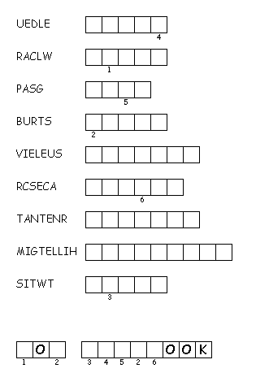
Unscramble each of the clue words.
Copy the letters in the numbered cells to other cells with the same number.

clues…. avoid, move on all fours, deep breath, explode, sneaky, rare, participant, famous, variant, sometimes bastard. all of the clues are in order

answers backwards….. twist.limelight.entrant.scarce.elusive.burst.gasp.crawl.elude

