File 7C
1 Vocabulary and speaking
2 Grammar
a
b
d
3 Pronunciation
b
5 Reading
b
c
d
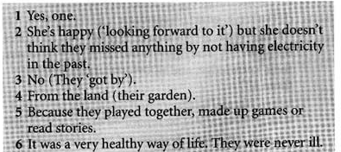
e
6 Listening
a
b

