BELGIAN COLONIAL EDUCATION POLICY:
A POOR FOUNDATION FOR STABILITY
JESSICA ACHBERGER
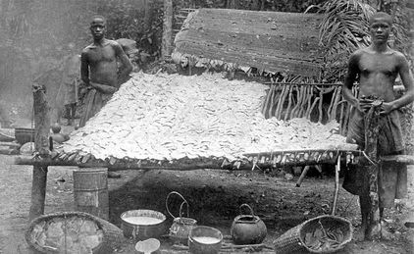
Workers stand next to drying rubber, Belgian Congo.
Often African nations are described as unstable. There is a great deal of truth in this statement as almost all post-colonial African nations have experienced political violence and severe economic mismanagement during the mid and late twentieth century.
Of all African nations, the Democratic Republic of Congo (DRC) has had an especially tumultuous post-colonial experience. Formerly a Belgian colony, the DRC still faces violence in the eastern portion of the country as well as political, economic, and social instability throughout.
There are many historical reasons for the DRC’s instability but Belgian colonial education policies are a key cause of this instability.
In 1884-1885, the Berlin West Africa Conference effectively divided up the African continent amongst the Great Powers of Europe. Attended by the colonial powers of Great Britain, France, Spain, Portugal, Germany, and Belgium, among others, the Conference created artificial state boundaries as well as a colonial system that was in effect for the next sixty years.
Among these territories, the Congo was a unique case. Granted to King Leopold II of Belgium, the Congo was a “personal” concession for the King, rather than a colony. The King, not the Belgian government, effectively owned and controlled the Congo. Leopold administered the Congo in a notoriously brutal manner, using it to augment his own personal wealth. The Congo’s wealth, which included its numerous rubber trees, was brutally extracted using what was basically slave labour. This rubber was then exported to fuel the industrial growth of both nineteenth- and early twentieth-century Europe and America.
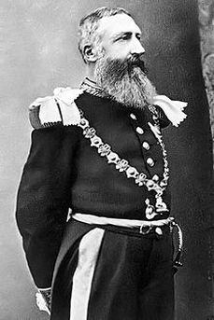
Figure 1King Leopold II of Belgium, as a Garter Knight.
Despite his growing reliance on the wealth of the Congo, Leopold never visited this territory himself. By 1908, the territory was so poorly managed that an international furor condemning Leopold had erupted. That same year, in an attempt to stem this furor, the Congo was ceded to Belgium and placed under the control of the Belgian government, not its king. Belgium then administered the Congo as a colony until independence in 1960.
Unlike other early twentieth-century colonial powers in Africa, Belgium did not directly oversee the education of the Congo’s indigenous population. Rather, it turned the responsibility for education over to missionaries.
In 1908, the Congo had 587 missionaries, mostly Catholic, who educated only 46,075 students, a very small fraction of the many residents. This small number of students stemmed from many factors. The number of missionaries was insufficient to educate a large population. But the missionary’s educational agenda, which often undermined indigenous African culture and promoted colonial domination, also deterred many Africans from pursuing European educations.
Throughout the late nineteenth and early twentieth centuries, the primary role of the Church, both in religion and education, was to promote colonialism. Many Congolese villagers at first avoided the mission schools because they had a religious agenda that threatened to undermine their cultural values and beliefs.
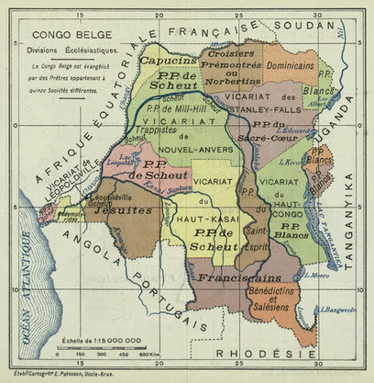
Map of Church Mission areas in the Belgian Congo, Hippolyte d'Ursel.
Along with concerns about the type of education the Congolese should receive, the Church also believed that higher education should be reserved only for those entering the priesthood. As a result, most students who did attend school in the Congo received only a basic primary education. This practice was reinforced by the Belgian colonial administration, which discouraged higher education for Africans. It was only in 1954 that the first Congolese citizen was admitted to a university for purposes other than religious education.
Belgian colonial education policy stood in stark contrast to the colonial educational policies of Britain and France. While government policies that discouraged the educational and vocational promotion of African peoples were a characteristic of every early twentieth-century colonial system, both Britain and France sent numerous missionaries to their colonies. These missionaries often founded schools and created educational programs for the communities that they worked in. But the British and French governments, unlike Belgium, also took strong control over the education of their colonial subjects.
With the Congo, Belgium not only took a less active role in education, it also used Catholic missionaries as a form of civil servants who were paid by the government. Ironically, Belgium’s hands-off policy toward education, which was characteristic of Belgian colonial policies overall, reflected the government’s reluctance in being a colonial power; the government had only agreed to take over the Congo to save its king from the public humiliation and outcry of the international community which had been horrified by Leopold’s brutal policies.
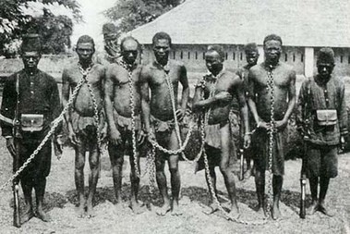
Chained Congolese slaves on a Belgian Rubber Plantation.
By the eve of Congolese independence in June 1960, the aspiring nation had only sixteen African university graduates out of a population of more than thirteen million. There were no Congolese engineers or physicians.
Perhaps most crucially, the lack of centralized education left the new nation in a stunted state of growth. Across the African continent, educated Africans had often played a key role in the independence movements and these leaders had then stepped in to govern the new nations which emerged in the 1960s. In many of these new African states, a uniform educational system had helped to promote national unity and identity---both of which were desperately needed as the colonial map had created artificially constructed nations that had numerous different and even competing ethnic groups.
In the Congo, educated Africans who could serve to unify the nation were basically non-existent. This was unfortunate because the Congo, as the third largest country in Africa, was home to many distinct ethnic groups and possessed incredible wealth in its natural resources. While post-colonial African nations needed to establish and create a national identity in the wake of colonialism and although all of these nations required an educated citizenry, the absence of these in the ethnically diverse Congo contributed greatly to its instability in the decades that followed.
No one single factor can be said to have caused the Congo’s road to independence to be a rocky one but the lack of educational opportunities for the Congolese when they were the colonial subjects of Belgium was clearly a central factor in the new country’s instability.

This article was taken from: http://www.ultimatehistoryproject.com/belgian-congo.html

