How did it come to be Sir and Miss?
http://www.bbc.com/news/blogs-magazine-monitor-27407789
14 May 2014 Last updated at 13:29 GMT
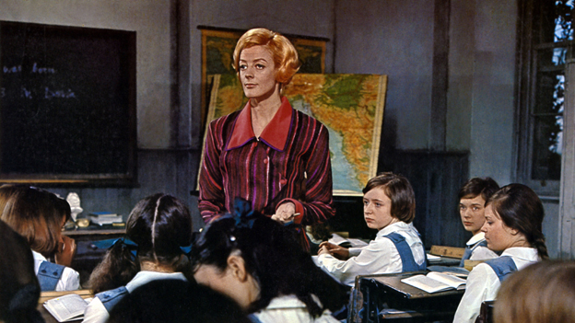
Calling teachers "Sir" or "Miss" is sexist, an academic has said. But why did these terms become the norm in British schools?
"Sir is a knight... but Miss is ridiculous - it doesn't match Sir at all," wrote Prof Jennifer Coates, emeritus professor of English language and linguistics at the University of Roehampton. But how did these terms catch on?
There are no clear answers. But it seems that "Sir" took hold in the public schools of two or more centuries ago. It was common for boys in upper class families to call their fathers "Sir". "Sir" also became the default term of respect for male authority figures, including teachers, in an age of deference. Grammar schools "aped" the tone of boarding schools, says Dr William Richardson, general secretary at the Headmaster's Conference - the group representing independent schools. And "Sir" soon spread from private to grammar, and eventually into the wider state system. The equivalent term of deference for a woman at this time was "Ma'am". But few schools use this, although a school in Runcorn has used "Madam".
The answer
- Sir may stem from public schools of 19th Century
- Miss probably used because women teachers were not allowed to marry up until 1944
"Miss" is a different story. Until the 1944 Education Act, women teachers could not marry and remain in post. Teaching had been seen as incompatible with a wife's domestic duties. When a female teacher tried to overturn the law in 1925, the Court of Appeal ruled against her: "It is unfair to the large number of young unmarried teachers seeking situations that the positions should be occupied by married women, who presumably have husbands capable of maintaining them." So before the marriage bar was lifted, "Miss" was always going to be accurate. Although the fact male teachers were not "Mr" gives credence to the idea that female teachers had second-class status.
Some British schools prefer a more egalitarian tone with first names being used. This is standard practice in Sweden. Meanwhile in France there is parity between men and women - maitre and maitresse at primary level, monsieur or madame above that. In many UK schools today, teachers are called by their name, such as Mr Jones or Mrs Jones. But in some, a woman teacher - even one who is married - continues to be referred to as "Miss". In many private schools there is a different kind of disparity. While male teachers are always known as "Sir", female teachers are called by their name - "Mrs Jones", for instance.

