St. David´s Day

When is St. David's Day?
The national day of Wales is St David's Day and is always observed on 1 March..

History of St. David's Day
Saint David (known as Dewi Sant in the Welsh language) was a Celtic monk born towards the end of the fifth century and was Archbishop of Wales. He spread the word of Christianity across Wales, founding 11 churches across Wales and Brittany. His influence is shown by the number of churches dedicated to him in Wales.
It is always observed on March 1, as the tradition is that he died on that day in 589 AD.

How is St. David's Day celebrated?
In 2000, the National Assembly for Wales voted unanimously to make St. David's Day a public holiday. Every year parades are held in Wales to commemorate St. David. The largest of these is held in Cardiff.
On St. David's day, Welsh people may wear one or both of the national emblems of Wales on their lapel - the daffodil or the leek on this day. The tradition of wearing a leek is said to have arisen when a unit of Welsh soldiers were able to distinguish each other from troops of similarly attired English enemy soldiers by wearing leeks.

St. Patric´s Day 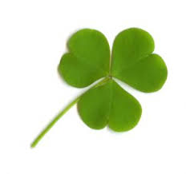

St. Patrick's Day is celebrated on 17 March as a holiday in the Republic of Ireland and a bank holiday in Northern Ireland. If 17 March falls on a weekend, the following Monday will be a holiday in both countries.

History of St. Patrick's Day
St. Patrick, the patron saint of Ireland, is a widely known historic figure and arguably the most famous patron saint of a country.
Patrick proved himself to be quite adept at winning converts to Christianity. So much so, that he upset the local Celtic Druids. In fact, he was arrested on several occasions, but managed to escape each time. He journeyed extensively across Ireland, establishing monasteries in several locations. In addition, he also set up churches and schools, all of which created the foundations for the whole of Ireland to eventually be converted to Christianity.
His missionary work in Ireland continued for thirty years. After that, Patrick retired to County Down in North Eastern Ireland. Patrick died on 17 March in 461AD.
Much Irish folklore surrounds St. Patrick's Day, Some of this lore includes Patrick healing the sick, and raising the dead. He is said to have given a sermon from a hilltop that drove all the snakes from Ireland. No snakes are known to have existed in Ireland at least since the end of the ice age. Some scholars think the driving away of the snakes may have been a metaphor for the conversion of the pagans.
A more plausible story attributed to Patrick is how he used the Shamrock, a three-leaved clover, to explain the Trinity. In his sermons he would use it to represent how the Father, the Son, and the Holy Spirit could be separate elements of the same entity.
Today, St. Patrick's Day is a day to recognise Irish heritage and celebrated by people of all backgrounds in many parts of the world, such as the United States, Canada, and Australia.
St. Patrick's Day became an official public holiday in Ireland in 1903.

St. George´s Day 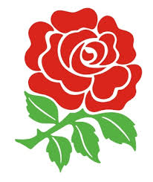

George's Day is England's National Day.It is celebrated annually on 23 April, as this is the generally accepted date of St. George's death.

Who was St. George?
St. George was a cavalryman in the Roman army at Lydda, now in modern-day Israel. He was a Christian at a time when Rome was ruled by the emperor Diocletian, who was anti-Christian. He refused to make sacrifices to the Roman gods. As a result, he was tortured over several years and eventually suffered a martyr's death, when he was beheaded in 303 AD.

The Dragon Slayer
Nowadays, it's not George's martyrdom that propelled him to popularity, but the tales of his heroism in slaying dragons and rescuing maidens.One version of the tale describes a dragon that would come from the sea to terrorise a nearby town. The locals offered animals each day to keep the monster from attacking further. When they ran out of animals, they became more desperate and started sacrificing humans. One day a princess was selected and about to be taken by the Dragon. Just as it was looking like the princesses fate was about to be sealed, St. George rode in on a white horse, and drove a lance down the throat of the beast. The dragon killer legends have been said to symbolize the victory of Christianity over paganism.
To mark the day, the Queen will announce new appointments to the Order of the Garter on St. George's Day.
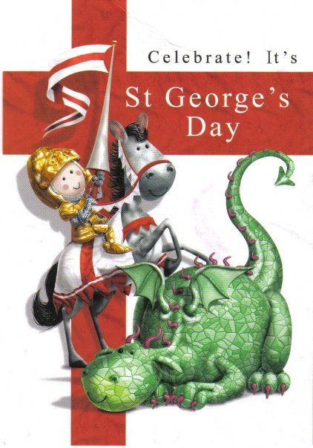

St. Andrew´s Day

The day is celebrated annually on 30 November, as this is the generally accepted date of St. Andrew’s death.
St Andrew was one of the Twelve disciples of Jesus (Apostles) and was originally a fisherman like his brother, St Peter. It is believed that Andrew died on a diagonally transversed cross which the Romans sometimes used for executions and which, therefore, came to be called St Andrews cross.

St. Andrew's Day in Scotland
St. Andrew's Day is Scotland’s National Day. In 2006, the Scottish Parliament designated St. Andrew's Day as an official bank holiday, but banks are not required to close and it is left to employers to decide whether to give their staff a day off.
If 30 November falls on a weekend, the next Monday is a bank holiday instead.
St Andrew's Day is marked with a celebration of Scottish culture with traditional Scottish food, music and dance. Schools across Scotland hold special St Andrew's Day events and activities including art shows, Scottish country dancing, lunchtime ceilidhs, dance festivals, storytelling, reciting and writing poems, writing tall tales, cooking traditional Scottish meals, and bagpipe-playing.

