Islam

Islam distinguishes between food that is lawful (Halal) and unlawful (Haram). All this is described in the holy book of Islam – Qur’an.
Muslims are not allowed to eat the meat of swine and animals dedicated to other than Allah. Animals that die of themselves are also forbidden to eat therefore, all animals must be slaughtered under strict rules.
Muslims are also not allowed to drink ethanol or wine. However, it is not a sin to consume any of the forbidden foods if there is a necessity. E.g. If one is starving or dying of thirst.

Judaism

- Jewish dietary laws – Kashrut
- everything must be Kosher

Jewish rules are extremely complex including restrictions on how meat is slaughtered, which animals may be eaten (most famously pork and shellfish are not allowed), the part of the animal that can be eaten, who makes certain foods, combinations of foods (meat and milk), avoiding contamination(utensils), what can be eaten on holidays, and more. Many non-Jewish people prefer foods labelled kosher because they believe them to be cleaner or more strictly prepared.

Forbidden kinds of animals:
- mammals – carnivores, animals that lack cloven hooves (camel, hare, horses)
- birds – scavengers, birds of prey
- all reptiles and amphibians
- water animals – those that do not have both fins and scales

Hinduism

Hinduism is the third most popular world religion and as the other religions, Hinduism has its own eating rules as well. The food is considered a gift from God, therefore it should be treated respectfully. It is a part of God or Brahman, and it nourishes the entire physical, mental, and emotional aspects of a human being.

There are strict rules that must be obeyed:
- beef is strictly forbidden, because cow is sacred and considered Mother in Hinduism
- pork is a strictly forbidden food too
- the Hindu religion believe that violence or pain inflicted on another living thing rebounds on you = karma
- to avoid causing pain to another living thing, vegetarianism is an option, but not compulsory
- alcohol, onions, garlic, and red-coloured foods such as red lentils and tomatoes are also prohibited
- in the Laws of Manu meat is not always forbidden
- fasting in Hinduism depends on a person’s caste or the occasion, e.g. serving food to the poor or a beggar is good karma

Food rituals:
- cleaning the place where the food will be eaten
- sprinkling of water around the food, accompanied by some mantras or prayers
- making an offering of the food, then offering five vital breaths (pranas) – prana, apana, vyuana, udana, and samanaya and then to Brahman seated in the heart

Vegetarianism in Hinduism
Vegetarian diet excludes the meat of animals, but does permit eggs. Vegetarian foods include grains, fruits, vegetables, legumes, and dairy products.
Some people associate vegetarianism with Mohandas K. Gandhi. He was a vegetarian by a conscious ethnical choice, because he believed that one should refrain from being harmful to any person or any living thing, even to animals. He was a strong adherent of this belief.
The practice of a vegetarian diet for Hindus is based on the following reasons:
- Medical grounds – vegetarian diet is easier to digest, provides a wider range of nutrients, and introduces fewer burdens and impurities into the body
- Ecological grounds – Earth is not suffering = no escalating loss of species, no destruction of rain forest to create lands for livestock, no air and water pollution in order to produce meat in the human diet
- Ethnical grounds – mentioned above, related to not harming any living thing
- Religious grounds – the principle of nonviolence, the intention to offer only “pure” vegetarian food to a deity, and nonvegetarian food is detrimental to the mind and spiritual development
- Economical grounds – practices vegetarianism from the philosophical viewpoint, concerning issues such as public health and curbing world starvation
- Cultural grounds – in some castes meat is allowed (excluding beef), e.g. lower-caste people will eat meat, but Brahmins are mostly vegetarians

Mormons

Religious and cult group with centre in Utah, the principal branch of the Latter Day Saint movement of Restorationist Christianity, the Mormons have also strict rules related to food. They are very committed to have good health.

It is prohibited to consume:
- alcohol, including wine and beer
- black tea, green tea, and other caffeinated teas
- iced coffee and iced caffeinated tea
- illegal drugs
- tobacco

Members of the Church of Jesus Christ of Latter-day Saints explain their eating commitment to the cult:
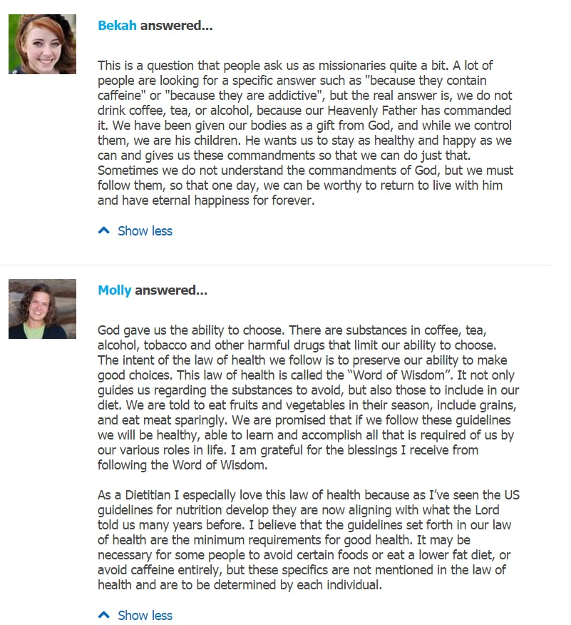

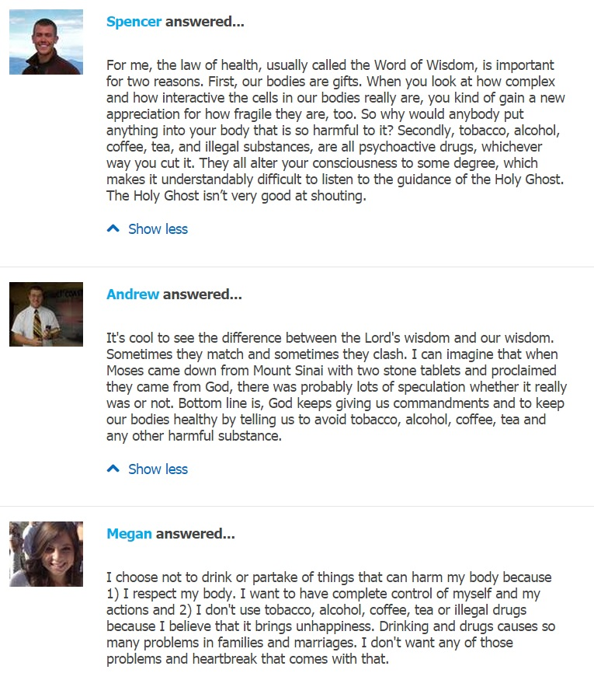

the most important work of the textual tradition of Hinduism
mainly priests and teachers who attain the highest spiritual knowledge

