2 Models of giftedness
There are more models of giftedness but they are not all universally known and accepted by teachers. Three of the best known models of giftedness will be introduced in the following text: Gagné’s Differentiated Model of Giftedness and Talent (DMGT), Renzulli’s “three-ring” model and Tannenbaum’s “sea star” model.

2.1 Gagné’s differentiated model of giftedness
The Gagné model was first published in 1985 and it has gained wide acceptance internationally, because according to experts it is practical, research-based and teacher-friendly. This model underlines that development of giftedness is not automatic and that, unfortunately, many gifted children fail to develop their high ability into high achievement. How mentioned above, Gagné distinguishes giftedness from talent, which is also evident from his model. Gagné defines, as gifted, children or adolescents who have the potential to perform, in some area of human ability, at a level more usually achieved by learners some years older. It defines as talented learners whose achievement or performance is already at this higher level. The model alerts teachers to the further learning needs of learners who are already talented achievers but even more importantly it draws their attention to the needs of gifted underachievers - learners who certainly have high ability but who, for some reason, have not yet been able to translate their potential into performance.
A diagram of Gagné’s Differentiated Model of Giftedness is below (Figure 1). It has three columns, with gifts on the left hand side, talents on the right hand side and catalysts that impact the developmental process in the centre. A child’s gifts are turned into talents through the developmental process. Gifts are divided into two groups: mental (intellectual, creative, social and perceptual) and physical (muscular and motor control). Talents are in the fields of: academic, technical, science and technology, arts, social service, administration/sales, business operations, games, sports and athletics. Gifts are developed into talents through the developmental process. The developmental process, designed to nurture and develop gifts into talents, has six main elements:
1. Enriched curriculum or training program
2. A clear and challenging excellence goal
3. Selective access criteria
4. Systemic and regular practice
5. Regular and objective assessment of progress
6. Personalized accelerated pacing.
The poor development process can be reason, why a gifted child may not become talented. Learners performing at very high levels exhibit innate gifts that if nurtured and developed often lead to the manifest of talent. Gagné’s Differentiated Model of Giftedness shows where the child – and the child’s family – can be influential.
In the centre of the model, between gifts and talents, are the catalysts. Catalysts are the important aspects of the learner’s environment, both external and internal, that impact their development. The developmental process can be influenced through the way catalysts are managed either directly or indirectly by the child’s family; for example, a child’s potential can either be developed or hindered by environmental and intrapersonal catalysts. Nurturing and developing gifts into talents involves a complex, structured program of activities over a period of time and depends on the individual child’s level of giftedness and need.

By placing the child’s learning at the heart of his model, Gagné puts teachers, in the driving seat. Gagné makes it clear that a child’s learning will not progress optimally unless he/she has the ongoing support of the school. Teachers have the opportunity - and the obligation - to identify the abilities of the gifted children in their classes and schools and to assist these young people to develop these high abilities into high achievements.

Further information on Gagné’s Model of Giftedness and Talent can be found at http://gagnefrancoys.wix.com/dmgt-mddt.

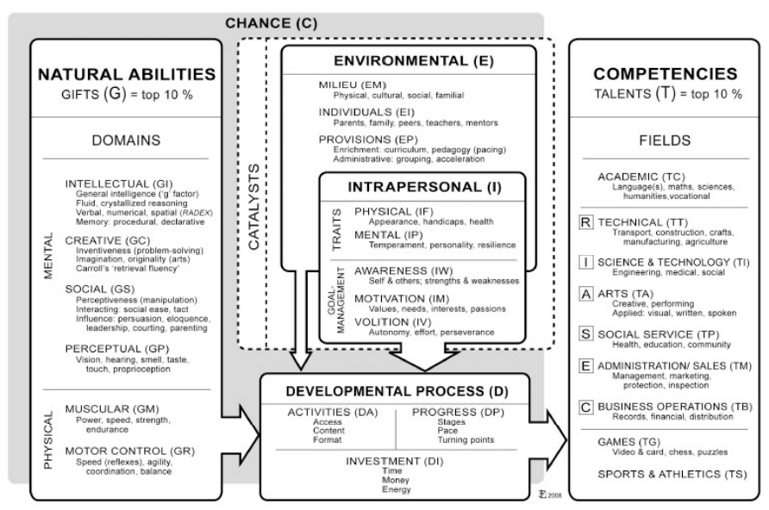

Fifure 1. Gagné’s Differentiated model of giftedness (http://gagnefrancoys.wix.com/dmgt-mddt)

2.2 Renzulli’s “three-ring” model of giftedness
This module was developed in 1975. At the time when Renzulli came to develop his own model the emphasis on the development of science giftedness had gone. Educators were now encouraged to identify and foster all areas of specific academic ability. He wisely affirmed that giftedness was multi-dimensional and could be sited in any area of human ability. However, he placed a new and strong emphasis on the role of creativity and introduced a third factor, which he termed “task commitment” – “perseverance, endurance, hard work, dedicated practice, self-confidence and a belief in one’s ability to carry out important work” (Renzulli, 1986, p. 69). Task commitment is a very specific form of motivation focussed on the task in hand (see Figure 2).

It might appear that this model has the potential for identifying a wider range of children as gifted than does the Gagné model. But it’s not as clear cut as it seems. According to Renzulli’s later writings, when he is talking about ‘above average’ general abilities, he is not referring to the upper 50% of children. He is referring to the top 15- 20% of people in any area of human effort (Renzulli, 1986). That’s not very different from Gagné’s 10-15%.
What is important, Renzulli underlines that none of the three ‘clusters’ of traits mentioned above is by itself sufficient to define a child as gifted. Above average ability isn’t enough by itself, nor is creativity, nor is task commitment. Only the interaction among the three clusters can lead to creative/productive accomplishment (Renzulli, 1987, p. 182).

The strong disadvantage of the Renzulli model is its ambiguity. For teachers in schools it is very difficult according to Renzulli model indentify a giftedness. Maybe the reason is, that according to the Renzulli model, gifted children are ‘those possessing or capable of possessing’ the three clusters of traits - but “potential possession” of motivation or creativity is by no means easy to assess. The premise that gifted children have all three characteristics (ability, creativity and commitment) has been based on observation of successful, creative adults hence the model completely ignores gifted children with great potential who are demotivated and/or underachieving for whatever reason. An added difficulty is Renzulli’s assertion that a child “earns the right” to special services by displaying the above-average ability, high levels of task commitment and high levels of creativity that are the “necessary ingredients” of giftedness (Renzulli & Smith, 1980, p. 10). Should a child have to earn the right to an appropriate education? If it is the interaction between the three “necessary ingredients” that makes giftedness, what about a child who has extraordinary ability but who is seriously demotivated and not performing in the classroom? Equally, what about the child who is very bright, academically successful and highly motivated but who has very little creativity - certainly not the “high levels” prescribed by Renzulli. Are these children gifted or aren’t they?

It needs to remember that Renzulli does not built his model on the characteristics of gifted children but on the characteristics of “creative/productive” adults (three groups of architects studied by MacKinnon in the 1950s). The Renzulli model was developed in the United States at a time when information about underachieving gifted children was not so known. But demotivated, bored gifted children who are required to work, in school, at levels far below their ability are not necessarily task committed. It’s difficult to commit to a task if it doesn’t engage their interest. It’s hard to become excited about engagement in work they was adequate for their capability months or years before.

When we copare the models mentoioned above, Renzulli and Gagné differ in view on talent and gifttedness. Renzulli has described children who are intermittent producers as ‘moving in and out of giftedness’. Gagné would say they are gifted but moving in and out of talent. Renzulli’s ‘three-ring model’ may be most successful in identifying children whom Gagné would call talented; young people who are successful, motivated achievers who have also been able to bring a creative feel - something new - to their work. Perhaps the three-ring model should be seen as a model of something to work towards; the synthesis of high ability, an enthusiastic commitment to work at something that is genuinely worthwhile committing to, and the capacity to contribute to one’s field of talent as well as take from it.

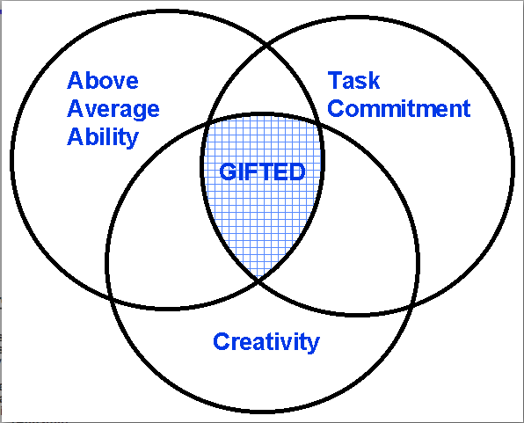

Figure 2. Renzulli’s “three-ring” model of giftedness (Renzulli, 1986, p. 69)

2.3 Tannenbaum’s “sea star” model of giftedness
This model developed by A. Tannenbaum in 1983. Model was described in the book “Gifted children: Psychological and educational perspectives” (Tannenbaum, 1983) which presented one of the best analytical reviews of the research literature in gifted education available at that time. Tannenbaum’s model was solidly grounded in psychological and educational research on the characteristics of gifted individuals. This model aims to identify children and adolescents who have the potential for “becoming critically acclaimed performers or exemplary producers of ideas.” The specificity of this view of giftedness means the model is designed to be fairly restrictive. The model is holistic because it goes beyond identifying general and specific abilities, to include personality attributes and environmental interactions.
Tannenbaum’s model is illustrated in a sea star design (Figure 3). It allows for potential as each arm of the sea star has both a static (child as they are currently) and dynamic (learning/changing) element. This model does not attribute more value to any one area and allows for infinite combinations of each but all five must be present for an area of giftedness to develop. Tannenbaum chose ﬁve internal and external variables that when combined produce giftedness: general ability, special aptitude, no intellective requisites, environmental supports and chance.
Similarly to Renzulli’s model this model aims to the interaction of several variables and all must be present in order to facilitate giftedness. Tannenbaum suggests that while different areas of giftedness may require different combinations of mentioned factors a serious deficiency in any one element cannot be compensated for by the other four factors.
Like Gagné’s Differentiated Model of Giftedness and Talent, which it preceded by only two years, Tannenbaum’s sea star model of giftedness deals with the relationships between ability and achievement – “the links between promise and fulfilment” (Tannenbaum, 1983, p. 95) - and clearly identifies the roles of both the child’s personality and the environment in which he/she is brought up and educated. Unlike the Renzulli’s model, which was derived from the characteristics of creative, productive adult achievers, Tannenbaum’s model is firmly based on the characteristics of highly able children and adolescents.
Tannenbaum (1983, p. 86) states:
“Keeping in mind that developed talent exists only in adults, a proposed definition of giftedness in children is the potential for becoming critically acclaimed performers or exemplary producers of ideas in spheres of activity which enhance the moral, physical, emotional, social, intellectual or aesthetic life of the community.”
Tannenbaum believes that children and adolescents who have the potential to be successful gifted adults not only require the general and specific abilities mentioned in some of the earlier definitions of giftedness, but also must have facilitative personality attributes and some ‘special encounters with the environment’ to foster the emergence of giftedness. The five internal and external variables that ‘mesh into excellence’ are illustrated by mentioned sea star design with giftedness produced by the overlap of all five factors.

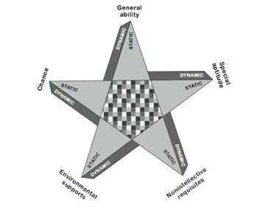

Figure 3. Tannenbaum’s “sea star” model of giftedness (Tannenbaum, 1983)

Tannenbaum explains five internal and external variables in following way (Gross et al, 2005, p.17-18).

General ability
Tannenbaum points out that the “g” factor, or testable general intelligence, features to some degree in all talent areas. He adds, however, that different levels of intellectual ability are required for various kinds of accomplishment. Very high levels of abstract reasoning ability may be required for certain activities - certain areas of academic study, for example – while somewhat lesser degrees may be required for other activities.

Special ability
For an individual to emerge as gifted, his reasoning ability must be anchored in some specific aptitude. As well as the capacity to think well, gifted people must have special capacities and affinities for particular kinds of work. Some special abilities can be identified in children in the very early years; others do not become apparent until much later in childhood.

Non-intellective factors
Ability alone will not produce outstanding accomplishment. Tannenbaum points out that this requires a confluence of various non-intellective facilitators such as motivation, a secure self-concept, the capacity to stay on task, “the willingness to sacrifice short-term satisfactions for the sake of long-term accomplishment”, sound mental health, the desire to show and share one’s talent, and many others.

Environmental factors
Tannenbaum identifies many environmental influences which dictate not only the degree to which the child’s ability will be permitted to develop but even the kinds of talent that a society is willing to honour (or tolerate?) and the amount of investment that the society is willing to make in the cultivation of these talents. These environmental influences include not only the child’s family, peer group, school and community, but also the economic, legal, social and political institutions of the country in which the child is being brought up and educated.

Chance factors
The influence of chance can be crucial to the emergence of an individual’s talent, yet it had not been addressed by previous researchers in gifted education. Chance factors are those entirely unpredictable events in a person’s life which can be critical in permitting exceptional potential to be recognised or encouraged. It may be that the child finds exactly the right teacher at exactly the right stage of her talent development. It may be, on the other hand, that the job market in a young person’s area of talent unexpectedly closes up, so that there is no opportunity for him to fulfil his promise. As Tannenbaum points out, “The unexpected can originate anywhere, in the economy, the social milieu, the workplace, the family, and even within the body itself when there is a sudden change in a person’s health status that can affect a career.”

The Tannenbaum’s model has both static and dynamic elements. Static elements describe the child as she is at the moment - how she stands in comparison to others at a particular stage in time. However, her level of maths, science or reading achievement, her state of health, and her relationships with family or classmates may well change over time. Dynamic elements, therefore, refer, among other things, to the processes of learning and the social and educational processes, which effect the child and which cause, or may lead to, change.

While earlier definitions such as those of DeHaan and Havighurst, Marland, and, to some extent, Renzulli, were, in the main, listings of the traits or constituents of giftedness, Tannenbaum’s model reveals the complex and subtle interweaving of the individual’s general and special abilities with personal and environmental variables, moderated by random factors which can support or defend the overturning of promise into fulfilment.

In later versions of the Tannenbaum’s model (Tannenbaum, 2003) Tannenbaum expands on the characteristics of the two broad types of gifted people he identifies as producers and performers. Producers are people who develop either things or ideas. Performers interpret or recreate these things or ideas. Both producers and performers can operate either creatively (bringing something original or new to the process) or proficiently (operating with high levels of skill). Tannenbaum identifies four main areas of human productivity and proficiency: thoughts and ideas and tangibles (something physical that can be seen, heard, tasted, etc.) which are developed by producers; and staged artistry and human services which are provided by performers.

In the context of Abraham Tannenbaum’s ‘sea star’ model of giftedness it is necessary to have in mind especially (Gross et al, 2005, p.19):
• Firstly, the four categories of activity listed above are not intended as a hierarchy. Tannenbaum does not view any one of the four as more valuable than the others to human society; nor does he rate producers above performers (or vice versa) or creativity above proficiency (or vice versa).

• Secondly, Tannenbaum’s view of giftedness is the potential for adult productivity as either a producer or performer. Very few individuals would completely fulfil their potential in any area, as either a producer or performer, in their childhood or adolescent years. The sea star serves as a guide to the qualities and interventions that the child must possess or experience if her potential is to be translated into performance in later years.
Training questions and tasks:
1. Which model do you believe would be most useful and practical in your school setting?
2. What are the main similarities between the Tannenbaum, Renzulli and Gagné models of giftedness and in what ways do they differ?
3. What are the main criticisms that have been levelled at the Renzulli ‘three-ring’ model of giftedness?

