**Inclusive Education – Distant version**

Note: Please fill following tasks and submit the paper into homework vault (odevzdávárna) in IS till 30th of May, 2020.

**Disability – its definitions according to WHO (1980 till now)**

In 1980 WHO issued the International Classification of Impairment, Disabilties and Handicaps in which the disability, impairment and handicap have been defined as follows:

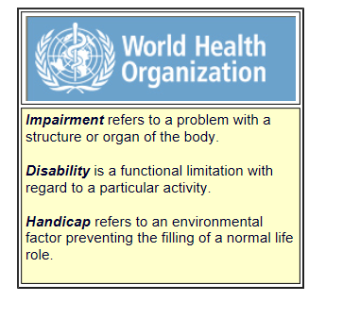

This concept of the identification of disability has been connected with so called Medical Model of Disability, where the disability itself (or person with disability) was understood as a „problem“:

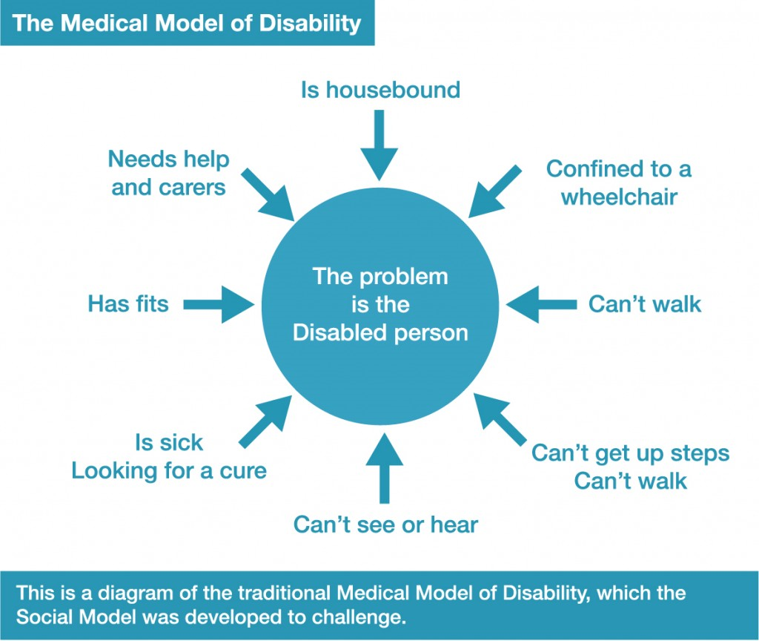

This approach however hasn´t anyhow reflects the idea of social inclusion of marginalized groups and those in risk of social exclusion. Therefore, changes in concept of disability and its perceiving has been implemented.

Contemporary, the Disability is defined by WHO (2020) as follows:

* Disabilities is an **umbrella term, covering impairments, activity limitations, and participation restrictions.** 
  + An **impairment** is a problem in body function or structure;
  + An **activity limitation** is a difficulty encountered by an individual in executing a task or action;
  + while a **participation** restriction is a problem experienced by an individual in involvement in life situations.
  + Disability is thus **not just a health problem**. It is a complex phenomenon, reflecting the interaction between features of a person’s body and features of the society in which he or she lives. Overcoming the difficulties faced by people with disabilities requires interventions to remove environmental and social barriers.

Based on mentioned above, the changes in approach to target group caused the development of the Social Model of Disability, where the difficulty to fulfil the social inclusion is caused by lack of society readiness to meet individual needs:

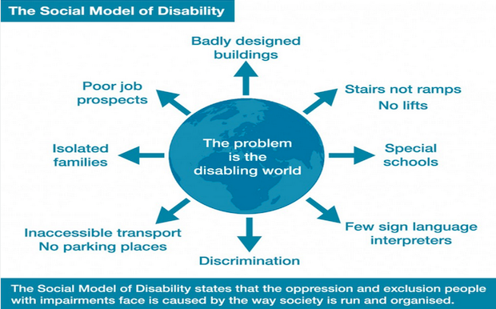

Currently, the main effort of international society is to minimize all barriers which might hinder the individual with disability in full social inclusion and thus full participation in everyday life activities.

1. **Your thoughts and knowledge in terminology**

Please define following terms according to your understanding.

Disability is …

Define difference in between visible and invisible disability …

Impairment is …

Special Educational Needs …

**Inclusive Education as an open school environment**

To clearly understand what inclusive education is, one need to understand the term social inclusion and social exclusion.

The term **social exclusion** was used for the first time by former French Secretary of State for Social Action, René Lenoir (1974), to refer to the situation of certain groups of people − “the mentally and the physically handicapped, suicidal people, aged invalids, abused children, drug addicts, delinquents, single parents, multi-problem households, marginal, asocial persons, and other ‘social misfits’”− whom he estimated to comprise one tenth of the population of France and who were considered vulnerable yet outside the realm of social insurance systems of the welfare state. The concept soon took hold in other developed countries; more recently, the European Union dedicated 2010 as the European Year for Combating Poverty and Social Exclusion

Where a conceptualization of social inclusion does appear in the social exclusion literature, it is often only indirect. Frequently, for example, it appears in invocations of ‘normal’ social expectation/participation or, more commonly,’ mainstream’ applied to various things that people are understood to be excluded from: labor market, economy, society, culture, citizenship, etc. The meaning and location of the mainstream is routinely taken to be self-evident. As this implies, social inclusion is most commonly defined only *negatively* – as whatever is *not socially excluded*. For this reason, much of the discussion of social inclusion is conceptually dominated by exclusion – social exclusion is the datum point against which social inclusion is both empirically measured and conceptually defined (Cameron, 2006:397).

“**Social inclusion** is a process which ensures that those at risk of poverty and social exclusion gain the opportunities and resources necessary to participate fully in economic, social, political and cultural life and to enjoy a standard of living that is considered normal in the society in which they live. It ensures that they have greater participation in decision making which affects their lives and access to their fundamental rights”(Commission of the European Communities, 2003, p. 9).

According to mentioned above, the **inclusive education can be perceived as a toll for social inclusion.**

As an educational terminology "integration" has been used for a long period of time, and this education format still exists in some countries. Integration means the process of transferring CSN from special schools to mainstream schools (Thomas et al., 2005). This process urged the children "to fit in" to the classroom setting and school environment. But the overall results of the process were assimilation However, unlike integration, the emergence of inclusive education concentrated on transformation of profoundly rooted structural obstacles rather than assimilation. This transformation changed dominant interpretation of "success", "failure", "ability" and so on (Barton, 2003).

Basically, inclusive education (IE) means educating learners with special educational needs in regular education settings. However, IE is not limited to only placement. Rather, it means facilitating education of students with special needs with a whole suite of provisions which include curriculum adaptation, adapted teaching methods, modified assessment techniques, and accessibility arrangements. In short, inclusive education is a multicomponent strategy or, perhaps, a mega- strategy (Mitchell, 2008).

**Inclusive education** is when all students, regardless of any challenges they may have, are placed in age-appropriate general education classes that are in their own neighborhood schools to receive high-quality instruction, interventions, and supports that enable them to meet success in the core curriculum (Bui, Quirk, Almazan, & Valenti, 2010; Alquraini & Gut, 2012).

1. **Your thoughts and knowledge in terminology**

Please define following terms according to your understanding.

Social Inclusion …

Social Exclusion …

Inclusive Education …

1. Take a look at the enclosed description of the Elementary school Yellow. Please **select factors** (aspects) from the description, which support inclusive education and which might hinder it.



**The Yellow Elementary school**

The Yellow Elementary School is located in the centre of the town in a three-storey building from year 1916. The school is equipped with gym and computer science classrooms in the first floor. Primary school classes are located on the third floor and the junior secondary school classes are on the 2nd floor. The classes are equipped with interactive boards and projectors.

The school arranges the leisure time activities in the afternoon. Nowadays it is language and sport courses for pupils of the first and junior secondary school classes.

The average number of pupils in the last 5 school years was 900 pupils. The Pedagogical Staff consists of 45 teachers, 6 teacher assistants shared between classes, 4 educators for leisure time activities, 2 special teachers, Educational counsellor and School prevention methodologist. The average age of the pedagogical staff is 48 years.

Pupils with special educational needs are educated at school. Their support is ensured by teacher assistants and special teachers. Remediation care is always carried out individually or in a group way in the afternoon, so the education of other pupils is not affected.

The school regularly organises joint events for parents and pupils. These are thematically oriented according to the seasons and include the Spring Feast, the June toasting of sausages, the Collection of chestnuts within the Autumn festivities and the Christmas Pavilion. The school is an open space for community life in the city district and regularly offers its space for events organized by non-profit organizations and municipality.

Dictionary:

Primary school classes – 1st till 5th grade

Junior Secondary School – 6th till 9th grade

Educational cousellor – Výchovný poradce

Remediation care – Reedukace

1. **Inclusive School Environment – Cooperation in between teachers**

Please read the co-teaching characteristics below and watch the video. Afterwards complete a written task.

**Co-Teaching Approach (Potts, E.A. & Howard, L. A., 2011)**

* + Two or more educators (general education teacher/special educator/other specialist) share the instruction for a single group of students
  + Popular service for delivery option in inclusive education in USA
    - In heterogeneous classroom combining strengths of special educator and general classroom teacher create options for all students
  + In the Czech Republic more often know as Tandem Teaching

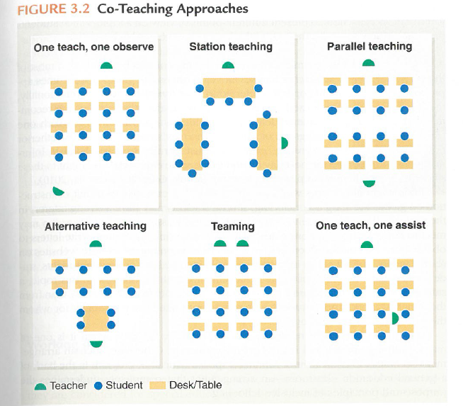

Fig.1 Models of Co-teaching application in the classroom

* Co-teaching as a marriage – short document on how co-teaching works in US schools: <https://www.youtube.com/watch?v=_pnxst7dkLk>

Co-teaching is a model of teaching not often used in Czech. However, the assistance for heterogenous groups can be given by teacher assistant.

**Write:** What do you believe it´s neccessary for efficient cooperation in between teacher and teacher assistant?

_______________________________________________________________________________________

_______________________________________________________________________________________

_______________________________________________________________________________________

_______________________________________________________________________________________

_______________________________________________________________________________________

_______________________________________________________________________________________

_______________________________________________________________________________________

_______________________________________________________________________________________

_______________________________________________________________________________________

_______________________________________________________________________________________

_______________________________________________________________________________________

_______________________________________________________________________________________

_______________________________________________________________________________________

_______________________________________________________________________________________

_______________________________________________________________________________________

_______________________________________________________________________________________

_______________________________________________________________________________________

_______________________________________________________________________________________

_______________________________________________________________________________________

_______________________________________________________________________________________

1. **Inclusive School Environment**

Please read the chart below and the description of the INCLUDE Strategy used in USA for the development of Inclusive school environment. Afterwards complete a written task.

**Factors affecting Inclusive School Environment**

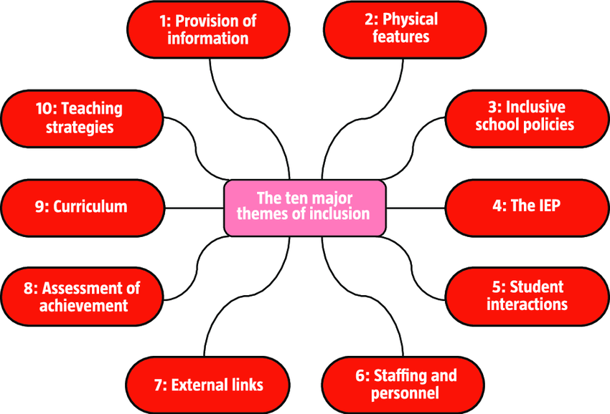

* Source: Literature Review of the Principles and Practices relating to Inclusive Education for Children with Special Educational Needs The National Council for Special Education (Ireland) was established under the Education for Persons with Special (2010)

**INCLUDE Strategy (USA)**

* Systematic approach for helping students with SEN through establishment of inclusive environment (USA)
* Combining universal design and differentiated instruction
* Universal design = instructional materials, methods and assessments designed with build-in supports (print alternatives such as graphics, video and digital text which allow students with reading difficulties to easily access the subject)
* Differentiated instruction = variety of teaching and learning strategies which are necessary (include materials and tasks at varied levels of difficulty)
* INCLUDE Strategy consisting of 7 steps
  + *Step 1* **I**dentify classroom demands
  + *Step 2* **N**ote student learning strengths and needs
  + *Step 3* **C**heck for potential problem areas
  + *Step 4* **L**ook for potential problem areas
  + *Step 5* **U**se information to brainstorm ways to differentiate instruction
  + *Step 6* **D**ifferentiate instruction
  + *Step 7* **E**valuate student progress

**Write:** What do you believe is needed for establishment of the Inclusive School Environment? Please focus on school itself, its staff and children.

______________________________________________________________________________________

_______________________________________________________________________________________

_______________________________________________________________________________________

_______________________________________________________________________________________

_______________________________________________________________________________________

_______________________________________________________________________________________

_______________________________________________________________________________________

_______________________________________________________________________________________

_______________________________________________________________________________________

_______________________________________________________________________________________

_______________________________________________________________________________________

_______________________________________________________________________________________

_______________________________________________________________________________________

_______________________________________________________________________________________

_______________________________________________________________________________________

_______________________________________________________________________________________

_______________________________________________________________________________________

_______________________________________________________________________________________

_______________________________________________________________________________________

_______________________________________________________________________________________

_______________________________________________________________________________________

_______________________________________________________________________________________

_______________________________________________________________________________________

_______________________________________________________________________________________

_______________________________________________________________________________________

_______________________________________________________________________________________

_______________________________________________________________________________________

_______________________________________________________________________________________

_______________________________________________________________________________________

_______________________________________________________________________________________

_______________________________________________________________________________________