Body composition and energy needs
- Calculate what is your BMI!

- Calculate what is your WHR!

Energy expenditure (EE)
- Calculate your basal metabolic rate (BMR or BM) with Harris–Benedict equatio!

- Calculate your energy expenditure!

Activity | BM factor | Duration (h) | Energy expenditure (kkal/kJ)
Sleeping
Learning
Walking
Watching TV
Running
Total

Formulas
BMI = body mass (kg) / height² (m²)

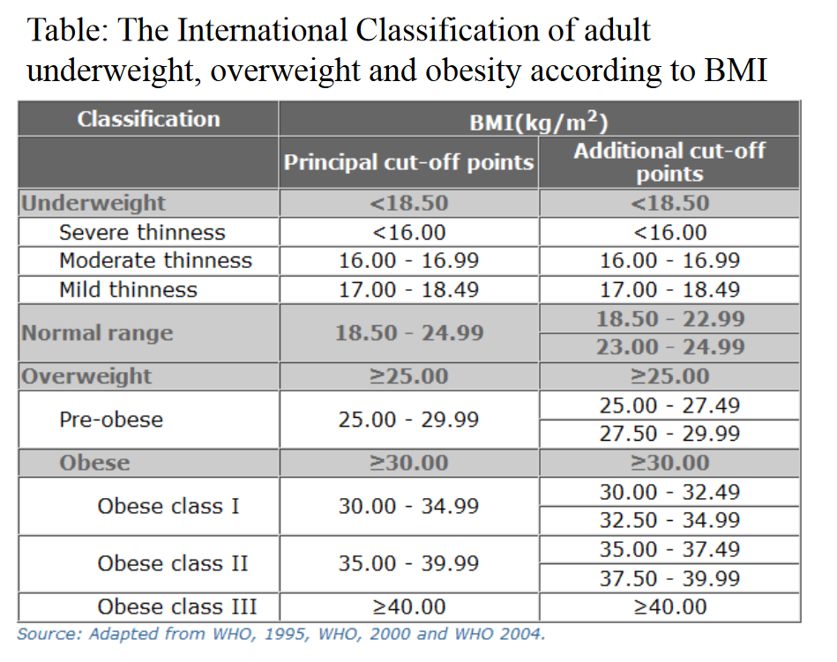
WHR = waist (cm) / hip (cm)

Harris – Benedict equatio for men
BM = 66 + (13,8 x masa (kg)) + (5 x višina (cm)) – (6,8 x starost (leta))

Harris – Benedict equatio for women
BM = 655 + (9,6 x masa (kg)) + (1,8 x višina (cm)) – (4,7 x starost (leta))
