CZECH PATRIOTIC QUIZ 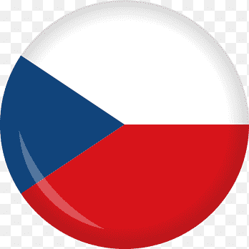

LISTEN TO THIS MUSICAL PIECE AT AN AMERICAN ARMY FUNERAL:
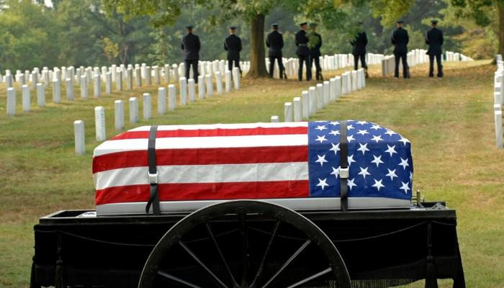
1 Composer? 2 Title to the symphony?
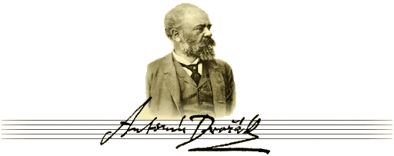

Opera: Rusalka

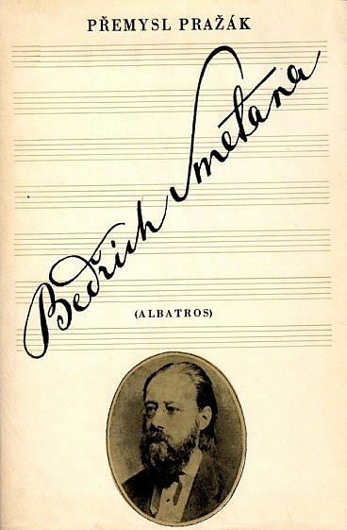
3 WHAT IS THE RIVER Vltava CALLED IN GERMAN AND ENGLISH?
3a Explain the difference between ‘MOTIVE and MO’TIF dove of peace?
3b On which occasion was the piece played in 2002?
4 What is the original Czech title to Smetana’s opera THE BARTERED BRIDE?
5 Who is the best known Moravian composer whose organ school turned museum still resides in Kounicova Street?
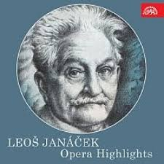
6 What are the original Czech titles to Janáček’s operas THE CUNNING LITTLE VIXEN and JENUFA?

7 WHICH SONG CONTAINS THESE LYRICS?

Water roars across the meadows,
Pinewoods rustle among crags,
The orchard is glorious with spring blossom,
Paradise on earth it is to see.
And this is that beautiful land…

8 Which play by Anton Pavlovich Chekhov features the word ORCHARD in its title?
9 Compare the national anthems of the Czech Republic, Slovakia, the U.K. and the U.S.
9a What is the European Union anthem? /R. Atkinson/
10 What is a hymn?
11 Can you sing the hymn “Closer, my God, to Thee“ as presented in the Titanic?

BEST-KNOWN CZECH WRITERS (OPEN TO DEBATE)
12 A 19-century female writer, free and unrestricted in her views and behaviour, very much ahead of her time, “the Czech George Sand“
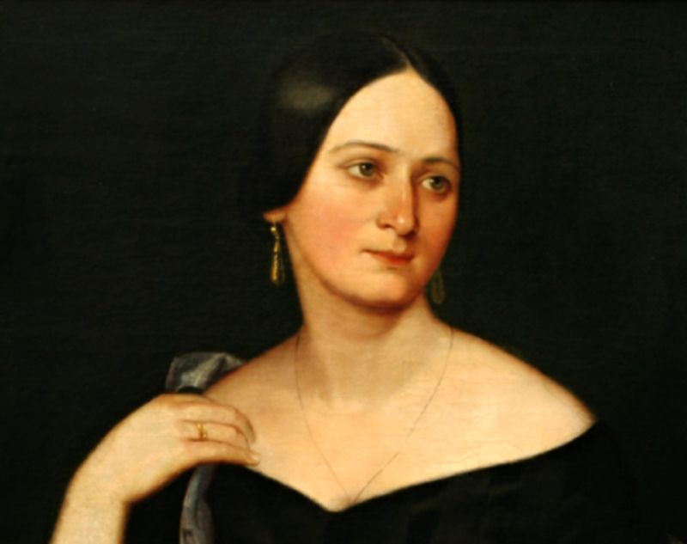
Božena Němcová

13 A visionary and humanist journalist and writer who “had his heart pierced by Chamberlain’s umbrella“
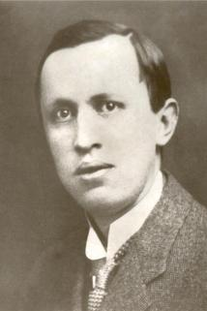
Karel Čapek

14 CZECH WORDS IN ENGLISH:
- Robot
- Dollar
- Pistol
- Polka, polka-dotted
- Howitzer

15 WHO INVENTED / 16 DISCOVERED

- Lightning conductor
- Fingerprints, heart fibres and brain cells
- Sugar cube
- Arc lamp
- Ship’s screw propeller
- Soft contact lenses

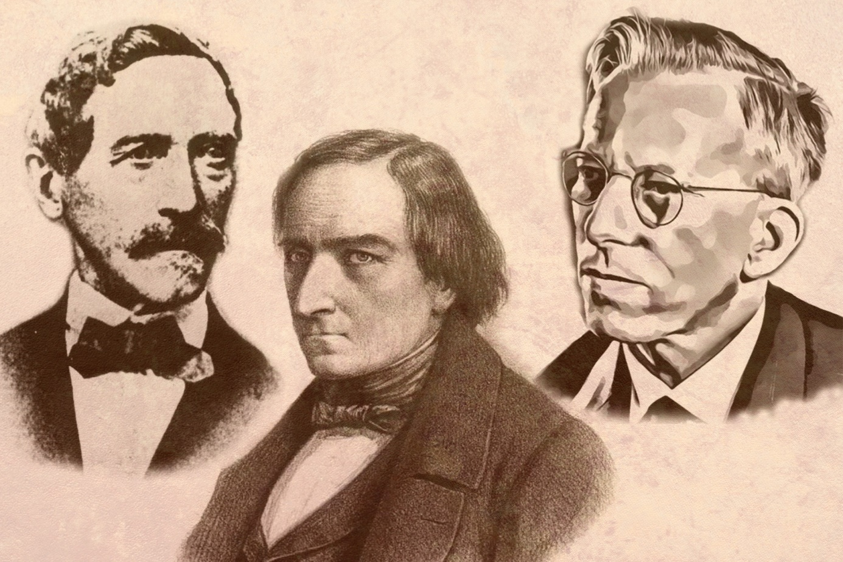
17 Jakub Kryštof Rad, 18 Josef Ressel, 20 Otto Wichterle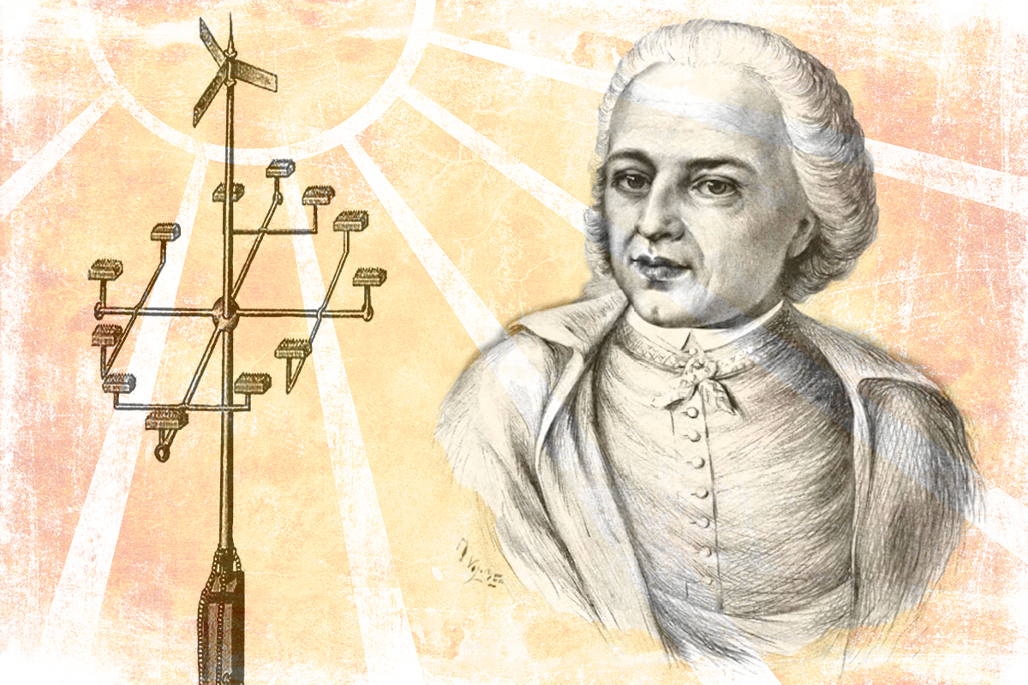
21 Václav Prokop Diviš
22 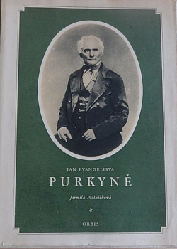, 23: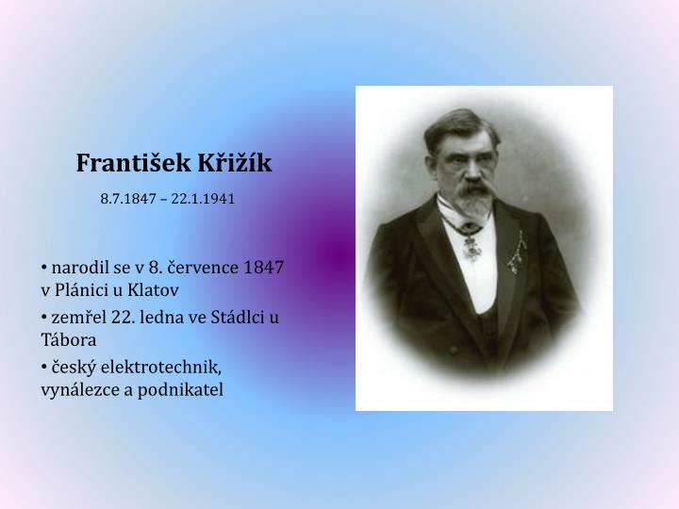
BRNO SCIENTISTS
24 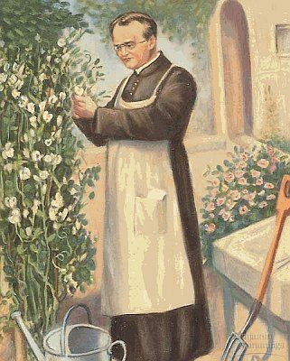
25