Intake Report (Assessment)

***Directions****: For this course you will select a new (real or hypothetical) client with whom to complete the intake and program development process. You will be learning about practicing components of the process throughout the course and receiving feedback along the way. You will be asked to complete this assessment throughout the course, as you learn more about each topic area. When completing this assessment you are welcome to use components that you created on prior assessments as well as materials that have been provided to you in the class. However, please do not seek outside assistance, collaborate with other students, or use resources from the internet.*

**List Identifying Information (12 components):**

*Feel free to skip this section if you are unsure what goes here and/or copy and paste from your previous work in this course.*

**Client’s name:** John Ralphio

**Birth date:** 03/09/2010

**Age:** 10

**Gender:** Male

**Parents’ names:** Jane Ralphio (mother), Mike Ralphio (father)

**Phone number:** 609-123-4566

**Email:** Jane_Ralphio@gmail.com

**Address:** 678 Mountain Road, Colorado Springs, CO 81234

**Funding:** TriWest Insurance Company

**Current diagnosis:** Autism

**Date of assessment:** 25/10/2018,27/10/2018, 28/10/2018, 31/10/2018

**Behavior analyst’s name:** Sheri Kingsdorf

**Describe Referral Information (3 components):**

**Source of referral:** The mother reported that their pediatrician recommended that they seek behavioral services, they were then referred by their TriWest Insurance Coordinator.

**List of all behaviors referred for and any additional/different behaviors for intervention:** John Ralphio, age 10 years, has been diagnosed with autism. Alan Sharp of the TriWest Healthcare Alliance®, Extended Care Health Option (ECHO) Program, referred John for a behavior assessment.  
  
Mrs. Ralphio, John’s mother, requested this evaluation due to John’s increasing level of noncompliance and lack of appropriate communication skills. These behaviors are most present in the school setting. Currently, John is at risk of being removed from his current school placement. If this occurs, the mother is not sure where John will attend school. Additionally, his mother stated that she would like the intervention to address decreasing the aberrant behavior of property destruction that she occasionally sees in the home setting. She also reports concerns associated with the absence of self-management skills (possibly across home and school environments). These areas will be described in the following report.

**Description of the Indirect Assessment Process (3 components):**

**Dates of interviews and observations, time, location:** An interview with mother and an initial observation of John in the home environment occurred on the 6th of November, 2018. School assessments and additional observations were also conducted, on the 8th, 10th, and 12th of November.

**Indirect (functional) assessment method(s) used:** Hanley’s Open Ended Functional Assessment Interview form was used (in addition to basic interview questions). The functional analysis screening tool (FAST) was also used. Both tools were used in the home and school settings.

**Background Information (13 components):**

The following information was collected via indirect assessment, as reported by a caregiver.

**General strengths and deficits:** The mother and teacher both reported that John enjoys, and excels at, physical activities (e.g., basketball). They share concerns about John’s compliance with single and multiple step directions and self-management skills.

**Communication (speaker and listener):** It is reported that John can follow multiple step directions when they are presented in the context of preferred physical activities. However, he struggles with complying with even single step directions in non-preferred/academic/adaptive skill demands. John can mand (request) and tact (label) using simple sentences. However, both the mother and the teacher report that John does not initiate conversations with others, although he will usually respond to basic intraverbals (questions).

**Self-help/adaptive skills:** It is reported that John is typically provided with a lot of support (e.g., broken down directions, frequent reminders, differing levels of prompts) during adaptive skill demands.

**Motor:**  John’s gross motor skills are reported as being developmentally appropriate. However, his fine motor skills (e.g., component skills related to writing, coloring, cutting) are delayed. John will often be noncompliant when presented with a task demand that requires fine motor activity.

**Academic:** John’s academic skills are reported as being developmentally delayed. He receives support for all academic subjects via the resource room in the school setting. John receives one-on-one support during homework assignments. He is attending an inclusive classroom in his local public school. John’s curriculum is modified, but not necessarily individualized. Due to his noncompliance with academic tasks assessment of his academic capabilities has been difficult.

**Play:**  It is reported that John does not engage in play activities, such as those involving: music, pretend play, or arts and crafts. He does engage in play activities such as: basketball, football, trampolining, and sometimes dance. However, his interactions with others even during these preferred activities are usually parallel and not reciprocal.

**Social:** It is reported that John plays functionally with other children when it is a preferred activity, usually a physical activity. However, occasionally he will become noncompliant when having to wait or take a turn. When other children initiate with John during a non-preferred activity, typically John will ignore them or lightly push them away.

**Other:** Both the mother and the teacher report that when John begins ignoring a task demand, or social initiation, it can be difficult to get him to comply again, even with a different task demand. However, when given a direction related to a gross motor movement transitioning out of the noncompliance can be more successful.

**Living situation and family history:** John lives in Colorado Springs, Colorado, with his mother, father, maternal grandmother, and two younger sisters (twins, four years old).

**School/day program placement and history:**  John is attending an inclusive classroom in his local public school. He receives support throughout the day in the resource room. He does not have one-on-one support assigned to him in the classroom. However, there is a paraprofessional in the classroom that provides support to all students, as needed.

**Medical history:** John received a diagnosis of autism at the age of six. He is not currently taking any medications.

**Language and culture:** English is the main language spoken in the home. However, the maternal grandmother and mother occasionally speak Spanish to one another.

**Previous or concurrent interventions:** John and his family have received respite services in the home periodically over the last four years. An assessment was recently conducted by a speech-language pathologist (SLP). However, services have not yet started. They have never received ABA (or behavioral) services in the home or the school setting.

**Preferences (3 components):**

The following information was collected via indirect assessment, as reported by a caregiver. A preference assessment checklist was used.

**List of potential reinforcers:** The mother and teacher report that John likes items that involve movement, such as: balls, trampoline, swings, slides, and chasing/being chased. John also likes most food items and drinks.

**Challenging Behavior Report Components**

*A certain number of specific components are expected in each of these areas. Do your best to complete each component.*

(Please protect client information by using pseudonyms throughout.)

**Functional Assessment for Behavior One (14 components):**

**Behavior one:**  Non-compliance in the academic setting

**Description of problem behavior (operational definition):** Doing something other than a given direction; not engaging in the behavior specified in the direction within 10 seconds of being given the direction; engaging with materials in a way other than what aligns with the expectation (e.g., swiping materials to the floor when they should be on the desk, putting head down on the desk when head should be up and attending to task/person, or not responding to the comment/statement of another person).

**History of problem behavior:** The mother and teacher report that the behavior of

non-compliance has been going on for a long time. They report that within the last 6

months it has become more intense, now including some property destruction.

**Baseline data (direct data collection):** During the three intake observations in the school setting the behavior of non-compliance with directions was observed as occurring an average of 5 times during a one hour observation (range 4-6).

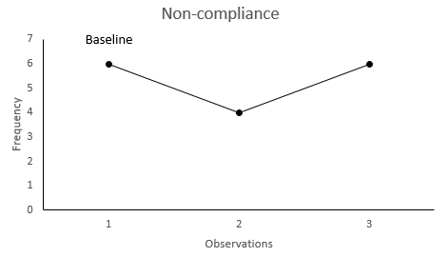

Figure 1.

*Figure 1.* The frequency of non-compliance with instructions presented in the school setting during 1 hour observations.

**Antecedents likely to trigger/precede problem behavior:**  Common antecedents to the challenging behavior were identified as being given an instruction or prompt to work in a group setting.

**Consequences likely to support/follow the problem behavior:**  Common consequences which seem to follow the challenging behavior were identified as having the work requirement/task demand verbally terminated or being left alone to engage in another behavior (without the continued presentation of attention, corrections, or new directions).

**Hypothesized function the behavior serves for the client:** Based on the data collected using the functional assessment parent interview, FAST, structured ABC form, and trial-based functional analysis, it is hypothesized that the function of the problem behavior is escape or avoidance of task demands, and therefore maintained by social negative reinforcement.

**Intervention Strategies for Behavior One (11 components)**

**Antecedent-based strategies:** The strategy of manipulating motivating operations, by creating the abolishing operation for escape, will be used prior to JR participating in a group-work environment. A high-p/low-p sequence, as a self-managed schedule, will be used during group-work time to target JR self-managing his participation in work tasks.

**Consequence-based strategies:** When the challenging behavior of non-compliance is emitted an extinction procedure will be used.

**Functionally equivalent replacement behavior:** Manding for a break, help, or task

reduction when presented with a direction in an academic or non-preferred activity.

**Goals and objectives:**

**Behavior Reduction**

* ***Goal***: Reduce noncompliant behavior in the school setting.
  + ***Long term objective:*** During a one hour observation in the school setting, when presented with a direction from an adult during a non-preferred activity JR will engage in 1 or less occurrence of noncompliant behavior.
    - ***Short term objective*:** During a one hour observation in the school setting, when presented with a direction from an adult during a non-preferred activity JR will engage in 3 or less occurrence of noncompliant behavior

**Functionally Equivalent Replacement Behavior:**

* ***Goal***: Increase appropriate mands in the school setting.
  + ***Long term objective:*** During a one hour observation in the school setting, when presented with a direction from an adult during a non-preferred activity, the appropriate establishing operation for escape, JR will emit an appropriate mand for escape from the independent work task (e.g., request for a break, help, or task reduction) in at least 8/10 presented opportunities.

**Generalization/maintenance:** Multiple exemplar instruction will be used to teach appropriate mands for escape across the settings of the resource room, the inclusive classroom, in the community, and in the home. The schedule of reinforcement for consequating the mand for escape will be gradually reduced to shape: Number of breaks during work, amount of help provided during work, and work completion.   
Self-strategies will also be incorporated to work towards JR managing the amount of breaks taken and the amount of work completed.

**Additional Skill Building (8 components)**

**Description of the procedures for assessing skills:** To further assess John’s communicative repertoire and social skills, portions of the Verbal Behavior Milestones Assessment and Placement Program (VB-MAPP; Sundberg,  
2016) and Assessment of Basic Language and Learning skills (ABLLS; Partington, 2010) were completed. Direct probes (trials without a consequence, to therefore assess rather than teach) were also conducted for certain skills.

*Further description of the assessment tools can be included, if needed for the audience of the report.*

**Baseline data (direct data collection):***.* Sections of the VB-MAPP were conducted on the 8th, 10th, and 12th of November. The scored assessment (please refer to Figure 4) revealed that John had some skills in the areas of mands (requests), listener responding, visual perception, imitation, play, social, and spontaneous vocalizations. However, all of these areas also needed to be targeted to increase John’s skills in each domain. Sections of the ABLLS were also conducted on those same dates. These sections revealed needs in similar areas, as well as domains related to academics and self-help skills. Some of the goals that will be targeted as part of John’s initial programming are presented below. Additional graphs for specific goals are also presented in some areas, depicting specific baseline data (e.g., Figure 5). As John’s program progresses more goals and objectives will be targeted and accompanying baseline data collected.

*The baseline data in this section can be graphs that align with the programs or graphs that align with the assessments. This decision is made based on the needs of the client/service model. More/less descriptive elaboration on the data may also be necessary.*

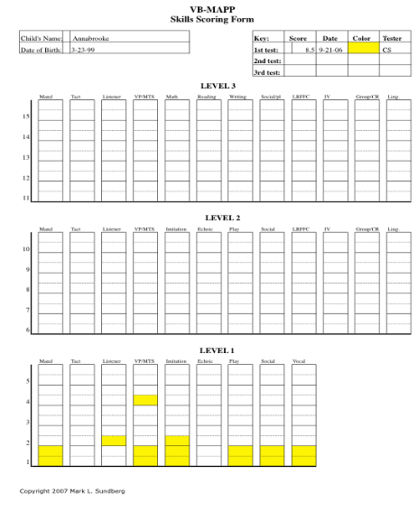

Figure 4.

*Figure caption 4:* Score report for John’s VB-MAPP assessment conducted in November 2018.

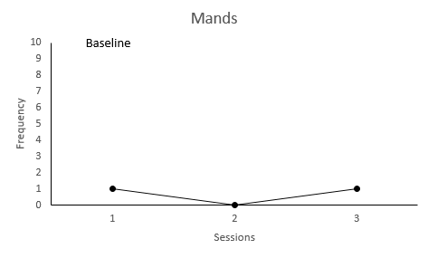

Figure 5.

*Figure caption 5:* The number of correct mands emitted out of 10 created opportunities during a session.

**Speaker**

* ***Goal:*** To increase mands in the school setting.
  + ***Long term objective:*** To emit (impure) mands for 4 different items when presented with the SD condition of “What do you want?”, the item within view, and the correct motivating operations, for 9/10 correct responses across 2 consecutive sessions.
    - ***Short term objective*:** Target the impure mands for cookie (x5) and drink (x5), when presented with the SD condition of “What do you want?”, the item in view, and the correct motivating operations, for 9/10 correct responses across 2 consecutive sessions.

**Listener**

* ***Goal:*** To increase direction following in the school setting.
  + ***Long term objective:*** To emit 10 specific motor actions, when presented with the SD that corresponds to the action (e.g., Can you jump like a frog?) for 9/10 correct responses across 2 consecutive session(s).
    - ***Short term objective*:** Target the motor action of jumping (x5) and clapping (x5), when presented with the SD condition of the direction for the action (e.g., Can you clap?), for 9/10 correct responses across 2 consecutive sessions.

**Play**

* ***Goal:*** To increase social interactions with peers by engaging in simplified board/card games.
  + ***Long term objective:*** To independently play simplified board/card games with peers, by doing the following: waiting for his turn, completing the simplified steps in the turn, and telling the next player that it is his/her turn, when presented with the natural SDs of the game, for 9 out of 10 opportunities across 2 consecutive session(s).
    - ***Short term objective*:** Target completing the steps of (1) waiting for his turn, (2) completing the simplified steps in the turn, and (3) telling the next player that it is his/her turn for the game Memory, when presented with the SDs of the directions for each step from the BT, for 9/10 correct responses across 2 consecutive sessions.

**Social**

* ***Goal:*** To increase social interactions with peers, as mands to peers, in the school setting.
  + ***Long term objective:*** To independently ask peers for items, mand to peers, when presented with the natural SD condition of the peer and the desired item in view, for 9/10 correct responses across 2 consecutive session(s).
    - ***Short term objective*:** Target manding to a peer for a desired item using an echoic to mand procedure. Present the natural SD condition of the peer with the item, the item in view, and the correct motivating operations. The criteria for success is 9/10 correct responses across 2 consecutive sessions.

**Academic**

* ***Goal:*** To establish a reinforcement history for writing and increase the legibility of written words.
  + ***Long term objective:*** To independently copy uppercase and lowercase letters when presented with the SD as presentation of an example of the letter to be copied and the SD “copy_____” for 18 out of 20 opportunities across 2 consecutive session(s).
    - ***Short term objective*:** Target copying the letters U, O, I, and C. SD as presentation of the letter to be copied (BT to create the model before each trial) and “copy __.” Criteria is 18/20 across 2 consecutive sessions.

**Self-help**

* ***Goal:*** To increase personal hygiene skills, beginning with face washing.
  + ***Long term objective:***  To independently wash his/her face with soap at the sink in the bathroom, when presented with 1 trial/SD per step in the task analysis, with 90% correct responses over 2 consecutive sessions.
    - ***Short term objective*:** Target washing face using backwards chaining with steps 1-8 in the task analysis modelled by the BT and steps 9-10 independent. Criteria is 5/5 (100%) across 2 consecutive sessions.