Intellectual Disability
English for Special Educators I 2023

What is intellectual disability?
Read the introductory text and note down any terms you did not know or would like to remember.
Intellectual disability is a condition characterized by significant limitations in intellectual functioning and adaptive behaviors. It typically emerges during childhood and affects a person's ability to learn, reason, and solve problems. Individuals with intellectual disability may have difficulty with tasks such as reading, writing, and basic math. They may also have challenges with social skills, communication, and daily living skills such as dressing, eating, and personal hygiene.
There are various causes of intellectual disability, including genetic factors, brain damage, and environmental influences. The severity of the condition can range from mild to severe, and it can affect individuals in different ways. For some, intellectual disability may be accompanied by physical and medical conditions that require ongoing support and management.
As special educators, it is essential to understand the nature of intellectual disability and how it impacts the educational and social development of individuals with this condition.
Created with openAI software.

Causes
- With your neighbors, brainstorm all the causes of intellectual disability that you know of.
- Have you had any experiences assisting or teaching a person with an intellectual disability? Tell us about it.

2. Poster Party - Intellectual Disability
In a small group of 2-3:
- Choose an article from the list about intellectual disability to read, note and create a poster about.
  - Wikipedia: Intellectual Disability (causes and symptoms)
  - Wikipedia: Intellectual Disability (diagnosis)
  - Fragile X Syndrome
  - Down Syndrome
  - Foetal Alcohol Spectrum Disorder (Foetal Alcohol Syndrome)
  - Prader-Willi Syndrome
- Read the article together or cut it into sections (one section per person) and make notes.
- Compare notes and teach each other about the section you read.
- Together, come up with a visual representation of the information on the poster. This could be a mind map, diagram, several drawings with captions, or an infographic style.
Then we’ll have a poster party where we display all the posters around the room, visit each other’ and
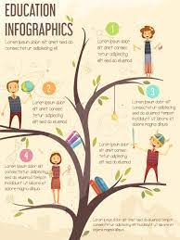 | 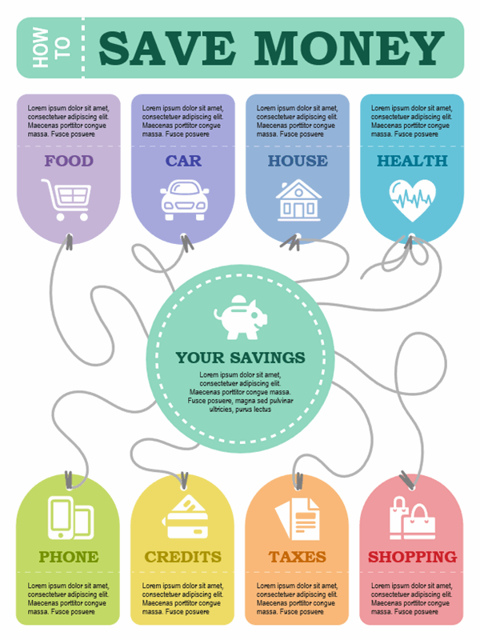 | 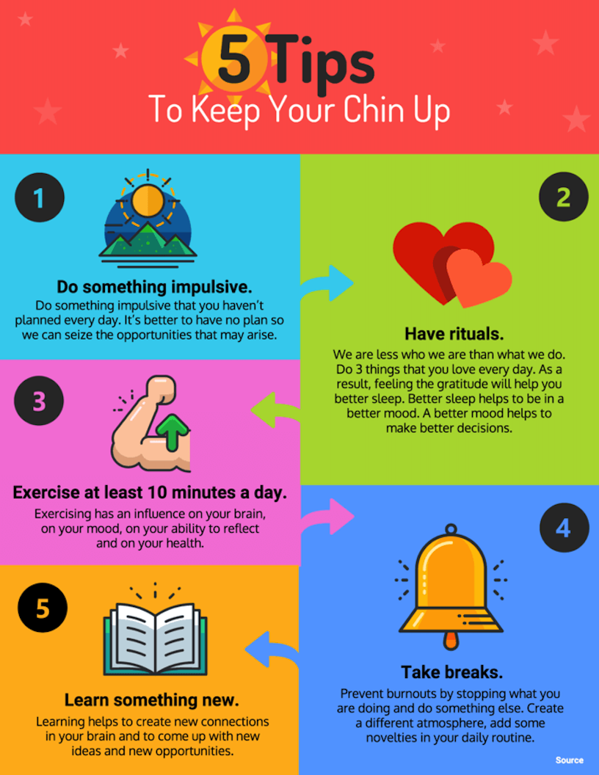 | 

3. Debate: Inclusion of intellectually disabled students
In groups of 3-5, discuss and debate (agree and disagree) about the integration/inclusion of students with an intellectual disability in mainstream schools.
Useful phrases when expressing an opinion, agreeing or disagreeing:
In my opinion, …  I (personally) believe/think that …  From my point of view, …  It seems to me that…  Let’s look at/see it from a different point of view.  Let me show you this issue from a different  perspective. | Exactly/Absolutely! …  I agree with you (entirely). …  That’s a (really) good point. …  I can’t agree with you because …  I’m not sure I quite agree. …  Personally, I don’t think it’s completely true. …

4. Teaching Students with an Intellectual Disability
Using your modal verbs: Remember to say what might be a challenge, what teachers could, should or must do, and also what you would do in the same situation (of a teacher or student with a physical disability).
- Brainstorm the challenges students with intellectual disabilities face when attending school. Think about inside and outside the classroom, learning and social skills, study time and lunchtime.
- Now think about teachers at a mainstream school; what challenges do they face, and what accommodations would they need to make for the students with intellectual disabilities?
- Watch this video about how to teach students who have an intellectual disability. What tips are there for teachers?

5. Working in the ID Field
- What would it be like working with people who have moderate, severe and profound Intellectual disabilities? What do you think would be the most important part of the job? What would be the number one skill or quality you’d need?
- Watch this mini-documentary interviewing people who work in the ID field.
  - What’s the most important part of the job?
  - What is the number one quality needed?
  - What does the job involve?
  - What does a typical day look like?
- Discuss with your neighbours how might we improve the quality of life for people with intellectual disabilities?

