Physical Disability
English for Special Educators A

1. Causes, Diseases, and Conditions
- What can cause physical disability? What diseases do you know? What are some conditions not stemming from a disease?
Diseases | Other Conditions
- Have you had any experiences assisting or teaching a person with a physical disability? Tell us about it.

2. Mini-lesson on a Physical Disability
With your neighbors/s:
- Choose a physical disability to research and teach others about.
- Research English websites and/or videos in English to learn about the disability (take notes).
- Decide on some key vocabulary and key points to know about this physical disability and create a poster or visual (e.g., mind map, academic poster, diagram, etc.).
- Teach the whole class about your physical disability of choice.
Examples
- cerebral palsy  - spinal injury | - ALS  - MND

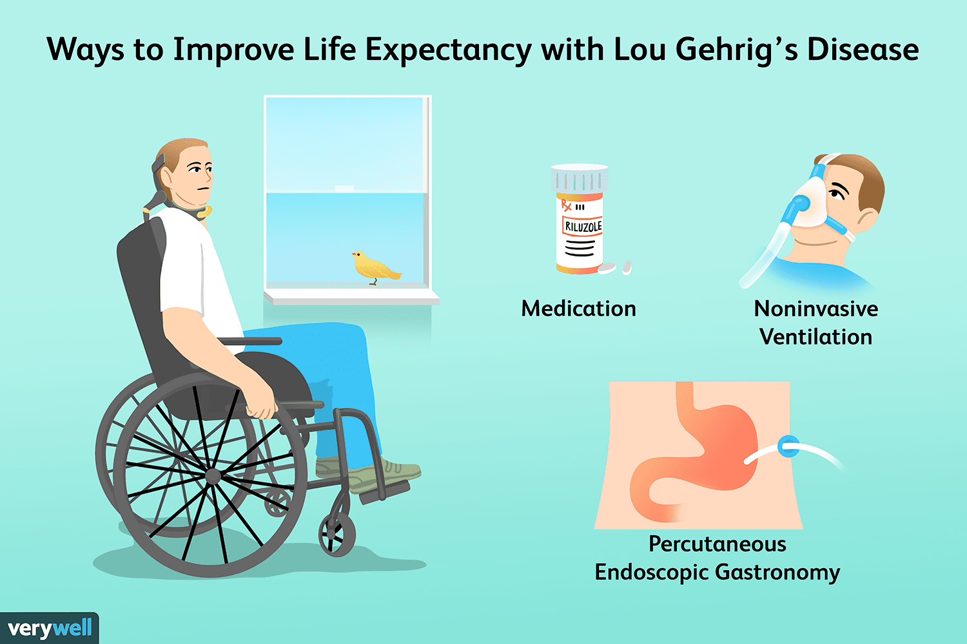 | 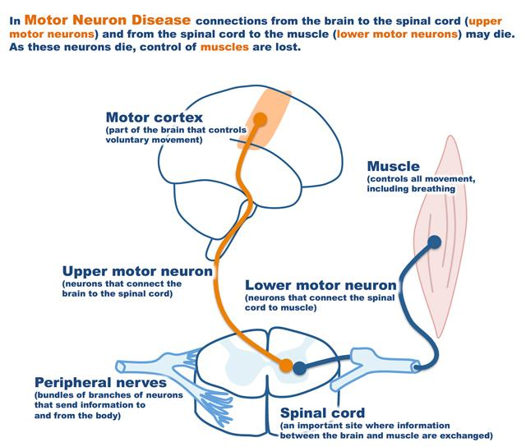 | 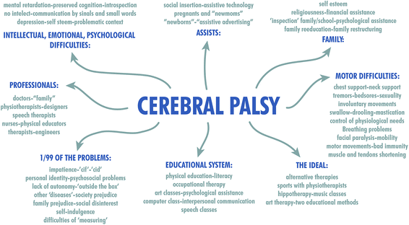

3. What can teachers do?
Using your modal verbs: Remember to say what might be a challenge, what teachers could, should, or must do, and also what you would do in the same situation (of a teacher or student with a physical disability).
- Brainstorm the challenges students with physical disabilities face when attending school. Think about inside and outside the classroom, learning and social skills, study time, and lunchtime.
- Now, think about teachers at a mainstream school. What challenges do they face, and what accommodations would they need to make for the students with physical disabilities?
- Watch teaching professionals talk about how they accommodate Charlotte, who has CP. What are the proven teaching strategies, impacts of CP on Charlotte at school, and adaptations to the school facilities they’ve made?
Teaching | Impacts of CP | Adaptations

4. Living with CP and Quality of Life
- How would you expect people to view and treat people with CP where they can see a walking impairment and/or hear a speech impairment?
- Watch this video where three people with CP talk about their experiences with CP and how people treat them. After viewing the video, discuss how you can educate people around you, such as teachers, students and friends on how to treat someone with CP.
- Discuss with your neighbors how might we improve the quality of life for people with physical disabilities?

