1. Definition of Basic Concepts

There are many different definitions of giftedness and talent. Some experts who are interested in this area understand the thesis of concepts in different way. In everyday communication these terms are often used identically. But some scholars in the field commonly use these two terms as synonyms, just like in the common expression: ‘the gifted and talented are…’. Occasional distinctions between the two terms will take many forms, and give rise to a diversity of views and theories (Gagné, 2004).

There are differences in the use of these terms in different countries – in some of them both terms are used as synonyms, and in some of them these terms are perceived differently. Usually giftedness and talent are defined in following way.

US Federal Definition of Gifted and Talented
"The term gifted and talented, when used with respect to students, children, or youth, means students, children, or youth who give evidence of high achievement capability in such areas as intellectual, creative, artistic, or leadership capacity, or in specific academic fields, and who need services or activities not ordinarily provided by the school in order to fully develop those capabilities." (No Child Left Behind Act, P.L. 107-110 (Title IX, Part A, Definition 22) (2002); 20 USC 7801(22) (2004))

J. Freeman (1998), one of the founders of the International Society ECHA (European Council for high ability, their research and development) gives following definitions of giftedness:
"Talented are those who have an extremely high level of activity, whether in the whole range or in a limited area, or those whose potential has not yet been through tests or experts recognized. There is a difference between the apparent talent of children, adolescents and adults. Talented children are usually perceived as faster development compared to their peers. Adult’s talent is seen in the high level of activity, based on many years of hard work in their chosen fields. Talent may apply simultaneously to several areas, such as intellect, art, creativity, movement and social skills, or may be limited to one or two of them. But the potential, whatever it may develop into an extremely high level of activity only in terms of providing adequate equipment and psychological learning opportunities. Discussion on the precise definition and identification of such children have been running for nearly a century and will no doubt continue. For education is more productive (and more scientific) to assess success in terms of the dynamic interaction between the individual and educational opportunities, which he received in his life. Children who have the potential for extremely high level of activity may need such training conditions as non-specialized schools cannot offer."
F. Gagné (1985, pp 105) is one of experts who distinguish giftedness from talent:
"The concept of giftedness means the ownership or use of untrained and spontaneous natural ability in at least one dominant area to level among the top 10 percent of their peers. On the other hand, talent points to greater mastery of systematically developed abilities, skills and knowledge in at least one area at a level between 10 percent of those peers who are actively engaged in the area. This model represents the five areas of talent: intellectual, creative, socio- affective, sensorimotor and „others" (i.e. extra-sensory perception). These natural skills that have a clear genetic basis, are reflected in the performance of all the tasks with which the child is struggling in school. "
This means that giftedness is the potential for high achievement, and talent refers to the development of that potential into performance.

It is also necessary to mention how Czech and Slovak experts define talent and giftedness. V. Dočkal (1987, pp 16) defines giftedness very shortly: "Giftedness is the complex of all the properties that are involved in the implementation of activities is relatively stable component of personality that regulates the performance of the activity."
Dočkal, Vladimir a kol. Psychológia nadania. Bratislava: SPN, 1987.

J. Škrabanková (2012, pp 14) prefers the term talented pupil and uses it in the following meaning:
"The term talented pupil indicates the student diagnosed with potential features and capabilities in intellectual, social, sensorimotor or aesthetic area in which exhibits a repeated performance beyond the normal population and this potential is able to develop and apply."
Škrabánková, J. (2012). Žijeme s nadáním. Ostravská univerzita v Ostravě, Pedagogická fakulta.

So who are the gifted? We can conclude:
• Briefly, the gifted are those with exceptional abilities compared to most other people of the same age.
• Those individuals have certain learning characteristics that give them the potential to achieve outstanding performance.
• Children who exhibit characteristics of giftedness have learning needs that are significantly different from those of other children.
• They require different opportunities and may need emotional and social support to realise their potential.

Intelligence
Generally, intelligence can be described as the ability to perceive or infer information, and to retain it as knowledge to be applied towards adaptive behaviours within an environment or context.
The Theory of Multiple Intelligences created by Dr. Howard Gardner
As defined by Gardner, intelligence is the ability to solve problems or fashion products that are valuable in one or more cultural settings.
Each person may have different multiple intelligence. Even everyone can possess more than one of it as Gardner divided the multiple intelligences into eight kinds.
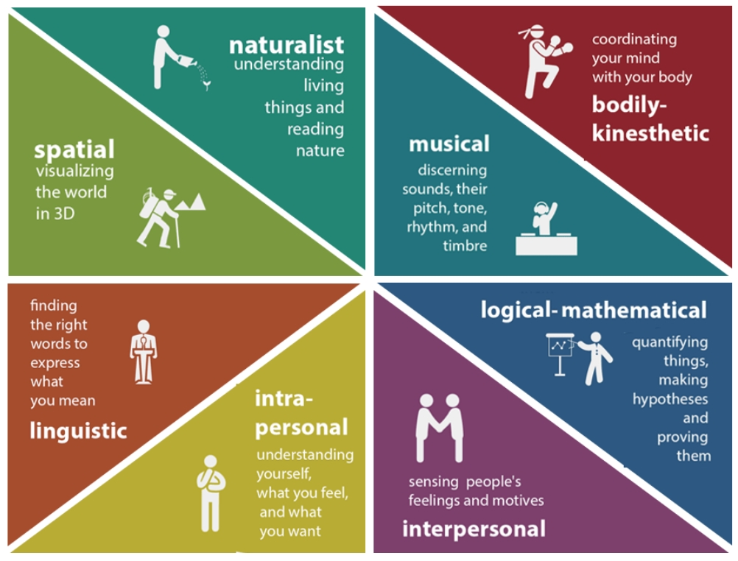

Gardner PPT– https://slideplayer.com/slide/2479532/
Test in AJ
https://www.literacynet.org/mi/assessment/findyourstrengths.html
Advantages how improve: https://www.literacynet.org/mi/practice/index.html

