Syntax, word order, constituent analysis, tree diagrams, complex sentences.

Different devices are used to show the relationship of one word to another in different languages. English language is a configurational language. It means it relies on word order when expressing the relationships between words. Then there are nonconfigurational languages such as Czech or Latin. In these languages endings or inflections indicate the relationship between words. The word order in these languages is irrelevant and mostly can be changed. We have just divided languages into two types. Anyhow there is another common device that can be used in both types to some extent. It is the use of function words, such as that, by, of. They indicate relationships between parts of the sentence. E.g.: I know that English is not easy. The trouble in English is that some of the function words can be used as both: function and content words, too. E.g.: Helen wants to play the piano. (function word) He went to the wood. (content word, meaning “towards”) There are even borderline cases that do not fit well into either type of usage: It seems to me a good idea.

The number of recurring sentence patterns in every language is limited. The linguists want to identify these patterns by a process of successive substitution. In the sentence:
The dog bit the thief. parts can be substituted:
The crocodile bit the man.
It bit him.
This substitution helps to distinguish the components of the sentence, its constituents. Therefore this linguistic procedure is known as constituent analysis. Tree diagrams can illustrate constituent analysis of a sentence, too. In the tree diagrams the successive layers of constituents, which make up a sentence can be seen:

The dog

bit the thief
TTheTh

the thief

the

dog

bit

thief

the

Each node or join on the tree can be labelled, which enables to bring the more general image:

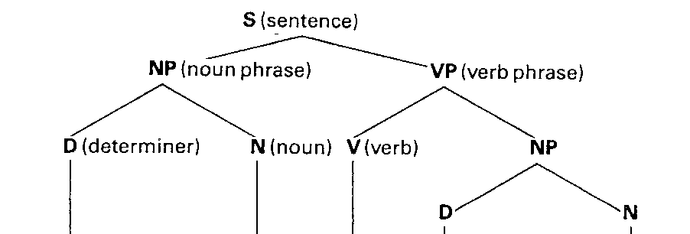
The dog bit the thief

An alternative way of presenting the relationships is by means of rewrite rules. Here an expanded form written to the right of the arrow replaces the symbol to the left of the arrow.
E.g.: S NP VP
VP V NP
NP D N

Thus the essential structure The dog bit the thief has been summarized in just three rules. Rewrite rules are perfectly explicit. They do not leave anything to the imagination.

Constituents behave in predictable ways. It is then possible to build up a store of specific patterns for the presence of a particular constituent in a given language. E.g. NP patterns:
English NPs recur in certain positions.

- At the beginning of a sentence before the verb.
The tiger ate the rabbit.
- At the end of a sentence after the verb.
The rabbit feared the tiger.
- After by in a passive sentence.
The rabbit was eaten by the tiger.
- After an auxiliary verb in questions.
Did the tiger eat the rabbit?

The patterns mentioned above are used whenever we find a phrase, which we suspect, might be an NP. _
We sometimes use N (pronounced N-bar) to something that is neither a simple N, nor a whole NP. E.g. a picture of a cat. Some linguists also give the label N-double bar. Bars can be used with adjectives (A), verbs (V), and prepositions (P), and also nouns (N). A noun in an NP is likely to be in a similar position to an adjective in an AP or a verb in a VP and a preposition in a PP. That is the head (main word) in a phrase is in a very similar location to the head in another.

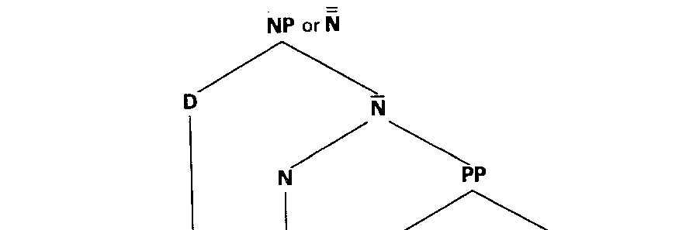

a picture of a cat

Sentences mentioned above are simple sentences. However, in practice sentences are joined together and they form complex sentences. They may be attached or inserted inside each other. When the sub-sentences are attached together to form a single one and they are of equal importance we call the phenomenon conjoining.
E.g. Eve went to school and her brother went to work.
In theory indefinite number of sentences could be conjoined together but usually it makes the meaning of a complex sentence less clear.
When a subsidiary sentence is inserted into one main sentence, it is known as embedding.
E.g. The fact that he might be seriously ill makes me worried.
The number of sentences embedded is also endless in theory.
Both conjoining and embedding prove an important property of language - that of recursion. It is the possibility of repeatedly using the same construction. It means there is no limit to the length of sentences and we cannot make a complete list of all the possible sentences of any language.

