**APPLYING TO UNIVERSITY: HOW TO SUCCEED IN AN INTERVIEW**

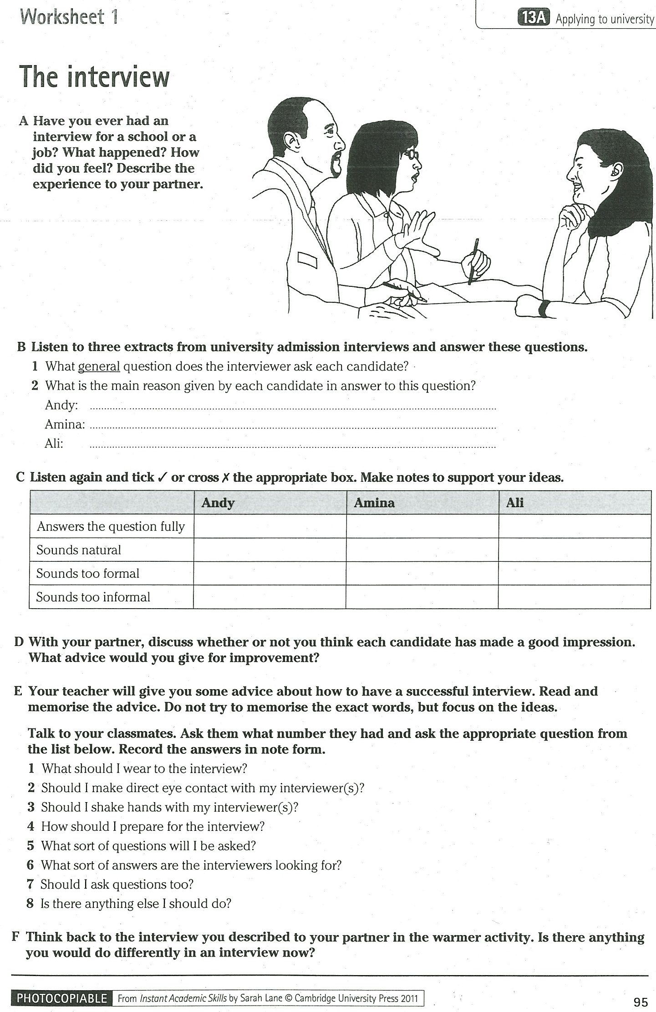

**C+ Listen again and underline/highlight any phrases that seem useful to you and you might use them at your own interview**

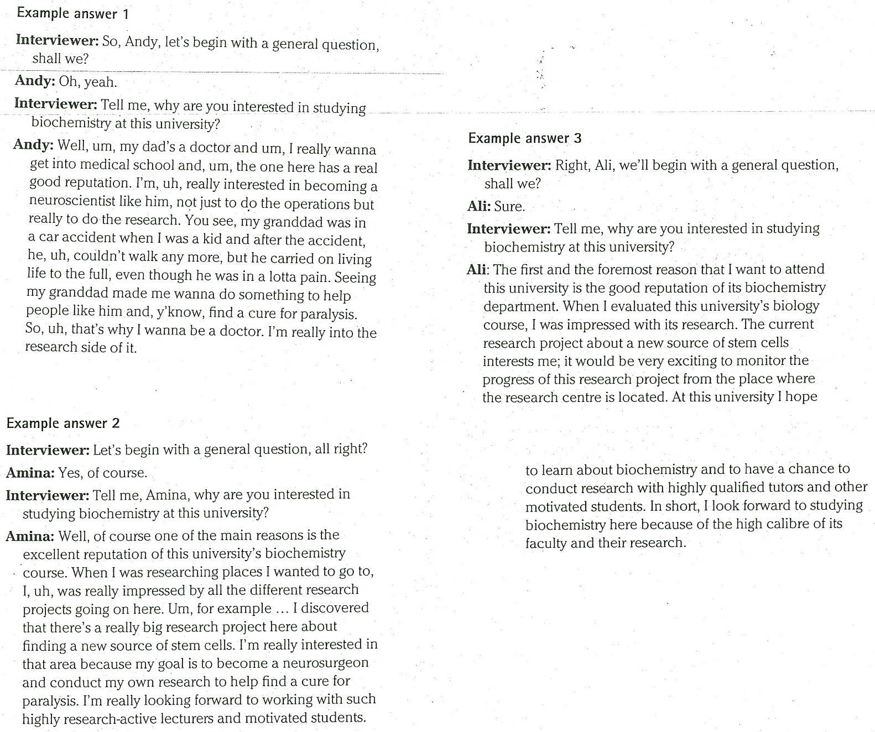

**VIDEOs**

**G Watch the following video giving some guidelines about how should a successful applicant perform during an interview compared to the unsuccessful one.**  (<https://www.youtube.com/watch?v=CMyD6c9Z3z8>)

**Which advice can you hear in the video that was not mentioned in exercise E?**

**H Watch two videos provided by the University of Cambridge about interviews and take notes about:**

* what the interviewers are interested in
* what the applicant shouldn’t miss if they want to be well-prepared/make a good impression

(<http://www.undergraduate.study.cam.ac.uk/applying/interviews>)

# Optinal video:

# "Tell me about yourself" - How to answer this interview question

(<https://www.youtube.com/watch?v=-C55ADRB8uc>)