Relativity in Your Hand
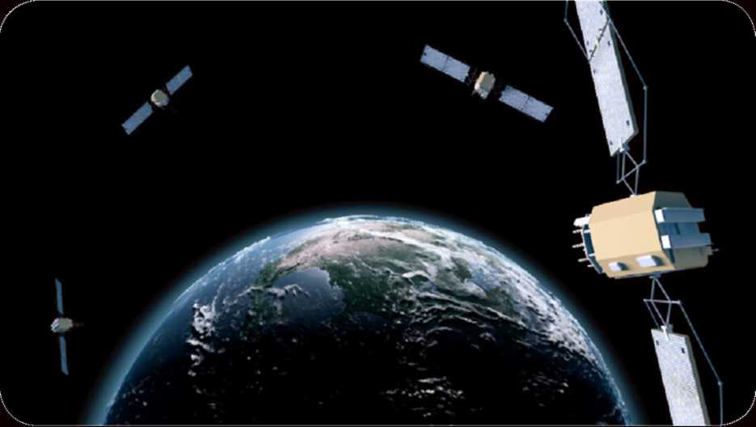
National Aeronautics and Space Administration
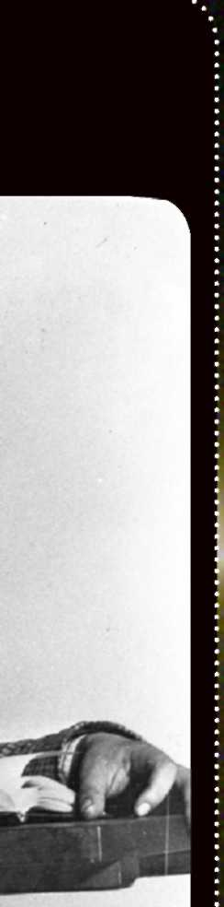
Background image: Galaxy Cluster Abell 2218's "Gravitational Lens" (credit: NASA, ESA, Richard Ellis (Caltech), and Jean-Paul Kneib (Observatoire Midi-Pyrenees, France))
Front cover: Portrait of Albert Einstein (©The University of New Hampshire, used with permission)
Inside: Mercury's limb imaged by MESSENGER (credit: NASA/Johns Hopkins University Applied Physics Laboratory/Carnegie Institution of Washington); equipment used to measure the stars near the eclipse in 1919 (credit: Science Museum/Science & Society Picture Library); artist's impression of Cygnus X-1 (credit: NASA/CXC/M.Weiss); Twin Quasar SBS 0957+561 (credit: ESA/Hubble & NASA); artist's impression of Gravity Probe B (credit: GP-B Image Archive, Stanford University).
Back page: Artist's impression of GPS satellites (credit: NASA/Goddard Space Flight Center).
When Einstein developed the general theory of relativity, he was trying to improve our understanding of how the universe works. At the time, Newtonian gravity was more than sufficient for any practical gravity calculations. However, as often happens in physics, GR has applications that would not have been foreseen by Einstein or his contemporaries.
How many of us have used a smartphone to get directions? Or to tag our location on social media? Or to find a recommendation for a nearby restaurant? These activities depend on GPS. GPS uses radio signals from a network of satellites orbiting Earth at an altitude of 20,000 km to pinpoint the location of a GPS receiver. The accuracy of GPS positioning depends on precision in time measurements of billionths of a second.To achieve such timing precision, however, relativity must be taken into account.
Special relativity shows that if we place a clock on a satellite and compare its recorded time to an identical clock in our rest frame on Earth, the satellite's clock will appear to be running behind. For the GPS satellites, this difference amounts to about 7 microseconds per day. Now enter GR. Because the satellites are farther from Earth's center, space-time is less curved and their clocks tick faster than those on the ground by about 45 microseconds per day. The combined effect is that the satellites' clocks tick faster by about 38 microseconds each day. The effects from relativity are nearly 1,000 times greater than the required timing precision for GPS. Without correcting for this, position errors would accumulate so quickly that the system would be useless for navigation in a matter of minutes.
Image Credits
; Further Reading
: • Bartusiak, Marcia. Einstein's Unfinished Symphony. Joseph Henry Press, 2000.
j • Hawking, Stephen. A Brief History of Time.
\ Bantam Books, 1988.
■ • Schutz, Bernard. Gravity from the Ground Up:
An Introductory Guide to Gravity and General j Relativity. Cambridge University Press, 2004.
j • Thorne, Kip S. Black Holes and Time Warps: Einstein's Outrageous Legacy. W. W. Norton & Company, 1995.
: • Einstein Online also has a list of suggested : reading:
j http://www.einstein-online.info/further_reading
This brochure is produced by NASA's Physics of the Cosmos (PCOS) Program Omce. me pcos Program concentrates on activities, technologies, and projects to enhance our understanding of how the universe works. The program's purpose is to explore some of the most fundamental questions regarding the physical forces and laws of the universe: the validity of Einstein's general theory of relativity and the nature of space-time; the behavior of matter and energy in extreme environments; the cosmological parameters governing inflation and the evolution of the universe; and the nature of dark matter and dark energy.
Visit PCOS on the web: http://pcos.gsfc.nasa.gov
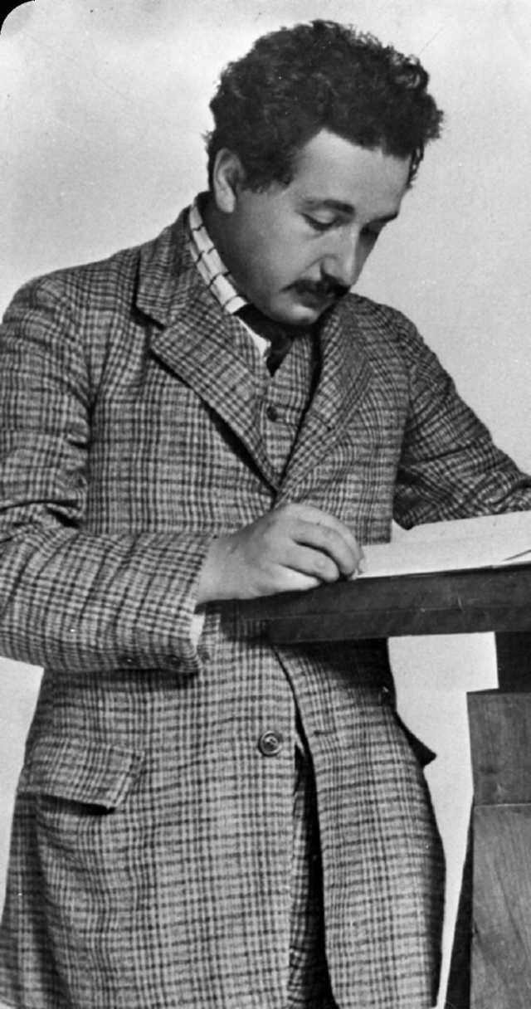
A Century of General Relativity
Einstein's general theory of relativity (GR), published in 1916, stands as one of the greatest triumphs of theoretical physics. It completely revised the scientific understanding of gravity first established by the work of Isaac Newton in the late 1600s.
With an earlier theory known as special relativity, published in 1905, Einstein detailed the physical relationship between space and time. Over the following decade, he worked to incorporate gravity into this picture. He presented his final result to the Prussian Academy of Science in 1915.
In special relativity, Einstein showed that space and time were interwoven as a single structure he dubbed space-time. He realized in GR that gravitational fields can be understood as the motion of particles—stars, planets, and even light—on the stretched and curved surface of space-time. Testing this picture means making precise measurements of GR's subtle consequences, such as the deflection of starlight as it passes near the Sun.
Scientists continue to look for cracks in the theory, testing GR's predictions using laboratory experiments and astronomical observations. For the past century, Einstein's theory of gravity has passed every hurdle.
Today, GR is present in our everyday lives, through the ubiquitous use of GPS technology (see back page for more), and astronomers are embarking on a new quest to look for GR's predicted waves rippling through space-time—gravitational wave astronomy.

NP-2014-10-194-GSFC

100 Years and Counting ...
Tests of general relativity (GR) require strong gravity, massive objects and/or high-precision measurements—conditions we don't readily find on Earth. Einstein proposed three tests of GR when he first published the theory in 1915: the precession of Mercury's orbit, the bending of starlight near the Sun, and the gravitational redshift of light. These represented just the beginning of a long list of tests which could be performed to bolster the case for GR. The timeline below shows a sampling of tests which have confirmed GR's predictions over the past century, with a preference for astrophysical confirmations. The dates reflect the publication of the results, not necessarily the date of observation.

1 a^r c\
1915 Mercury's orbit
For over two centuries astronomers had known that the perihelion of Mercury's orbit precesses faster than predicted by Newtonian gravity, but they did not have a good explanation for why. The answer fell out of general relativity, with the accelerated precession attributed to Mercury's proximity to the sun.
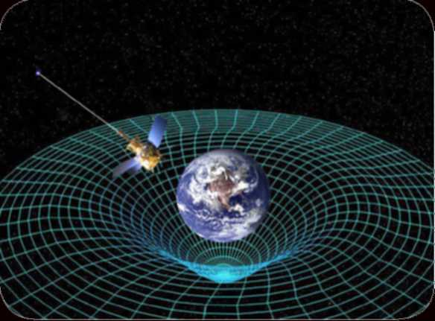
1920 Deflection of starligh
Both Newtonian gravity and general relativity predict that massive objects will deflect starlight, but the effect is more pronounced in GR. In 1919, Arthur Eddington and Frank Dyson led separate teams in Principe and Brazil to photograph stars near the sun during a total eclipse. The results confirmed the predictions of GR.
₁₉₇₅ First binary pulsar
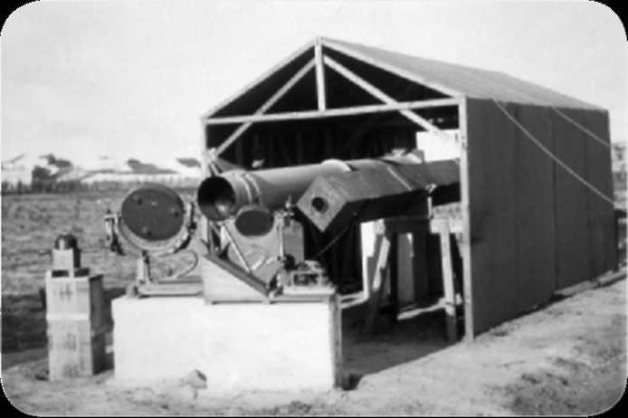
According to general relativity, accelerated masses radiate gravitational waves, which results in the loss of energy. This means that stars in binary systems will gradually grow closer over time. The discovery of pulsar PSR 1913+16 in a binary system gave astronomers a unique opportunity to test this prediction, since pulsars are the most accurate clocks in the universe. Precise timing of radio pulses from PSR 1913+16 over 18 years provided the first evidence of gravitational radiation.
1959 Gravity's redshift
1965
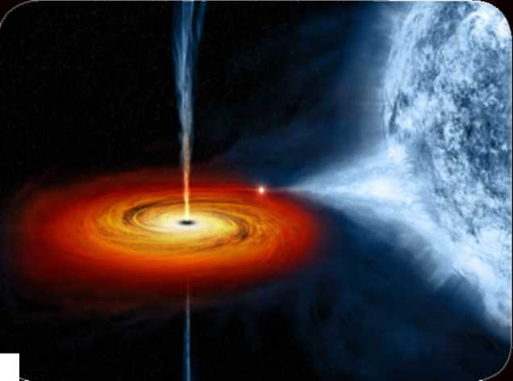
One of the central ideas of general relativity is the equivalence principle, which asserts that everything responds to gravity, whether light or matter. Simply stated, all things fall equally in a gravitational field. Einstein proposed that this could be measured by observing how light became redder as it traveled upward, away from a gravitational source. Physicists Robert Pound and Glen Rebka performed an experiment in a tower at Harvard University that demonstrated just this effect—the first laboratory test of GR.
First black hole
General relativity predicts there are some places where space-time becomes so distorted that not even light escapes. We call these objects black holes. One of the first X-ray sources observed beyond the solar system was Cygnus X-1. Astronomers couldn't readily identify an optical or radio counterpart to the source. Within a few years, they observed extremely rapid changes in the object's X-ray signals, indicating a very small dense object. This made Cygnus X-1 the first candidate black hole. Today, overwhelming evidence shows that it is, indeed, a genuine black hole.
1979 Gravity's lens
General relativity predicts that massive objects warp space-time, resulting in a deflection of light passing nearby. With enough mass and the right alignment, it could act as a lens and produce multiple images of a more distant object. The discovery of the "Twin Quasar" or SBS 0957+561 provided the first confirmation of a gravitational lens.
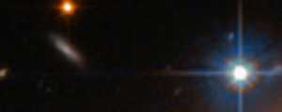
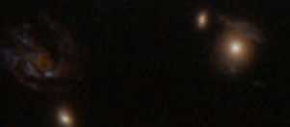
1996 High-preci;
Clocks on satelli will appear to tick just a bit fast ground, according to general rel lower curvature of space-time fa surface. Satellite-based high-pre systems, such as GPS in the U.S validity of GR every day, since t for the effects of GR and special commercialized in 1996 when P declared it to be a "dual-use" sys military alike.
2011 Earth-warped space-time
A basic premise of general relativity is that all massive objects warp space-time. The more massive the object, the stronger the effects. Launched in 2004, Gravity Probe B was designed to measure how Earth warps and drags space-time as it rotates. The satellite took data for about 17 months, but researchers needed about 5 years for a full analysis. The final results confirm GR's prediction that space-time is twisted around the Earth as it rotates.
Coming soon
20162018
Astronomers have already observed gravitational waves (GWs) through their effects on binary systems. The next step to verifying this prediction of general relativity would be to watch GWs pass through the solar system. Scientists expect to begin detecting GW signals from various sources in the coming years.
Ground-based laser measurement
Between 2002 and 2010, scientists at the Laser Interferometer Gravitational-wave Observatory monitored precise laser measurements to attempt detection of passing gravitational waves. Upgrades to the system, called Advanced LIGO, are scheduled to be completed in 2016. Scientists expect it will be capable of seeing GWs from merging neutron stars.
2017- Timing pulsars
2020
20252035
Astronomers have begun using collections of millisecond pulsars in hopes of finding slight changes in their timing caused by a gravitational wave passing near Earth. This method is called Pulsar Timing Arrays and, as of 2014, three ongoing projects anticipate results within the decade.
Observatories in space
Within a couple of decades, astronomers anticipate placing a laser-based GW detector in orbit around the sun. The European Space Agency's planned eLISA mission—short for Evolved Laser Interferometric Space Antenna— will observe GWs from a wide variety of sources, including merging supermassive black holes in distant galaxies.

1915 1920 1925 1930 1935 1940 1945 1950 1955 I960 1965 1970 1975 1980 1985 1990 1995 2000 «2005 2010 2015 2020 2025 2030

