TOPIC 2: SOCIAL EXCLUSION

TASK 1A BRAINSTORMING. Work out a mind map about social exclusion and share it with your neighbour. Put SOCIAL EXCLUSION in the centre and try to place some the following words there too, beside your own words:
race, sex, age, religion, health, socio-economical status, discrimination, bullying, blacklisting…

TASK 1B DISCUSSION. In pairs discuss the following questions.

- Have you ever experienced exclusion? If so, what kind?
- What are the reasons for exclusion? Why do people exclude other people?
- How closely should teachers monitor for possible exclusion (of any kind for any reasons) of (a) certain pupil(s)/student(s) by the rest of the group?
- What coping mechanisms should children be taught at school?

TASK 2A A PINK-HAIR GIRL STORY. Watch the video https://www.youtube.com/watch?v=OMbYEyBeSsU and make notes on the following:
- How is „exclusive“ perceived in the society?
- What was the positive thing about her experience?
TASK 2B TWO SIDES OF THE SAME COIN. What are the two sides of social exclusion? Write 5 to 7 sentences based on the pink-hair girl story and add your own opinion. Use the following linking words to express the opposing aspects of her experience.

however
on the other hand
on the contrary
although
whereas
similarly to
like
as well as
in the same way

TASK 2C PEER REVIEW. Exchange your writing with your neigbour´s writing and give him / her feedback. Try to comment at the following aspects of writing and / or make suggestions for improvement. Ask the teacher for help.
Does it make sense?
Is the text to the topic?
Does the text flow naturally? Is it easy to read?
Are the linking words used correctly?
Is there a wide range of vocabulary?

TASK 2D MAIN MESSAGE. What is the main message of the pink-hair girl story? Summarize the main point in one sentence:

TASK 3A SURVEY. Read the following statements and rate what you think your comfort level would be in each situation using the scale below. There are no right or wrong answers. Simply be honest with yourself and do not over-think the situations.
1 | 2 | 3 | 4 | 5
Very  Comfortable | Comfortable | Neutral | Uncomfortable | Very  Uncomfortable

Section A:
_________ Your best friend starts dating a Latino-American.
_________ You go into a Japanese restaurant where all the patrons and employees are Asian.
_________ You realize you are the only person of your race when you visit a community.
_________ A Saudi Arabian sits down next to you on a crowded bus.
_________ Your new doctor went to medical school in India.
Section B:
_________ You find out a family friend is choosing to be a stay-at-home dad.
_________ You greet someone but can’t determine the person’s gender.
_________ You take your car in for repairs and the head mechanic is a woman.
_________ You see a little boy playing with a princess Barbie.
_________ You see a businessman getting a manicure.
Section C:
_________ You see two men holding hands.
_________ A person of the same sex is flirting with you.
_________ You move in next door to a same sex couple who have two children.
_________ You go on a date with someone who used to date someone of the same sex.
_________ You see two females kiss lovingly in public.
Section D:
_________ You don’t know whether to open a door for someone in a wheelchair.
_________ You watch someone who does not have a visible disability park in a handicap spot.
_________ You walk by a mentally disabled person who is talking loudly in the grocery store.
_________ Your friend is dating someone with Aspergers Syndrome (high functioning autism).
_________ You are standing in line behind a deaf person at a fast food restaurant.
Section E:
_________ A heavily obese person is working out in the gym next to you.
_________ You are sitting next to an obese woman on a plane.
_________ You notice a coworker who is obese is holding up the cafeteria line because she/he wants to fill the tray.
_________ You watch an obese man get stuck trying to sit in a desk in a classroom.
_________ Your friend sees an overweight person and makes a joke about him/her.
Section F:
_________There is a 30 year age difference between you and your lab partner.
_________Your internship coordinator assigns you to an assisted care facility.
_________Your senior citizen landlord wears a hearing aid and often has difficulty understanding you.
_________Your grandmother often asks you for help with her computer.
_________Your 70-year-old next door neighbor can never remember your name.

Results: Compute your total for each section by adding up the numbers from your responses
Higher numbers indicate greater discomfort with social situations in that section.

_________ Section A: Race
_________ Section B: Gender
_________ Section C: Sexuality
_________ Section D: Disability
_________ Section E: Weight
_________ Section F: Age

http://breakingprejudice.org/assets/AHAA/Activities/Subtle%20Prejudice%20Activity/Comfort%20in%20Social%20Situations%20(Student%20Version).pdf

TASK 3B SURVEY. Look at your scores and at the statements above again. Do the numbers reflect your concerns? How could the survey be adapted to be more suitable for the Czech environment / for children / for teenagers? Discuss in groups.

TASK 4A PRE-LISTENING. Describe the picture below in 2 – 4 sentences. What does the picture illustrate? How does it relate to social exclusion?

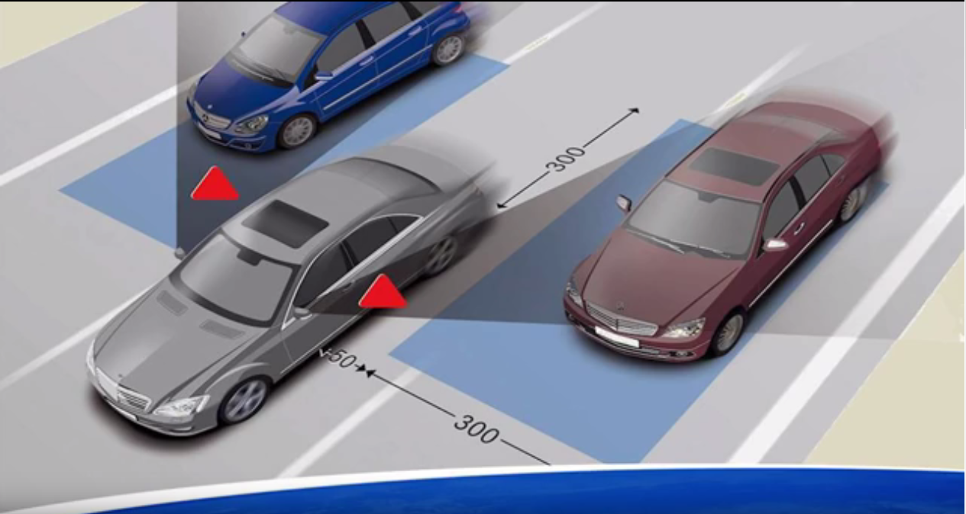
TASK 4B LISTENING. Watch and listen to the first part of a TED Talk https://www.youtube.com/watch?v=zdV8OpXhl2g (up to 4:23min) and answer the questions:

- What are the different features that make people uniquely different? _________________, _________________, _________________.
- What could and should be flat and smooth?
- The neuropathways that we use are the same for ourselves and for who?
- What is the presenter´s image of a competent pilot? _________________, _________________, _________________, _________________, _________________.

TASK 4C FOOD FOR THOUGHT. Watch the end of the same TED Talk https://www.youtube.com/watch?v=zdV8OpXhl2g (from 11:51min) and answer the question asked by the presenter for yourself in writing. What is your blind spot about other people? Who do you exclude and why? How can you change this?

MINIPRESENTATIONS – useful phrases
- I would like to familiarize you with the ______________________.
- In my short presentation I am going to deal with ______________________ .

- First, I will give you the details of __________________________.
- First, I will provide you with the basic facts concerning _________.
- First, I will describe __________________________________.

- Then, I will deal with the _________________________________ .
- Then, I will discuss the differences between A and B.
- Then, I will give you an overview of ________________________.

- Is everything clear?
- Are there any questions?
- (If not) Thank you for your attention.

Referring to visual information
- The graph / map represents ________________________ .
- The numbers which you see show us that ________________________ .
- To simplify the main message of this picture I would say that ________________________.

General expressions
- as I've said earlier – jak jsem již řekl
- generally speaking – obecně řečeno
- in other words – jinými slovy
- to sum it up / to summarize it – abych to shrnul
- to get to the point – abych se dostal k tomu nejpodstatnějšímu
- to put it simply – abych to řekl jednoduše
- now I would like to give the floor to Mark – teď bych rád předal slovo Markovi
- over to you Mark – teď ty, Marku

TASK 5A THE STIGMATISING OF DRUG ADDICTS Highlight 3 to 5 keywords in every paragraph.
Drug addicts have a lot in common with other marginalised groups, such as sex workers, people with disabilities and asylum seekers in that many people have never met them and know very little about the realities of their lives. Where there is a void of factual information, stigma and prejudice often rush in to fill the space. This week's report from the UK drugs policy commission, Sinning and Sinned Against: the Stigmatisation of Problem Drug Users, confirms this. The report finds that many people don't like drug users and that this dislike hinders the prospects of social integration and future employment for this group. This stigma is based on a fundamental misunderstanding of drug users and the nature of drug use. Problematic drug use often develops as a result of many and complex issues such as childhood abuse, dysfunctional family life, social exclusion and various emotional traumas. Class A drugs such as heroin and cocaine can provide a convenient form of chemical oblivion for those who want to blot out pain. Many who become addicted to these drugs are self-medicating to deal with this emotional and sometimes physical pain.
There is a huge emphasis on treatment but those who stop using drugs without treatment are not recorded in the official statistics. The statistics also don't comprehensively record those who relapse months or years after treatment – a common problem because addiction is a chronic, relapsing condition. It's important to recognise that addiction, once it takes hold, is not logical. I used to edit a magazine for an HIV charity that did outreach work with drug users, providing clean needles and other paraphernalia. I'll never forget the woman who limped into the outreach van with a horrific abcess on her leg from repeatedly injecting into it. Drugs workers warned her that she needed to get down to A&E immediately otherwise she was in danger of losing her leg. She declined the offer of a staff member to drive her to the nearest hospital, said that her priority was not her leg but her next fix and limped away.
Many drug users are able human beings who, with the right support, can make a contribution to society. This means emotional, as well as practical, support, including housing and employment opportunities, rather than a three-line whip to "get clean or else". Treatment can help problematic drug users but without kindness, support, empathy and an absence of judgmentalism it will fail many. People often stop using class A drugs because something or someone better comes into their lives. But for those who are leading truly wretched lives they may feel that there isn't anything better than crack and smack. The government needs to address this uncomfortable reality for which there is no quick, cheap fix and beware of coercing people into a vacuum. If they really want to help drug users, they need to look beyond drug use.
Adapted from https://www.theguardian.com/commentisfree/2010/aug/24/stop-stigmatising-drug-addicts

TASK 5B Summarize the text in your own words with the help of the keywords.
TASK 5C Use the following words to complete the sentences below. (dope = marijuana)
ADDICTIVE, BENEFICIAL, DAMAGING, DESIGNER, ILLEGAL, IMMEDIATE,
LEGAL, LONG-TERM
1 Cigarette smoking is more ______________ to your health than smoking marijuana or cannabis.
2 Nicotine is more ______________ than marijuana.
3 Marijuana can have very ______________ effects on cancer patients, helping them through chemotherapy.
4 The ______________ effects of smoking dope are well-known - feeling extremely carefree and relaxed. The ______________ effects are less clear.
5 How can it be ______________ for a 16-year-old to buy and smoke cigarettes when at the same time it is ______________ for a 21-year-old to buy and smoke marijuana? It's crazy!
6 One of the biggest dangers today is the so-called ______________ drugs which young people use at
discos and parties.

HOMEWORK WRITING. Select one of the topics and write a short argumentative text. Express pros, cons and your own opinion on the issue in around 200 words, i.e. 3 paragraphs. Remember to use linking words and transitional expressions.

1 Getting high on a joint is less dangerous than getting drunk. | 5 Soft drugs lead to hard drugs. Just don't even think of starting!
2 People who smoke dope change their personality over time. They become irresponsible, unreliable and ruin their lives. | 6 More people die from alcohol-related problems or accidents than drug-related problems. Statistically, drugs are safer than alcohol.
3 The drug laws in our country are already too relaxed. They should be far stricter. Fine people for a first offence and then send them to prison if they re-offend. It's the only way. | 7 All recreational drugs should be made legal for adults. That would immediately stop related crime.
4 Experimenting with drugs is OK. You just need to know when to stop. | 8 Some countries in the Far East have the right idea - execute all drug dealers. That would soon stop the drugs trade.
Taken from: MacAndrew, R. & Martínez, R. (2001). Taboos and Issues. Thomson, Heinle, pp. 37.

VOCABULARY
*aspiration /ˌæspɪˈreɪʃ(ə)n/ aspirace, ambice
*to attribute sth to sth /əˈtrɪbjuːt/ připisovat něco něčemu
*attribute /əˈtrɪbjuːt/ atribut, znak
disability /ˌdɪsəˈbɪləti/ postižení
disabled /dɪsˈeɪb(ə)ld/ mající postižení, osoba postižená
to discriminate against sb/sth / dɪˈskrɪmɪneɪt/ diskriminovat
environment /ɪnˈvaɪrənmənt/ prostředí
environmental /ɪnˌvaɪrənˈment(ə)l/ týkající se prostředí
to exclude sb/sth /ɪkˈskluːd/ vyloučit
exclusion /ɪkˈskluːʒ(ə)n/ vyloučení
gender /ˈdʒendə(r)/ pohlaví (pojem dle společenských věd)
to include sb /sth /ɪnˈkluːd/ zahrnout
inclusion /ɪnˈkluːʒ(ə)n/ zahrnutí, inkluze
income /ˈɪnkʌm/ příjem
mechanism /ˈmekəˌnɪz(ə)m/ mechanismus
to participate in sth /pɑː(r)ˈtɪsɪpeɪt/ participovat, účastnit se
participation in /pɑː(r)ˌtɪsɪˈpeɪʃ(ə)n/ účast na
phenomenon /fəˈnɒmɪnən/ jev
poor /pɔː(r)/ /pʊə(r)/ chudý
poverty /ˈpɒvə(r)ti/ chudoba
powerless /ˈpaʊə(r)ləs/ bezmocný
(to) research /rɪˈsɜː(r)tʃ/ zkoumat, výzkum
researcher /rɪˈsɜː(r)tʃə(r)/ výzkumník, vědec
*resilience /rɪˈzɪliəns/ nezlomnost, odolnost, výdrž
*resourcefulness /rɪˈzɔː(r)sf(ə)lnis/ vynalézavost
social /ˈsəʊʃ(ə)l/ sociální

SELECTED PHRASES
absolute poverty vs. relative poverty – absolutní vs. relativní chudoba
to be able to stand up to social exclusion – být schopen postavit se sociální exkluzi
to be at a risk of social exclusion – být vystaven nebezpečí společenského vyloučení
below a certain income line – pod určitou hranicí příjmu
coping mechanism (to cope with sth, to cope with poverty) – kompenzační mechanismus, mechanismus zvládání
damp, unusable parts of the house – vlhké nepoužitelné části domu
to deal with poverty – zabývat se, řešit chudobu
disabled children – postižené děti
to feel exluded – cítit se vyloučen
to feel powerless – cítit se bezmocný
to feel resentful - cítit se rozmrzelý
gender pay gap regardless of whether you have a degree or not – rozdíly v platech mezi muži a ženami bez ohledu na vysokoškolské vzdělání
to live below the living standards of the majority – žít pod životní úrovní většiny
to live on a very small income – žít z velmi malého příjmu
to participate in economic and social activities – účastnit se ekonomických a společenských aktivit
unique attributes people bring to society – unikátní atributy, které lidé společnosti přinášejí

