TOPIC 3: PHYSICAL DISABILITY

TASK PHYSICAL DISABILITY. POSTERS

TASK 1A Discuss the following the message communicated by the below posters. Would you add another picture?
1  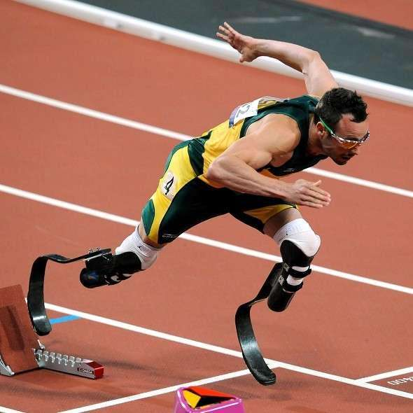 | 3  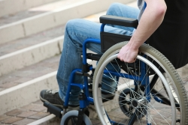
2  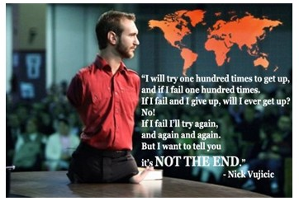 | 4  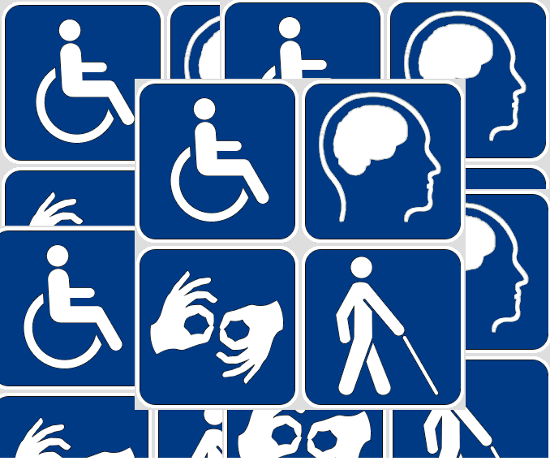

Picture 1 taken from: http://www.ranker.com/list/athletes-who-are-disabled/people-in-sports
Picture 2 taken from: https://www.linkedin.com/pulse/20140616020500-154207450-disability-it-s-just-a-mindset
Picture 3 taken from: http://us.reachout.com/facts/factsheet/physical-disability
Picture 4 taken from: https://topnjteacher.wordpress.com/category/physical-disability/

TASK PHYSICAL DISABILITIES

TASK 2A To prepare for the introductory text about physical disabilities discuss the meaning of the words and phrases in the box and how they might be used in the given context.

acquired disability | pre-natal disability | post-natal disability
pregnancy | congenital disability | partial or total inability

TASK 2B Translate the words and phrases above into Czech.
1 acquired disability = _________________________________________
2 pregnancy = _________________________________________
3 pre-natal disability = _________________________________________
4 congenital disability = _________________________________________
5 post-natal disability = _________________________________________
6 partial or total inability = _________________________________________

Physical disabilities
A physical disability is a limitation on a person's physical functioning.
Prenatal disabilities are acquired before birth. These may be due to diseases or substances that the mother has been exposed to during pregnancy, or genetic disorders.
Post-natal disabilities are gained after birth. They can be due to accidents, obesity, infection or other illnesses. These may also be caused by genetic disorders.
Mobility impairment includes physical defects, including upper or lower limb loss or impairment. Disability in mobility can be a congenital or acquired problem, or a consequence of disease.
Visual impairment is another type of physical impairment. There are hundreds of thousands of people who suffer greatly from minor to various serious vision injuries or impairments. These types of injuries can also result in severe problems or diseases such as blindness.
Hearing loss is a partial or total inability to hear. People who are only partly deaf can sometimes make use of hearing aid to improve their hearing ability.
Adapted from: https://en.wikipedia.org/wiki/Physical_disability

TASK 2C Answer the questions:
1 What is the difference between prenatal and post-natal disabilities in terms of the time when they are formed and their causes.
2 Which three major types of impairment are mentioned in the text? Characterize them briefly.

TASK PSYCHOLOGICAL AND SOCIAL ASPECTS OF DISABILITY

TASK 3A To prepare for the introductory text about psychological and social aspects of disability, discuss the meaning of the words and phrases in the box and how they might be used in the given context.

denial | psychological intervention | acceptance
to cope with transitions | to mourn sth | self-evaluation

TASK 3B Translate the words and phrases above into Czech.
1 denial = ______________________________________________
2 to cope with transitions = ______________________________________________
3 psychological intervention = ______________________________________________
4 to mourn sth = ______________________________________________
5 acceptance = ______________________________________________
6 self-evaluation = ______________________________________________

TASK 3C Read the following text about the psychological and social dimension of disability and answer the questions.

Psychological intervention can help a person with a disability progress through stages of disability and assist them with difficulties experienced.

People who experience disability for the first time undergo stress; cope with life transitions, value changes, and experience disability issues across their life spans. From a sociological perspective, people who experience disability for the first time also have to deal with the role of family, cross-cultural issues and adjustments, the consequences of negative attitude towards people with disabilities as a whole, and the roles of professionals who work to assist them with adjusting. Their system of life and living has changed in many different ways, meaning they must undergo a process of adjustment and self-evaluation.
The experience of an injury that leads to a psychological or physical disability is similar to a mourning process and might be compared to the loss of a loved one; for example. The mourning process can involve adjustment to the disability the person experiences and may be divided into a series of four stages or tasks - shock, denial, anger/depression, and adjustment/acceptance.
The stages are expected, yet are not orderly or neat. People with disabilities go through these stages at their own paces and might skip whole stages entirely. A difficulty exists when the person has trouble with one of the stages or becomes, 'stuck.' When this happens, further progress towards adjustment and acceptance is blocked.
Adapted from: http://www.disabled-world.com/disability/social-aspects.php
1 What is the acquisition of physical disability compared with?
2 What stages does a person with a recently acquired disability go through?
3 What happens when a person with a recently acquired disability gets stuck in one of these stages?

TASK 3D VERBS Complete the gaps with the correct forms of the following verbs. One of the verbs is not used.
ACQUIRE, COMPARE, DIVIDE, SKIP, UNDERGO
1 People who experience disability can ___________________ stress.
2 For people who ___________________ disability as a result of accident, it is extremely difficult to cope with their new situation.
3 The mourning process can ___________________ into four stages.
4 All the disabled do not necessarily have to go through all the stages, they may ___________________ some.

TASK 3E WORDFORMATION. Complete the gaps with words made from the words in the brackets.
1-2 Hearing ___________________ is a ___________________ or total inability to hear. (LOSE, PART)
3 She suffers from a severe visual ___________________ . (IMPAIR)
4 From a ___________________ perspective, people with disabilities have to face a negative attitude from the rest of the society. (SOCIOLOGY)
5-6 When people get stuck in one of these stages, their further progress towards ___________________ and ___________________ is stopped.(ADJUST, ACCEPT)

TASK PERCEPTION OF DISABILITY IN DEVELOPED AND DEVELOPING COUNTRIES

TASK 4A DISCUSSION. In pairs discuss the following questions.

1 Is the public attitude to disabled people shaped by the country's standard of living?
2 Do you expect the attitude to disabled people to be the same in the developing and developed world?
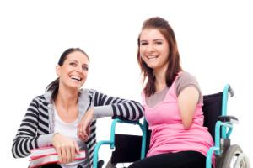

Picture taken from: http://learnenglish.britishcouncil.org/en/magazine/disability
TASK 4B Match the words and phrases in the box with their definitions below.
Before you listen to the recording, study the following vocabulary. To get the right definitions, match the numbers in the left column with the letters in the right column. Complete the middle column with the Czech translations of the English words or phrases.
English | Czech | Definition
1 tactile |  | A unable to move
2 to beg |  | B touching other people a lot
3 a breadwinner |  | C sudden, uncontrolled movement of many people because of fear
4 burdens |  | D artificial slopes
5 clumsy |  | E belief and confidence in your own ability and value
6 to crawl |  | F here: difficult people you have to worry about
7 on the grounds that |  | G artificial arms or legs
8 ostracized |  | H person who is refused a place in a society or group
9 an outcast |  | I to ask for food or money because you are poor
10 paralysed |  | J because of
11 prosthetic limbs |  | K avoided or prevented from taking part in group activities
12 ramps |  | L person who earns money that their family needs
13 self esteem |  | M awkward in movement
14 stampede |  | N to move slowly on hands and knees
Definitions taken from: http://learnenglish.britishcouncil.org/en/magazine/disability

TASK 4C FIRST PART OF THE RECORDING. Complete the first part of the text about the perception of disability in developed and developing countries.

A raise people’s awareness
B are supposed to announce
C enable people to walk
D are adapted
E mustn’t discriminate against
F are recognised
G are far less marginalised

Nowadays in the "west" the able bodied are constantly reminded that disabled people have rights just like everyone else and they 1 _____________________________________ them in any way. Public buildings have to have ramps and toilets big enough for wheelchairs. Bus drivers 2 _____________________________________ every stop so that blind people know when to get off. One is not allowed to refuse a person a job on the grounds that he or she has only one leg, or cannot speak. We use phrases like "physically challenged" instead of crippled or spastic. We avoid using the word “dumb” to mean stupid - and this is not just us trying to be "politically correct". Things like the Para Olympics have done wonders to 3 _____________________________________ with so many positive images and perceptions of disabled people genuinely have changed. Not that Western society doesn't still have a long way to go, but disabled people 4_____________________________________ , far more integrated than in the past when they were confined to institutions, out of sight and out of mind.

Disabled people's own self esteem has risen enormously in recent years and they have become far more assertive and insistent on their rights, and their ability to compete with everyone else. Even the words "disabled" and "handicapped" are challenged. Is a blind person disabled when he or she can function just as well as everyone else? New technology of course is making a huge difference. Instead of clumsy wooden legs, for example, new materials and designs in prosthetic limbs 5 _____________________________________ and run as fast as everyone else. High tech hearing aids exist for the deaf, as well as laser surgery for the very short sighted. Cars 6 _____________________________________ so that people can drive them with only one hand, or even no hands at all. Very recently a chip was inserted into the brain of a person paralysed from the neck down enabling him to move a cursor on a screen simply by looking at it. This means he can now do all sorts of things - switch the television and the lights on and off, type, surf the internet, even send e-mails. Who knows what he'll be able to do next? Drive a car? Also many things that previously were not considered disabilities now 7 _____________________________________ for what they are - serious handicaps, and arrangements have been made for the people who suffer from them. Dyslexia is a good example. Not so long ago dyslexic people were considered at school to be slow, or stupid, and that was that. Nowadays it is seen as a serious condition and teachers have to be aware of it.

Adapted from: http://learnenglish.britishcouncil.org/en/magazine/disability

^{RECORDING 1 – PART 1} TASK 4D Listen to the first part of the recording (transcript is the above exercise) and classify the below statements as true (T) or false (F) based on the information provided.

1. All over the world attitudes towards disabled people have changed. T/F

2. Bus drivers in the "west"" always announce every stop so that blind people know when to get off. T/F

3. "Spastic" is used in an offensive way these days. T/F

4. The Para Olympics have helped a lot to make people see disabled people more positively. T/F

5. When disabled people were confined to institutions other people didn't think about them. T/F

6. Disabled and handicapped mean the same thing. T/F

7. Soon paralysed people will be able to drive cars. T/F

8. Dyslexic people often see letters in a word the wrong way around. T/F

^{RECORDING 1 – PART 2} TASK 4E SECOND PART OF THE RECORDING. Listen to the second part of the talk, the transcript of which is provided below. Based on the information shared in recording discuss the following.

1 The recording suggests the attitude to disabled people in the West is actually insincere. Do you agree? Do you think that the arguments (given by Anna) to support this view are justified?

******************************************************************************************************

But what is it like in the Developing World? In places where there are no facilities at all? Where polio victims have to crawl through the traffic on their knees and elbows? Where every disabled person is unemployed and forced to beg, or depend on relatives?

"Despite all that" says Anna, a Swedish Volunteer in Mozambique, "it is often in these places that disabled people are actually more integrated and happier in society. Western society is so obsessed with beauty and physical perfection that even an overweight person feels ostracised, let alone a person missing an entire limb. Here having one leg is no more remarkable than having a big nose".

But is this really so?

"Yes and no" says Adolfo, a blind Mozambican who, as an accomplished guitar player, is actually the only breadwinner in his family. "I'm lucky. I have a skill. More importantly I was given the opportunity to acquire one. And so I am able to contribute to society and I am respected. Most disabled people are totally unskilled and so are burdens on society whether they like it or not. Maybe we are more generous, we don't reject people who cannot contribute. They are not outcasts - but that doesn't mean we respect them either. I think that is too idealistic a view of African society, how we would like it to be rather than how it really is. In reality these days, with so much poverty and HIV Aids, it's every man for himself, every woman for herself, and disabled people are completely forgotten, left behind. I heard a story about a woman in a very dry part of our country. She had lost both legs in a land mine explosion. Because of drought there was no food and when a UN truck full of supplies arrived she was left behind in the stampede, and so she got none. Later everyone had to register in order to get a ration card, then because she didn't get one she was told that she did not officially exist and therefore was not entitled to food! No thank you, I would rather have no legs in Europe any day than here".

"I don't believe that story" says Anna. "People here just wouldn't behave like that".
"Have you ever been really hungry? " asks Adolfo.
"No" she is forced to admit.
"Then how would you know? "

But Anna still thinks its worse in the west. “In Africa people are much more tactile, much more tolerant, much more accepting. Even the mentally deranged are part of society. What's the use of all those facilities if no one actually ever talks to you? Disabled people in Europe are dying of loneliness. People are physically repulsed by handicapped people. The idea that disabled people have sexual desires just like anyone else is quite shocking. Here in the market there is a young girl who sells tomatoes. She must have been in an awful fire because one side of her is completely burnt and her left hand has no fingers at all. Her face is terribly disfigured, she has only one eye and just a hole for a nose. But she flirts with all the guys, and then makes bawdy jokes about them to the other women, and has everyone in fits of laughter.”

"That doesn't mean they actually fancy her though" says Adolfo. "Unless they're blind like me" he jokes.
"But going back to technology, it is making things easier here too" he adds. "Look at my mobile phone".
"Wouldn't you like a speaking clock or a computer with software to enable it to read aloud to you?" asks Anna.
Adolfo just laughs. "My wife does that for me" he says. "She reads the newspaper to me every day".
"You see!" says Anna. “That proves me right. Nobody where I come from has got time to read to a blind person! And don't tell me that a machine can do it just as well because it can't! "
******************************************************************************************************

Taken from: http://learnenglish.britishcouncil.org/en/magazine/disability

TASK 4F Work in groups of three. You are each supposed to write (100-150 words) and orally present a summary of the following aspects.

Summary 1: The attitude to and treatment of disabled people in the West now and in recent history. (The first part of the recording)
Summary 2: The developing world is able to integrate disabled people better than the developed world. (The second part of the recording, Anna's view).
Summary 3: It is better to be disabled in a developed country than in a developing country. (The second part of the recording, Adolfo's view).

Your summary:

TASK DISABLED DOLL
TASK 5A DISCUSSION. In pairs discuss the following questions.
1 What message do the doll in the wheelchair and the doll with a cane send?
2 How could these dolls be used in education?

1  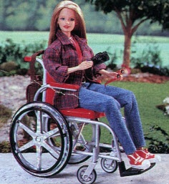 | 2 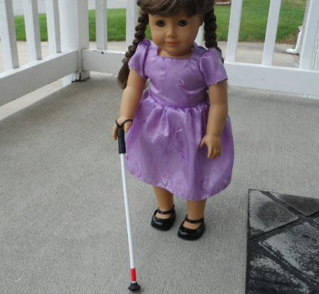
Picture 1 taken from: http://rampyourvoice.com/wp-content/uploads/2014/02/Becky-doll-1.jpg
Picture 2 taken from: https://www.pinterest.com/pollyannaflower/special-needs-toys-dolls-playground/

TASK 5B Before you listen to the recording, study the following vocabulary. To get the right definitions, match the numbers in the left column with the letters in the right column. Complete the middle column with the Czech translations of the English words or phrases.
English | Czech | Definition
1 controversial |  | A humiliating, affecting someoneʼs dignity
2 cerebral palsy |  | B something that causes offence, often a remark or action
3 insult |  | C causing or likely to cause argument or offence
4 retard |  | D a physical condition in which muscles tighten, caused by damage to the brain around the time of birth
5 degrading |  | E to regard with disrespect, to feel superior to someone or something
6 to look down on sb |  | F offensive slang for a mentally disabled person
Definitions adapted from: http://www.bbc.co.uk/worldservice/learningenglish/general/sixminute/2012/06/120607_6min_disabled_doll.shtml

^{RECORDING 2} TASK 5C Listen to the recording and answer the questions.

1 What attitude is behind the creation of a disabled doll?

2 In what context is the phrase “degrading kindness“ used?

TASK 5D VERBS. Complete the gaps with the correct forms of the following verbs.

BRING, CAUSE, ENCOURAGE
1 This doll ___________________ controversy.
2 The disabled doll is supposed to ___________________ debate about the way we treat people with disabilities.
3 They try to ___________________ this topic to the surface.

TASK 5E WORDFORMATION. Complete the gaps with words created from the words in brackets.
1 The doll is meant to raise the ___________________ of peopleʼs attitudes to the disabled. (AWARE)
2-3 This doll has irregular ___________________ features and twisted arms of someone with a ___________________. (FACE, ABLE)

TASK BLIND MASSAGE THERAPISTS

TASK 5A Before you listen to the recording, discuss the following statement.
1 In some countries only blind people are legally allowed to do a certain type of work. Do you think certain jobs should only be kept for people with disabilities?

^{RECORDING 3} TASK 5B Listen to the recording and answer the following questions.

1 Describe the job of a massage therapist.

2 What do you know about the law that has been in force in South Korea since 1963.

3 Who is protesting against this law and why?

4 How many people are working as massage therapists legally and illegally, i.e. without a licence in South Korea?

Adapted from: BBC Learning English, 6 Minute English, Blind massage therapists (2008)

TASK 5C VERBS Complete the gaps with the correct forms of the following verbs.

APPLY FOR, BREAK, COPE WITH, DISCRIMINATE, KEEP, LIVE, RUB

1 About 10% of the world population _____________ with disability of some kind.
2 Massage therapists mainly use their hands and fingers to _____________ different area of the body to stop pain or to help people to move more easily.
3 In South Korea more massage therapists are needed to _____________ the growing demand for these services.
4 Sighted massage practitioners believe the new law _____________ against them.
5 People _____________ the law by providing services which they are not licensed to provide.
6 Blind people who are favoured by the current law want to _____________ their monopoly.
7 Most of the people would say that anyone should be able to _____________ or in other words ask for any job.

VOCABULARY
ability /əˈbɪləti/ schopnost
to accept sth/sb / əkˈsept/ přijmout, akceptovat
acceptance /əkˈseptəns/ přijetí, akceptování
to acquire /əˈkwaɪə(r)/ získat
to adjust to sth/sb /əˈdʒʌst/ přizpůsobit
artificial /ˌɑː(r)tɪˈfɪʃ(ə)l/ umělý
attitude to sth/sb /ˈætɪˌtjuːd/ přístup, postoj k
to be aware of sth/sb /əˈweə(r)/ být si něčeho vědom
awareness of sth /əˈweə(r)nəs/ povědomí o
birth /bɜː(r)θ/ narození
blind /blaɪnd/ slepý
blindness /blaɪndnis/ slepota
celebral palsy /ˈserəbrəl/ /ˈpɔːlzi/ mozková obrna
congenital /kənˈdʒenɪt(ə)l/ vrozený
controversial /ˌkɒntrəˈvɜː(r)ʃ(ə)l/ kontroverzní
controversy /ˈkɒntrəvɜː(r)si/ kontroverze
deaf /def/ hluchý
deafness /defnis/ hluchota
defect /ˈdiːfekt/ vada
to degrade /dɪˈɡreɪd/ degradovat, ponížit
degrading /dɪˈɡreɪdɪŋ/ ponižující
denial /dɪˈnaɪəl/ zde: neschopnost přijmout pravdu
to deny /dɪˈnaɪ/ popřít, zapřít
disability /ˌdɪsəˈbɪləti/ postižení
disabled /dɪsˈeɪb(ə)ld/ osoba postižená, postižený
extremity /ɪkˈstreməti/ končetina
to humiliate /hjuːˈmɪlieɪt/ ponížit
humiliating /hjuːˈmɪliˌeɪtɪŋ/ ponižující
impairment /ɪmˈpeə(r)mənt/ postižení, poškození
inability /ˌɪnəˈbɪləti/ neschopnost
injury /ˈɪndʒəri/ zranění
to insult sb /ˈɪnsʌlt/ urazit
irregular /ɪˈreɡjʊlə(r)/ nepravidelný
to mourn sth/sb /mɔː(r)n/ oplakávat, truchlit
ostracized /ˈɒstrəsaɪzd/ ostrakizovaný, vyloučený
to patronize sb /ˈpætrənaɪz/ poučovat
*polio /ˈpəʊliəʊ/ dětská obrna
post-natal /ˌpəʊs(t)ˈneɪt(ə)l/ post-natální
pregnancy /ˈpreɡnənsi/ těhotenství
pre-natal /ˌpriːˈneɪt(ə)l/ pre-natální
self-evaluation /self ɪˌvæljuˈeɪʃ(ə)n/ sebezhodnocení
therapist /ˈθerəpɪst / terapeut
therapy /ˈθerəpi/ terapie
transition /trænˈzɪʃ(ə)n/ přechodové období, období změny
to undergo sth /ˌʌndə(r)ˈɡəʊ/ podstoupit něco
victim /ˈvɪktɪm/ oběť (zranění, útoku, apod.)

PHRASES
aquired disability - získané postižení
congenital disability - vrozené postižení
genetic disorder - genetická porucha
hearing aid - sluchadlo
hearing loss - ztráta sluchu
lower / upper extremity - dolní končetina
physical defect - fyzická vada
physical disability - fyzické postižení
post-natal disability - postnatální zdravotní postižení
prenatal disability - prenatální zdravotní postižení
to progress through stages of disability - postupovat fázemi postižení
psychological intervention - psychologická intervence
to raise public awareness of the issue - zvýšit veřejné povědomí o problematice
visual impairment - zrakové postižení

TRANSCRIPT 1: DISABLED DOLL
Sean: Hello and welcome to 6 Minute English from BBC Learning English, the programme where we discuss a topical subject and introduce you to some of the interesting vocabulary connected to that topic. I'm Sean and with me is Rosie.
Rosie: Hi there.
Sean: So - Rosie, you're a girl!
Rosie: Yes, I am!
Sean: Well, then I'm guessing you played with dolls when you were younger?
Rosie: And your guess is right. I did indeed play with dolls but not only girls play with dolls... there's nothing wrong with boys playing with dolls too!
Sean: Not at all... in fact, I can remember playing with a doll myself… a doll with red hair…. but today’s story is about another kind of doll which is causing some controversy in Sweden. We'll hear all about that in a minute, but of course we’ll start as usual with a quiz question. Are you ready Rosie?
Rosie: Yes I am.
Sean: Okay. This may give everyone a bit of a clue to the subject of today's story. Here is the quiz question: Which of these sports is NOT in the Paralympic Games: Basketball? Cricket? Football?
Rosie: Well, I'm going to say cricket. I don't think cricket is in the Paralympic Games. Sean: Okay, any particular reason? Rosie: Well, I just think that only certain countries really appreciate cricket.
Sean: So, Rosie, have you ever played cricket?
Rosie: Well no I haven't. I am one of those people who doesn't really understand the rules.
Sean: Hmm. OK. And you're English.
Rosie: I know.
Sean: But, anyway we'll find out the answer at the end of the programme.
Rosie: So, we were talking about dolls.
Sean: Yes, and one doll in particular that has been causing controversy in Gothenburg Sweden. It's controversial because it's a disabled doll.
Rosie: A disabled doll. That is controversial. A controversy is a debate or argument with people expressing different opinions. So if something is controversial it means it’s causing or likely to cause some argument.
Sean: And that's because this doll has irregular facial features and twisted arms of someone with a disability... It’s meant to encourage debate about the treatment of people with disabilities. But now, listen to the first part of a report from the BBC's Jo Fidgen about the CP doll. What does she say the letters CP are short for?

BBC correspondent Jo Fidgen: It's called the CP Doll, CP being short for cerebral palsy, but also a common insult meaning someone or something that isn't functioning properly. The slogan on the packaging reads, ''Treat her like a real retard.'' The group behind the idea, The Gothenburg Cooperative for Independent Living, provides personal assistance for the disabled.

Sean: Jo Fidgen in Sweden. She says that the group behind the idea of the CP doll provides personal assistance for the disabled. And...
Rosie: And she said CP is short for cerebral palsy, a condition causing disability.
Sean: That's right. It's an abbreviation for cerebral palsy but in Sweden it has another meaning as well. It's an insult meaning someone or something isn't functioning –isn't working- properly. The insult is on the packaging as well
Rosie: Yes 'retard' is used as an insult; a term of abuse. So this doll has offended people – they are shocked.
Sean: Yes, they are shocked but the director of the organisation that produced the doll, Andush Vestia, who uses a wheelchair, says that he got fed up with what he calls ''degrading kindness'' Here he talks about what often happens when he goes shopping. Listen out for how he says people treat him.

Andush Vestia: Often times when I go shopping people tap me on my head and tell me ''Oh it's great for you to be able to shop by yourself.'' People treat you more or less like a child. That is something that we are tired of. We would like to be treated as regular people and the doll is a means for us to be able to bring this topic to the surface.

Sean: The Director of the Gothenburg Cooperative for Independent Living, which helps disabled people. He doesn't like people's attitudes. He says it's degrading.
Rosie: He calls it 'degrading kindness'. – taking away his dignity. Or patronising.
Sean: Yes and he gave the example of people patting him on the head and saying that it is great that he shops by himself. Did you catch how he says people treat him?
Rosie: Yes, he said that people treat him more or less like a child.
Sean: And that is degrading. So, back to the story of the doll: the CP doll is meant to raise awareness of people's attitudes to the disabled. It has been policy in Sweden that the disabled have the same opportunities and access as everyone else.
Rosie: Which brings us back to the quiz question you asked at the beginning of the programme.
Sean: That's right it does. So, did you get it? Which of these sports is NOT in the Paralympic Games? Basketball Cricket Football So, Rosie?
Rosie: I said cricket.
Sean: You did. You said cricket. Are you sticking with cricket?
Rosie: I did. Is it right? Sean: It is right. Gold medal to Rosie.
Sean: And with that cricket is not in Paralympic Games coming to London very soon. But for now we've come to the end of the programme. So, Rosie, just please remind us of some of the words we heard today.
Rosie:
controversial
cerebral palsy
insult
retard
degrading
look down on
Sean: That's all we have time for today but do join us again for more 6 Minute English. Bye for now! Rosie: Bye! Bye!
Taken from: BBC Learning English, 6 Minute English, Disabled doll (3 December 2013)
http://wsdownload.bbc.co.uk/learningenglish/pdf/2013/12/131203101820_1200606_6min_disabled_doll.pdf

TRANSCRIPT 2: BLIND MASSAGE THERAPISTS

Yvonne: Hi, I'm Yvonne Archer and this is '6 minute English'. And joining me today is William Kremer. Hello William!
William: Hello Yvonne!
Yvonne: Now recently, I heard an interesting report about how, in South Korea, only people who are blind are legally allowed to do a certain type of work.
William: Oh – but what type of work? And is that law fair to everyone else – especially to people with other types of disability?
Yvonne: Well, they're all good questions William – but before we find out a few answers, I've got a question for you. Are you ready?
William: As ever…
Yvonne: Good! Approximately how many people in the world are living with a disability of some kind? Is it a) two percent b) ten percent OR c) twelve percent
William: I don't know but I'm guessing B – ten percent. Because there's a lot of old people obviously, and old people very often have disabilities of one kind or another. And there's unfortunately, there're a lot of wars and that leaves people with a lot of disability. So ten percent…

Yvonne: Good answer - ten percent. Okay, we'll find out whether you're right or wrong at the end of the programme. Since 1963, people in South Korea who are blind have been the only ones allowed to work as massage therapists. William, what type of job that?
William: Certainly. A 'massage therapist' is a person who mainly uses their hands and fingers to rub different areas of the body, head, arms or legs to help stop pain or to help people move more easily. So someone who's been in an accident, for example, might have 'massage therapy'.
Yvonne: And people in South Korea, especially those who've recently become blind, are really happy that the law keeps those jobs for them. But people who aren't blind want that law changed so that they can also earn money in the same way. In today's report, we'll come across the expression 'to cope with demand'. William, what's that mean?
William: Yes, if a person or a company 'copes with demand', they provide what their customers need when they need it. So for example, a dressmaker who can't sew all her customers' dresses on time has more work than she can manage and she can't 'cope with demand'.
Yvonne: Great – and what does 'awash with' mean?
William: 'Awash' literally means covered with water. But here, it means that there's lots of something. So for example, if you said 'London is awash with tourists in the summer' it means that there's lots of tourists in London in the summer.
Yvonne: Excellent. Now in his report, the BBC's John Sudworth explains that there are about seven thousand massage therapists who are blind in South Korea. But how many people who aren't blind would like to be legal massage therapists too?
JOHN SUDWORTH There may be seven thousand, but they can't cope with demand. South Korean cities are awash with massage parlours, barbers' shops and bath houses – all offering massages by unlicensed, sighted practitioners. An estimated half a million of them in total.

Yvonne: So the cities in South Korea are awash with all kinds of businesses which offer massages. But William, how many sighted people – people who can see - are breaking the law by providing those massages?
William: Well, John says that there are about half a million people who are working illegally – without a licence.
Yvonne: That's right – and they've asked the courts to change the law because they believe it's unfair to stop them from earning money and it actually makes them into criminals by doing massages. Now the massage therapists who are blind aren't happy either…

JOHN SUDWORTH Now blind masseurs and masseuses have been taking to the streets to defend their monopoly. Some massage therapists have even jumped off bridges into the Han River.

William: Wow – that's a powerful protest. They really do want to keep their legal right to be the only group of people who can become massage therapists; they're desperate to hold onto their 'monopoly'.
Yvonne: They certainly are and luckily, so far, no-one has been seriously hurt in the protests. Now even though there's more than enough work for everyone, blind people are worried that this won't always be the case - and say it would be really difficult for them to find other types of work. But here's a final question from John which gives us all something else to think about.

JOHN SUDWORTH So is massage work a valuable protection for a vulnerable minority, or a patronising excuse for a lack of equality? Yvonne: Hmmm, a question the courts will have to answer. But William, what are your thoughts - should certain jobs be kept for people with disabilities?
William: Umm…I don't know – that's a very, very difficult question. Umm – maybe. Maybe that's the fairest thing until everyone can apply for every job. I don't know.
Yvonne: Well, there's a lot to think about and discuss after the programme. But for now, let's get the answer to today's question: William, approximately how many people in the world are living with a disability of some kind? William: I said ten percent…
Yvonne: You're absolutely right.
William: Yeah!
Yvonne: It's an extraordinary number, isn't it?
William: It is actually. It's a much higher number than a lot of people would think, I believe.
Yvonne: Anyway, that's all we've time for today – but do join us again next time for more '6 Minute English' from BBC Learning English. W/Y: Goodbye!

Transcript taken from: http://downloads.bbc.co.uk/worldservice/learningenglish/6minute/6minute_081203_blind_masseurs.pdf

