CZECH EDUCATIONAL SYSTEM

International Standard Classification of Education - ISCED 1997
0 – Pre-primary school (nursery schools)
1 – Primary school (1st – 5th grade)
2 – Lower secondary school (6th – 9th grade)
3 – Higher secondary school (10th – 13th grade)
4 – Postsecondary/Nontercial school (e.g. accredited language school after final upper-secondary final examination)
5 – First stage of tertiary education (state post-secondary technical school, bachelor‘s and master‘s degree)
6 – Second stage of tertiary education (doctoral study programme)

https://www.mzv.cz/file/936809/Education_system.pdf

Basic informations
- Compulsory school attendance
- Classification system: marks, 1 -5 (best to worst)
- Compulsory preprimary education is guaranteed for children in their last year before entering elementary school
- Elementary education takes 9 years, usually from ages 6-15
- Elementary education is divided into two stages: primary (grade 1 – 5) and lower secondary (grade 6-9)

Framework Education Programme (Rámcový vzdělávací program - RVP)
- FEP defines the expected outcomes and main objectives of each level of edcation and study branch.
- FEP also characterizes the priorities, objectives, key competencies and content of the educational areas (for example Language and Languague Communication).
- Schools have to create its‘ own School Educational Programme based on the FEP, however adapted to the regional and local context and needs.
- Two-levels: national and school (interconnected documents)
- The Czech educational reform has establisted the two-level curricula system:

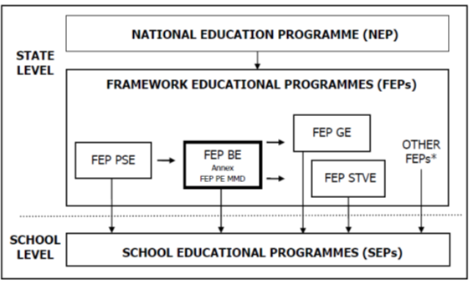

https://www.msmt.cz/vzdelavani/zakladni-vzdelavani/framework-education-programme-for-basic-education

Objectives of basic education
- To create preconditions for pupils to acquire basic learning strategies and motivate them to life-long learning.
- To stimulate and encourage pupils to creative thinking, logical reasoning and problem solving.
- To guide pupils to engage in efficient, effective, open communication on all aspects of their life.
- To develop pupils’ abilities to cooperate and to value their own work and achievements as well as the work and achievements of others.
- To guide pupils so that they should become free and responsible individuals who exercise their rights and meet their obligations.
- To induce the urge to express positive feelings and emotions in chidren’ behaviour, ways of acting and when experiencing important situations in their lives; develop in them sensitivity and responsiveness towards other people, the environment and nature.
- To teach pupils to actively develop and protect their physical, mental and social health and to be responsible for it.
- To guide pupils to tolerance and consideration for other people, to a respect for their culture and spiritual values; teach pupils to live together with others.
- To help pupils to discover and develop their own abilities and skills in the context of actual opportunities and to use their abilities and skills in combination with their acquired knowledge when making decisions regarding the aims of their own life and profession.

Educational fields
- Language and Language Communication (Czech Language and Literature, Foreign Language)
- Mathematics and Its Applications (Mathematics and Its Applications)
- Information and Communication Technologies (Information and Communication Technologies)
- Humans and Their World (Humans and their World)
- Humans and Society (History, Civic education)
- Humans and Nature (Physics, Chemistry, Natural Sciences, Geography)
- Arts and Culture (Music, Fine Art)
- Humans and Health (Health Education, Physical Education)
- Humans and the World of Work (Humans and The World of Work)

Key competencies
- learning competencies;
- problem-solving competencies;
- communication competencies;
- social and personal competencies;
- civil competencies;
- working competencies

Cross-Curricular Subjects

- Cross-curricular subjects in the FEP BE are subjects related to discussed present-day issues and represent an important and inseparable part of basic education.
- Cross-curricular subjects:
  - Personal and Social Education
  - Democratic Citizenship
  - Education towards Thinking in European and Global Contexts
  - Multicultural Education
  - Environmental Education
  - Media Education

